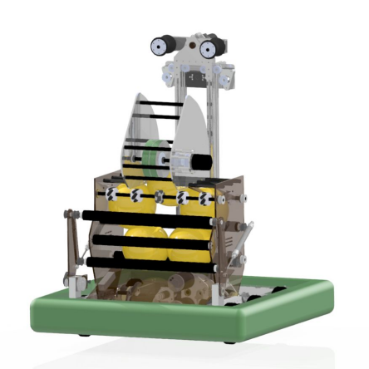| K REN 2020 technical binder
Table of Contents
Kickoff 2
Analysis 3 Priority List 4 Design 6
Drivebase 7 Drivebase Gearbox 8 Climber 9 Climber Gearbox 10 Translator 11 Intake 12 Hopper 13 Shooter 14 Software 15
Autonomous 16 Vision 17 Climber 18 Shooter 19
1
Kickoff
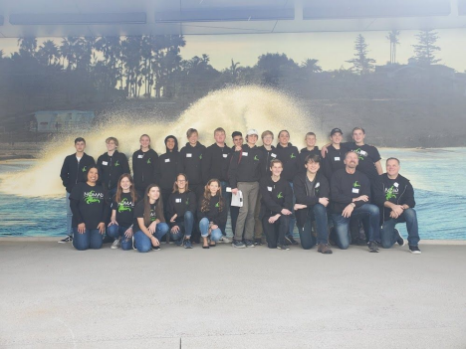NOMAD, FRC Team 6995, began our 3rd season by attending the kickoff at Viasat in Carlsbad. With 19 students and 5 mentors, we were ready to start another fantastic season.
Our measure of success this year was to have a functional robot that completed the tasks that we wanted the robot to do before our first competition.
After two months of hard work and testing, NOMAD would like to present to you our 3rd robot: K-Ren.
2
Analysis
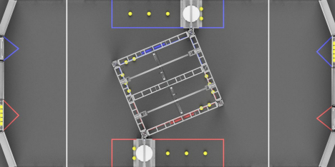This year, our team wanted to be very specific and intentional when choosing what we wanted to do in the game this year. We recognized the two extra ranking points, climbing and
shooting, and made the comparison to the 2019 game.
We believed that the climbing ranking point was way more feasible compared to shooting balls, in addition to the points per second advantage.
With these facts in mind, we also noticed that two robots had to be balanced on the bar, so we knew that being able to balance the bar in some way was mandatory.
After a lot of discussion, the team leads eventually made a list of all of the ‘Must do’ and ‘Don’t do’, prioritized from first to last.
3
Priority List
Do Don’t
Drive SWERVE
Climb | Turreted shooter
Translate | Lowball
Acquire, Store, and Shoot 5 balls | Go under trench

Other unidentified actions, such as spinning the Wheel of Fortune, were lower on our priority list and would be progressed only when the main goals were accomplished.
Design Goal Robot Design Equivalent
Simple, strong, easy to construct drivebase
Andymark drivebase with new wheels and a custom bellypan

Move fast, with decent torque without battery drainage | Custom gearboxes, likely 8.36:1 reduction
Climb in 5 seconds | Custom gearbox driving an 8020 elevator with chain
Balance the bar | Have a translation mechanism on the top of the ladder
Grab powercells from outside of the robot boundary | Pneumatically actuated intake, grippy rollers, leads to hopper
Store 5 balls | Hopper with room for 5 balls, with the ability to rotate rollers to intake yet stall powercells within
Shoot into the high goal | Single flywheel shooter

4
K REN
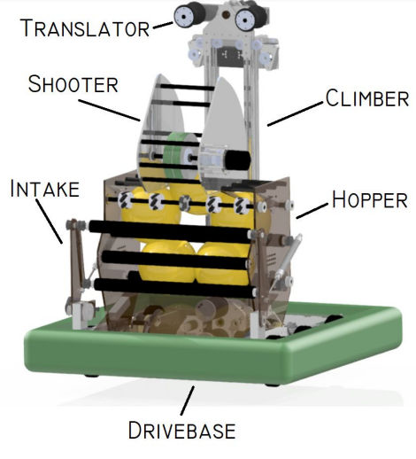5
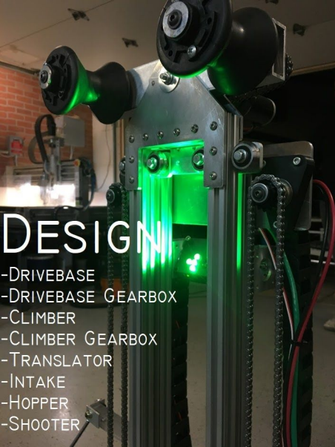Design 6
Drivebase
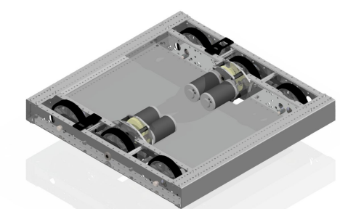Specs
● Andymark 14U4 Chassis
○ 28x28.3in
● 6in 60A Stealth Wheels
● 1/8in Center Drop
● 3d printed encoder mounts for reading wheel rotation
● 1/8in aluminum bellypan to mount electronics, as well as prevent balls from wedging in our robot
7
Drivebase Gearbox
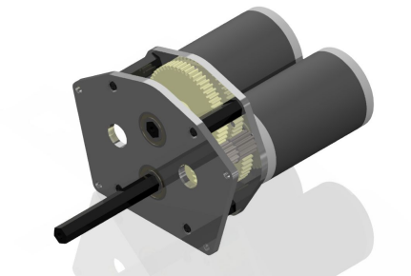Specs
● Custom CNC’d 1/4in plates
● Dual CIM configuration
● 8:36:1 reduction - 15.44 f/s
● Victor/Talon running either motor, with encoder wired into the talon to enable autonomous paths
*In 2019, we had severe battery issues due to a combination of improper gearing, not using counterweights, and over complication of certain mechanisms. Our current configuration has not experienced any drainage issues.
8
Climber Specs
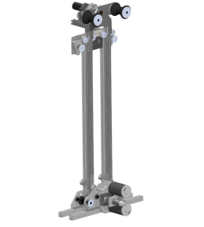
● Custom elevator system using 8020 with Rev linear slide kits. Modular system drops and mounts on drivebase
● Reaches max height in less than one second, in addition to climbing and locking in the same amount of time
● Driven by chain
● 28.25in of extension, with a max height of 70in from the ground
9
Climber Gearbox
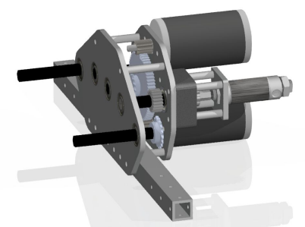Specs
● Dual CIM Custom SS Gearbox, with custom CNC’d 1/4in plates
● 7.11:1 reduction, 2 42T gears spin against each other to create correct rotation for driving the inner sprockets
● Custom pneumatic brake allows us to hold our robot ○ 1/2in stroke cylinder
○ Customized andymark hub with 40A durometer urethane on the bottom that allows the cylinder to press, without any rotational force on the shaft
10
Translator
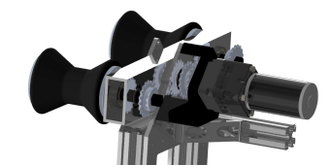
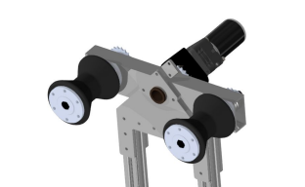
Specs
● BAG motor with a 50:1 Versaplanetary gearbox, spinning 16T Sprockets with chain to drive the wheels
● CNC’d 1/8in 2x1 Boxtube with bearings on the end and a bushing through the center allow smooth rotations. 3/16 Plate on either side allows the system to stay trapped, and can rotate ± 15 degrees
11
● Rollers are rubber boat things lathed down, with hex hubs
Intake
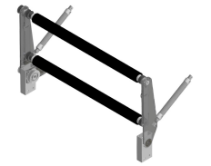Retracted Deployed
Specs
● 4in pneumatic cylinders that rotate the intake 90 degrees
● CNC’d 1/4in polycarb. Material was used due to its flexibility and weight
● Top roller section is sprung up with torsion springs ● RS775 Pro with 2:1 reduction driving rollers
● Belts are used to drive the rollers, and the hubs are custom designed to fit inside of the rollers and fit the
12
pulley. These hubs are 3d printed with carbon fiber reinforced PETG
Hopper
Specs
● CNC’d 1/4in Polycarb for sides, 1/8in polycarb for angled pieces to direct the balls
● RS775 Pros driving either side of the hopper rollers. They each have a Versaplanetary gearbox with a 7:1 reduction
13
● 6 Rollers, the bottom 4 are PVC pipe with a foam covering. The top two have two mecanum and omni wheels to ensure ball alignment to the shooter
Shooter
Specs
● Neo driving the flywheel via a belt, with a 1.5:1 ratio
● CNC’d 1/4in polycarb side plates, with an 1/8in polycarb sheet along the back and front of the shooter
14
● Flywheel consists of two 6in performance wheels with two 100T belts along the outer section to provide grip on the ball. The ball compression is approximately 1in
15
Software 16
Autonomous
During the autonomous period, the robot follows paths we create allowing us to leave the initiation line and score power cells without input from the driver. This is the first year we have been able to move autonomously.
Characterization:
This year we were able to make use of one of the tools provided by WPI called Robot Characterization. It allows us to create a mathematical model of a system and estimate the optimal feedback gains for that system. It has significantly shortened the tuning time for most of our mechanisms, especially autonomous.
Trajectory Generation:
At the start of a match, our robot generates a trajectory based on a path picked prematch by the drivers. Rather than using a series of straight lines, stops and turns for autonomous, trajectory following lets us smoothly move from point A to point B in a continuous movement.
Sensors:
For Autonomous, we use the following sensors:
● NavX: This measures the heading of our robot.
● 2 Grayhill encoders: these measure how far each side of the drvebase has moved so we can estimate our position.
17
Vision
Our robot uses a vision system to align with the retro-reflective targets on the field. We use a limelight to calculate the vertical and horizontal offsets from the target and use those offsets to correctly position the robot.
18
Climber
The code running our climber uses a standard PIDF loop to lift the elevator to the proper height and pull the robot off the ground. The calculations are done on a Talon SRX, giving us faster loops. It uses a REV through-bore encoder to measure the position of the elevator.
19
Shooter
The shooter was the first time we programmed a mechanism to use velocity PID instead of positional PID. It was also the first mechanism we have programmed using a Spark Max. We were very happy with the results. It uses a PID loop, and thanks to characterization, it was accurately tuned in a very short amount of time. It uses the built in encoder of the Neo driving the shooter to measure its velocity.
20

