6995 Team NOMAD

Outreach Binder

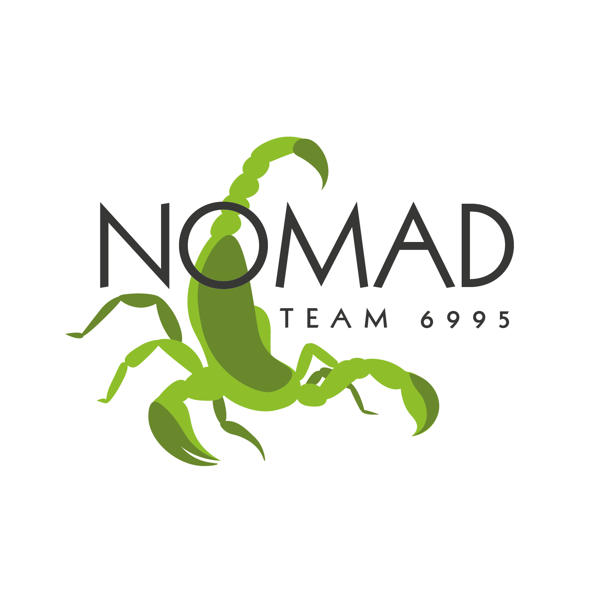

Mission Statement
NOMAD’s goal is to provide opportunities for all students to develop lifelong skills through hands-on STEM and business experiences in an exciting and fun environment. NOMAD endeavors to give students who would not normally have the opportunity to be part of a robotics team (such as homeschool or charter school students) the chance to be involved in the FIRST community. In all of our pursuits, NOMAD strives to build productive relationships, inspire the next generation, and leave a positive impact.

Outreach Philosophy
Through our seven years of existence, NOMAD’s outreach has developed into a particular style of initiative. We strive to bring the community together, whether that is the local FRC community or the broader community our students are a part of. Most of our outreach efforts depend on word-of-mouth advertising from our small number of students (under 22 each year), which causes distinct groups to overlap and find a common interest in robotics. Recently, outreach events such as Water Games (explained below) have brought the local FRC community together and helped students develop cross-team friendships.

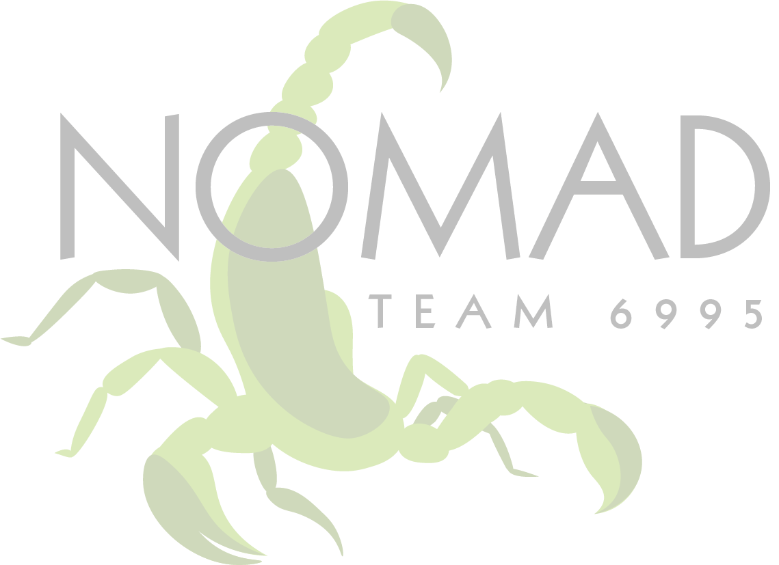
Outreach Over The Years
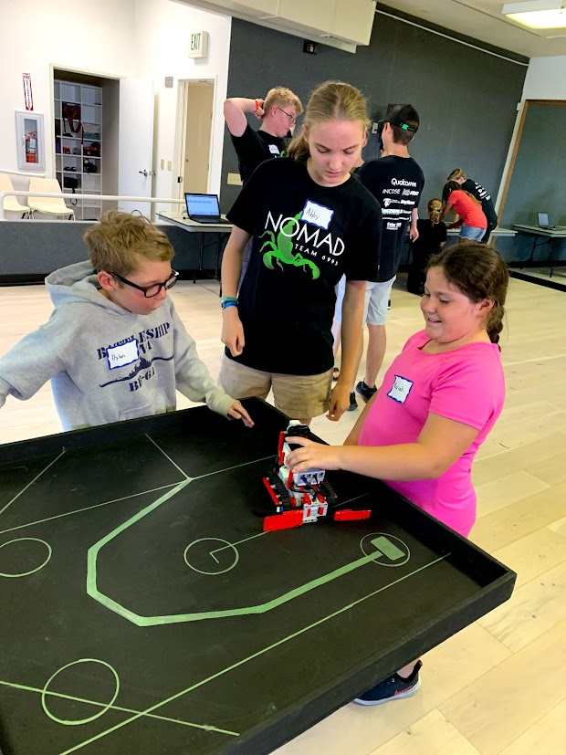
Robocamps 2018
Our very first team outreach effort took place during the fall of 2018, before NOMAD had even competed in FRC, with the creation of Robocamps. Robocamps were day camps for kids aged 8-14 to learn the basics of robotics using the LEGO EV3 kits. We operated several camps in 2018, impacting 40 kids at the end of the program.
Robot Demonstrations
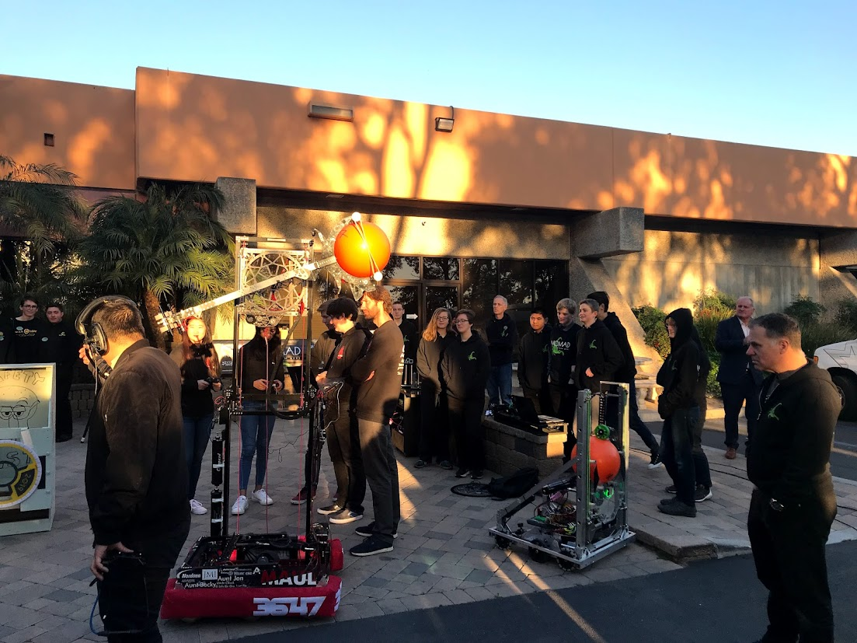
Our team has made robot demonstrations a core part of our outreach from the beginning. Because our team members come from so many circles, we have plenty of opportunities to demonstrate our robot at schools, local events, or open house nights at our workshop. We believe robot demonstrations are the fastest and most exciting way to introduce the idea of FRC and FIRST Robotics in general to adults and students of all ages.
KUSI News Appearance
After winning the San Diego Regional in 2019, NOMAD and our alliance partners were invited to appear on the local television station KUSI Morning News with our robot. Here, we shared our team story and robot design process live on air. This was our first of now three news appearances, the second and third of which occurred at the World Championships that year.
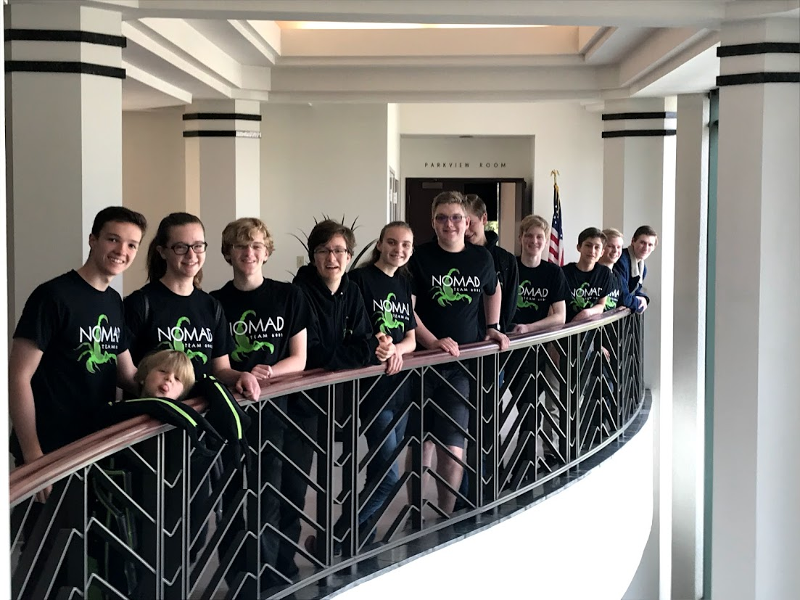
Meet the Mayor
That same year, before traveling to the 2019 FRC World Championships, we had the honor of meeting Escondido's mayor, Paul McNamara. While there, we attended a City Hall meeting and presented our team to both the mayor and the city council. After we mentioned our Robocamp outreach, Mayor McNamara asked if we would be willing to make it part of their city summer camp program. We agreed and added it to our outreach plans.

Robocamps 2019
In the fall of 2019, we repeated our Robocamp outreach and fundraiser. This time, we hosted Robocamps in multiple locations, impacting approximately 50 kids. Partnering with the city of Escondido, we were able to provide one set of Robocamps free of charge to their summer program for low-income kids. As this was hosted at the Escondido Library, our presence there also sparked a few conversations with library patrons about FIRST Robotics.
INCOSE STEM Night
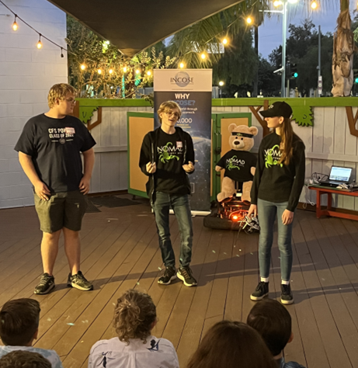
In 2019, NOMAD was invited to INCOSE STEM night, where we showcased our robot alongside other grant recipients. Three years later, in 2022, we attended once again, this time demonstrating a specific feature of our robot that we had focused on developing during the previous year – our vision systems. Through this event, we were able to form connections with professionals in systems engineering, as well as meet the other nonprofits INCOSE has sponsored.

2024-2025 Outreach
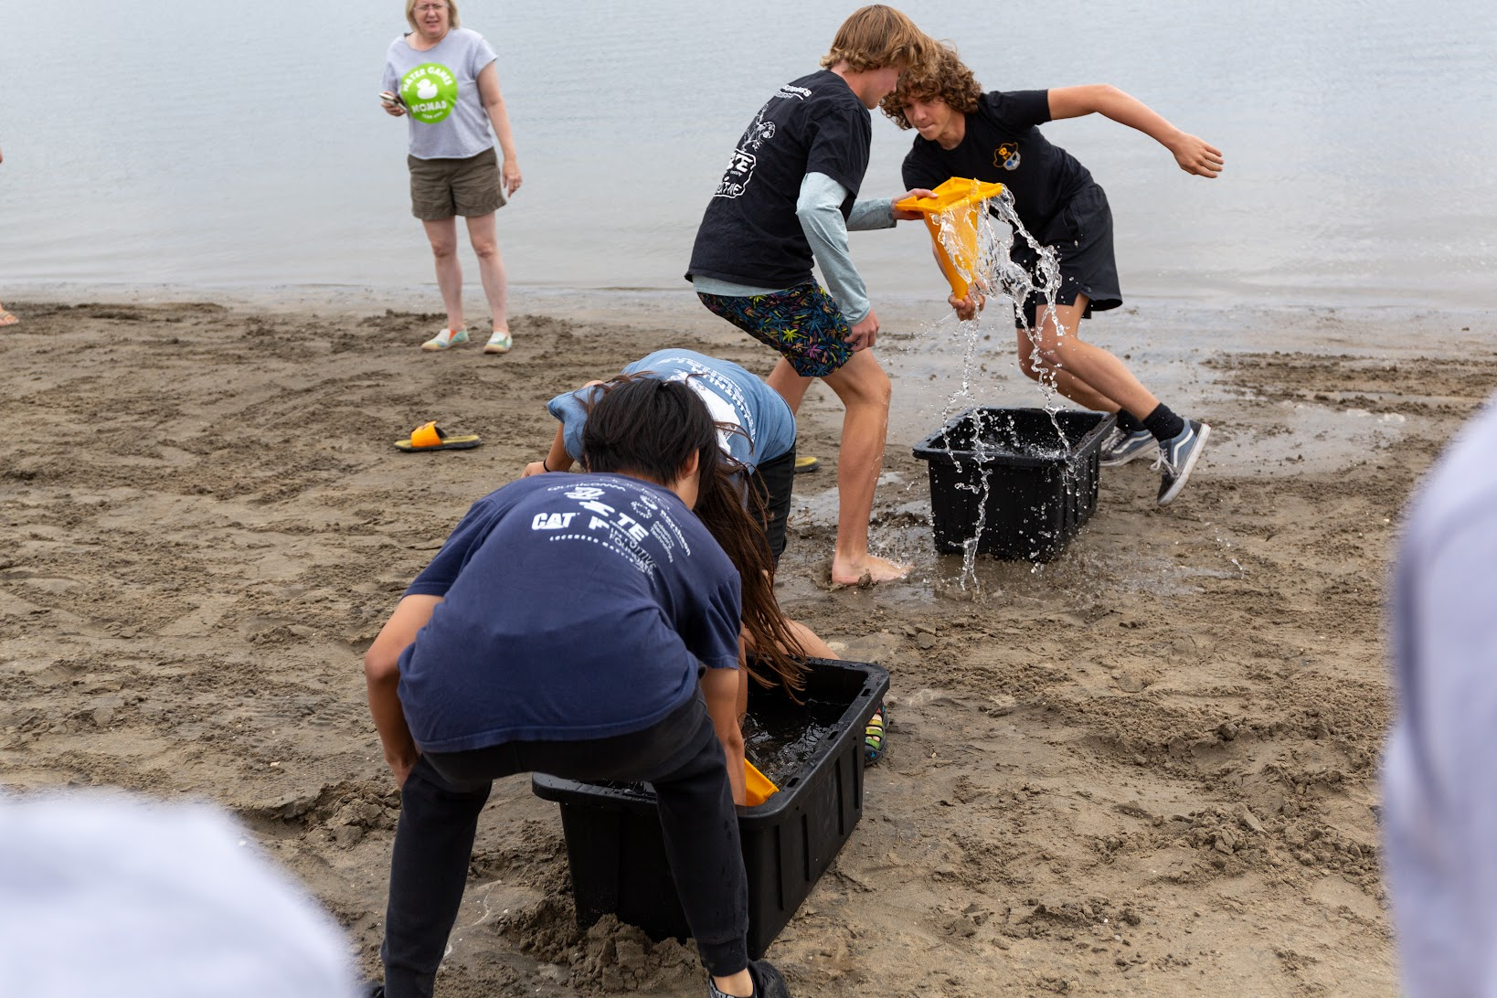
Water Games
On September 14th, 2024, we hosted the Second Annual NOMAD Water Games, where six teams from the San Diego area competed in head-to-head robotics-inspired beach games.
This year, we ran four games:
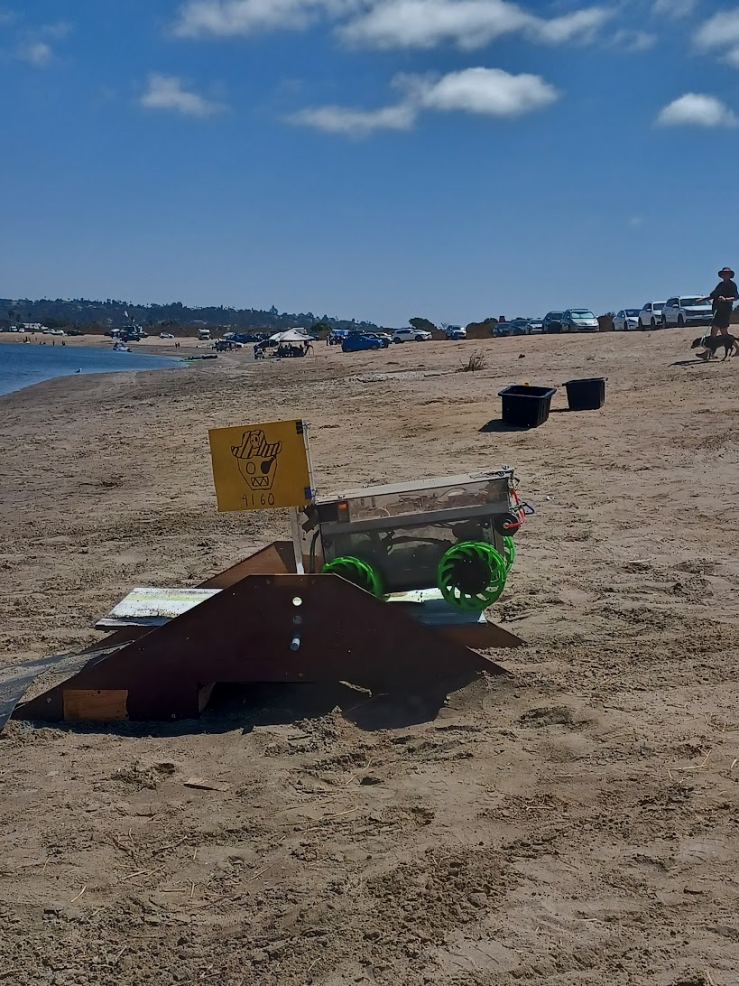
- Gear Shift Gauntlet – a balancing and running game involving teamwork and sabotage
- Spotlight Duet - a ring (CRESCENDO note) throwing game on 2023 CHARGED UP cones for points
- Don’t Drip, Don’t Trip - a game involving two people each holding the same 2023 cone with one hand and carrying water in it.
- The last game consisted of driving our software learning robot, Baby Bot, through an obstacle course, using an onboard water gun to accomplish tasks and score points.
Through this event, we expanded our outreach program and improved our relationships with other local teams.

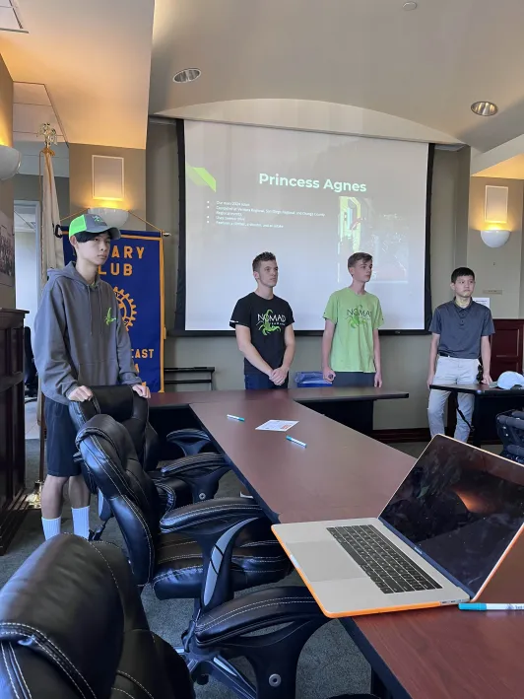
Escondido Rotary Club
We reached back out to the Rotary Club in May of 2024 for our offseason project, the JV Bot. The JV Bot was a student-led robot-building initiative that aimed to give our team overall technical experience. The Escondido Rotary Club was generous in providing our team with a $500 check for funding robot parts and materials for the project. In October of 2024, the Escondido Rotary Club invited our team to speak at one of their weekly meetings to present our 2024 competition robot, Agnes. We showed pictures of our robot as well as an interactive demonstration with functional subsystems and handoff routines. After our presentation, we answered questions and interacted further with the Rotary Club members.

SDR Field Trip
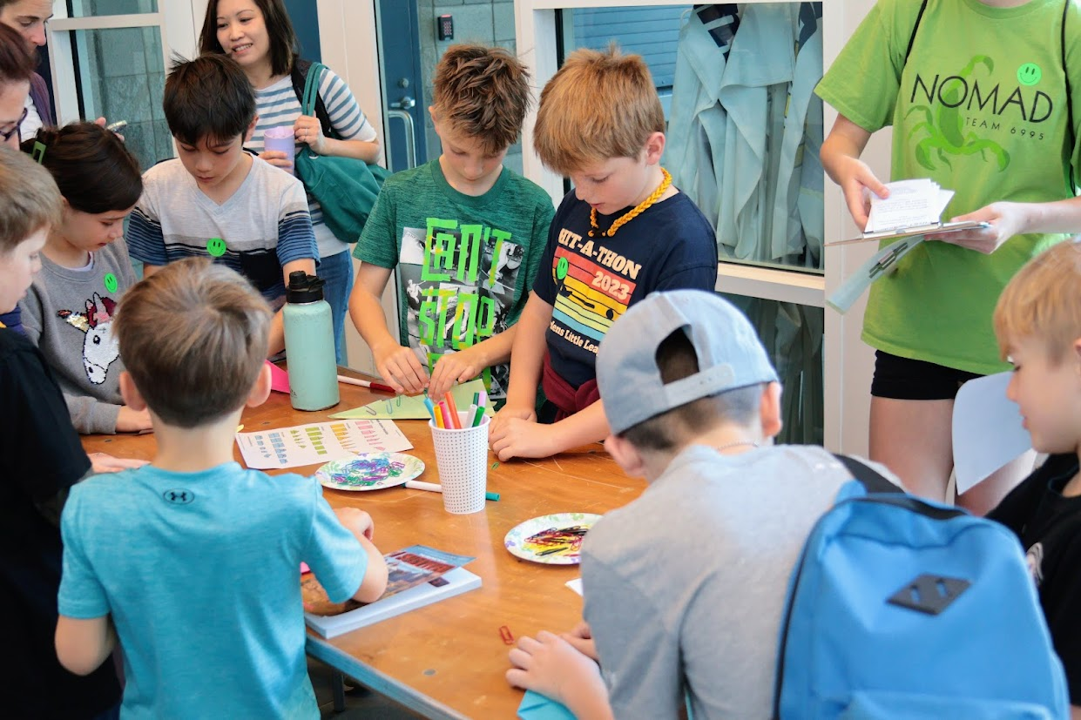
Last year, our San Diego Regional field trip brought 125 elementary school students, 25 chaperones, and 12 families from about 4 different schools into the world of competitive robotics. This year, we are expanding the event to 200 different students and their chaperones. Students will be split into groups of ten and will be assigned an FRC Student Ambassador either a member of our team or a volunteer from another team.
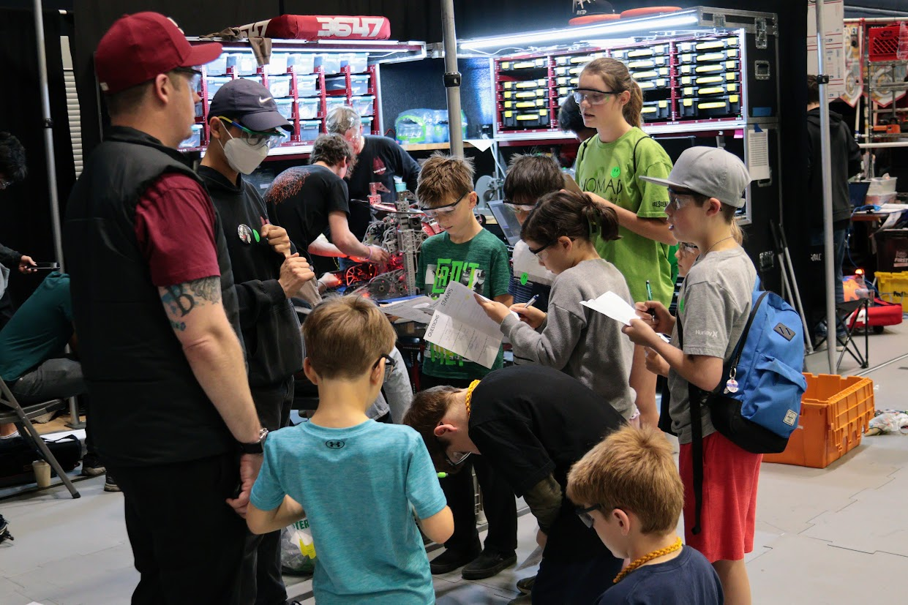
We prioritized inviting elementary schools that are connected to a high school that has an FRC team. To highlight these connections, kids who attend our field trips will be assigned to an ambassador from the high school that they are likely to attend in the future, creating a pipeline of STEM education and sparking excitement for FRC in the future, and FLL now
Groups will then participate in three primary activities:
1. Watching practice matches
2. Exploring the pits with a scavenger hunt
3. A competition to see whose tinfoil boat can be engineered to hold the most weight
Since this is such a large project, we have been working closely with FIRST California to find which schools to invite and how to run the event most efficiently. This year, we will impact up to 200 students and their chaperones. Through this field trip, we hope to ignite passion in FIRST and especially FLL among groups that do not already have an FLL team available.

Future Opportunities

FLL Info Night
Since the San Diego Regional field trip is aimed at FLL-aged kids, we have organized a FLL information meeting for May 1st. Here, parents and teachers will learn how to find a local FLL team or start their own at home or in the classroom.

Water Games
This coming 2025 summer will feature the Third Annual NOMAD Water Games. After the success of the second year, we received lots of positive feedback from the teams and mentors. One possible direction to take the event would be for teams to build amphibious robots to compete in a racing-style challenge.

Sustainability
As a community-based team, we do not have access to schools or clubs for direct recruitment. We host open house nights where students and their families can learn more about joining the team. NOMAD students typically recruit other students via word of mouth. The other method we utilize is through social media. We have a video production crew showcasing our accomplishments and our website includes a form anyone can fill out if they are interested in joining.

