6995 Team NOMAD

Business Plan



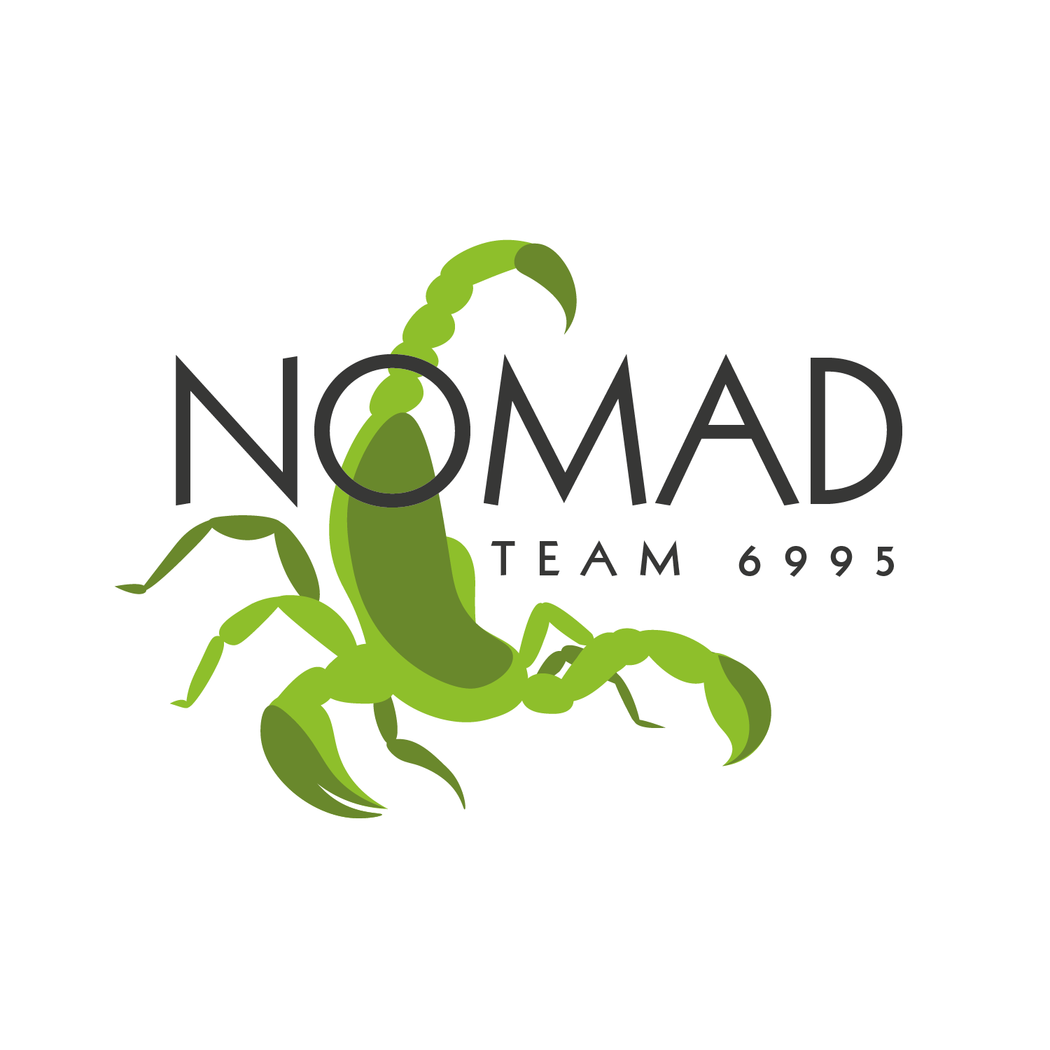

## Mission Statement

NOMAD’s goal is to provide opportunities for all students to develop lifelong skills through hands-on STEM and business experiences in an exciting and fun environment. NOMAD endeavors to give students who would not normally have the opportunity to be part of a robotics team (such as homeschool or charter school students) the chance to be involved in the FIRST community. In all of our pursuits, NOMAD strives to build productive relationships, inspire the next generation, and leave a positive impact.

## Team History & Growth

Our head mentor, Kevin Brady, and his family lived in Australia for several years where they were involved in the formation of the FIRST Robotics Competition team 5584, ICRobotics. When they returned to the States, their son wanted to continue participating in FRC but was not eligible to join any of the existing teams in San Diego County. In September of 2017, FRC Team 6995 NOMAD was established, allowing all students in San Diego County the opportunity to participate in FRC.

**2018 - FIRST POWER UP**

* 7 students with very little FRC experience
* Highest Rookie Seed, San Diego Regional

**2019 - DESTINATION: DEEP SPACE**

* Grown to 22 students
* Winner, San Diego Regional
* World Championships

**2020 - INFINITE RECHARGE**

* COVID restrictions prevented NOMAD from participating
* Robot completed

**2021 - INFINITE RECHARGE AT HOME**

* Established FIRST Lego League team 52311 Techno Tigers
* Participated in Innovation Award challenge
* Industrial Design, Titanium Group

**2022 - RAPID REACT**

* Quarterfinalist, San Diego Regional
* Semifinalist, Las Vegas Regional
* Innovation in Control, Las Vegas Regional
* Winner, Beach Blitz offseason

**2023 - CHARGED UP**

* Innovation in Control, Ventura Regional
* Innovation in Control, San Diego Regional
* Finalist, Las Vegas Regional
* Innovation in Control, Las Vegas Regional
* Created and hosted Water Games for FRC community
* Designed and manufactured amphibious robot, Duck Norris
* Rank 24, Curie Division, World Championships

**2024 - CRESCENDO**

* Finalist, Ventura Regional
* Semifinalist, Innovation in Control, San Diego Regional
* STEM field trip for 135 3rd-5th grade students, San Diego Regional
* Finalist Captain, Industrial Design, Orange County Regional

## 

## Team Sustainability

Because NOMAD is not affiliated with a school, we actively seek and recruit new team members through outreach events and presentations at various homeschool communities (such as CFS Poway and Classical Conversations). In addition, the establishment of the FLL Team Techno Tigers introduced elementary-school students in our community to the world of FIRST. When new members join NOMAD, experienced team members and Team Leads train them for future leadership positions. Since we intentionally keep our team roster small, every student contributes and is valued as a member. At the end of each season, several of our team members graduate from Team NOMAD. However, because these graduates train other students and pass on their knowledge, NOMAD is well prepared to continue full-force with the new set of Team Leads. In 2024, NOMAD built an FTC sized robot for software, CAD, and mechanical training. We have also switched to an all year calendar which allows us to be more formal with new student training. We’ve also added a JV bot during off to help multiple students get better hands-on experiences. The JV bot is entirely student coordinated, led, designed, and manufactured. JV bot is planned to be entered in the 2024 offseason regain, battle at the border.

## Organizational Structure

NOMAD is divided into four major sub-teams (Business, Design, Mechanical, and Software), and three minor sub-teams (Drive, Scouting, and NVPC). Many students contribute to more than one sub-team. To view a detailed description of each sub-team, see the chart in the Appendix. Each sub-team has a Lead, in addition to an overall Team Captain.

Team NOMAD’s organizational structure greatly encourages the mentorship of new students by older team members. Because almost all of our Team Leads are seniors, NOMAD is actively training our sophomores and freshmen to learn new skills, take on more responsibilities, and become future leaders. This method ensures that NOMAD has eligible Team Leads each season, which will help to sustain the team for years to come.

In addition, NOMAD fosters a diverse and inclusive environment which allows every new idea and opinion to be heard and discussed. NOMAD team members are encouraged to become leaders and to train other members in new skills. Each season NOMAD has a total of approximately 20 Because Team NOMAD is a community based team, we are able to keep our roster small and ensure that every student gains hands-on experience. homeschool, charter school, and private school students. To spread team awareness and gain potential recruits, NOMAD travels to different homeschool communities (such as Classical Conversations, CFS Poway and Masters Community) to present the robot and to introduce students to the world of FIRST. In addition, NOMAD hosts an annual open house event for highschool students interested in robotics. By participating in frequent outreach events, NOMAD gains new team members annually.

## Risk Analysis

Team NOMAD was founded on risk and opportunity. As a small community-based team, NOMAD has extremely limited resources. Back in 2018, however, several mentors and seven inexperienced students decided to take the risk to start up Team NOMAD. As a community team, NOMAD doesn’t have an affiliate school, resulting in team workshops being hosted out of our Lead Mentor’s garage. When NOMAD advanced to the 2019 World Championships, the team did not have the funding to attend, but NOMAD was determined to make it to Houston. (We ended up receiving a grant, making the journey possible!) Along the way there have been many teams in the FIRST community who have helped us, but NOMAD has still faced challenges due to being a small community team. This year, we have been able to pay it forward and see our own reputation as “the helpful team” grow. We hope to once again see many of the same teams who helped us in our early years at the 2025 World Championships.

Team NOMAD was started in order to provide students with the opportunity to experience the world of FIRST. At the time, NOMAD was the only San Diego team to not be affiliated with a school or organization, allowing students who wouldn't normally have the option to join a robotics team to learn about FIRST and to participate in competition. Team NOMAD upholds and encourages FIRST’s ideals of Gracious Professionalism and Coopertition both inside and outside the workshop. When new students join Team NOMAD, they are immediately taught and mentored by older students, equipping them with the knowledge and skills to assume a leadership position in the future. This process, as well as FIRST’s ideals, equip students with both the experience and character needed to be a valuable asset in the workplace and community after highschool.

One of NOMAD’s biggest strengths is the community that we have as a team. During the competition season, the Team Leads and Mentors have weekly meetings to ensure each subteam is working according to a proper schedule and in unison with their fellow teammates. Team Leads train up younger students and encourage them to become leaders in the future. In addition, team members are recruited from diverse backgrounds and schooling, allowing the team to discover new perspectives and ideas during the competition season. For more information, see NOMAD’s SWOT analysis in the Appendix. As a result, NOMAD fosters a fun, inclusive and hardworking environment, preparing students for the future.

## Marketing

Team NOMAD prioritizes team branding throughout the season, making an effort to keep all documents and merchandise (judges’ gifts, social media, shirts, sponsor resources, etc.) consistent with team colors, fonts, and design. All merchandise includes the NOMAD logo and the logos of the season’s sponsors. In addition, Team NOMAD runs active social media accounts on both Facebook and Instagram, where the Business sub-team posts 1-2 times per week, informing followers and sponsors about NOMAD’s progress in the workshops. We include a generous helping of FIRST-related hashtags, to connect our posts to those from other teams or FIRST itself. Since our social media presence was created, NOMAD’S number of followers has dramatically and steadily increased.

NOMAD runs several different fundraisers throughout the year. In November of 2023, NOMAD conducted a Christmas wreath fundraiser through Sherwood Forest Farms. Each wreath sold included a NOMAD pin which allowed different members of our community to learn about our team and display NOMAD’s team name and logo on their household decorations. In December of 2023, we hosted a formal dance fundraiser for teens and alumni. In addition, NOMAD has hosted fundraisers at restaurants such as Chipotle, allowing the team to spend time together while raising awareness for FIRST and spreading the team name throughout the community.

## Financials

Team NOMAD is funded through sponsorships and grants. Because NOMAD is not affiliated with a school, the team does not receive school funding or support. As a result, team members must personally reach out to companies and businesses in order to gain sponsors and arrange fundraisers. Because our sponsors are integral to the team’s success, NOMAD values sponsor connections and makes it a point to send out updates and thank you notes throughout the year. As detailed in the Appendix, sponsors will receive certain benefits based on the amount donated (although all sponsors will have their name advertised on the team slideshow while at competition events).

NOMAD budgets approximately $14,000 for Regional competitions, including travel expenses, and roughly $500 for offseason competitions. Additionally, $8,000 is budgeted for robot parts, and $1,000 for team expenses (shirts, machining, etc.). We have also predicted approximately $8000 in costs if we were to attend the World Championships.

# Appendix

### Team Organizational Structure:

| Major Sub-Teams | |
| --- | --- |
| Business | * Coordinates sponsorships and fundraisers * Promotes NOMAD to the community with outreach efforts * Creates documentation for competitions * Responsible for branding and public image |
| Design | * Creates representation of robot sub-assemblies through CAD (Computer Aided Design) * Responsible for design documentation necessary for robot construction * Works closely with Mechanical sub-team |
| Mechanical | * Responsible for machining and assembling the robot * Uses specifications given by Design sub-team |
| Software | * Responsible for developing and testing the code that operates the robot, both in Tele-Op and Autonomous periods * Uses Java |

| Minor Sub-Teams | |
| --- | --- |
| Drive | * Selected through tryouts and responsible for driving the robot at all competition and demonstration events * Includes Driver, Operator, Technician, Human Player, and Drive Coach, as well as backup members |
| Scouting | * Responsible for scouting and strategy at competitions * Match scouters collect data about robot performance, pit scouters collect data from team representatives * Uses a custom scouting app revised each season |
| NVPC | * NOMAD Video Production Crew * Responsible for capturing videos and pictures, video editing, and creating video form content |

### Sponsor Benefits:



|  | Platinum | Gold | Silver | Bronze |
| --- | --- | --- | --- | --- |
| Amount: | $5,000 and above | $2,000 - $4,999 | $500 - $1,999 | Under $500 |
| Team Shirt: | Large logo of business | Medium logo of business | Small logo of business | -- |
| Robot: | Large logo of business | Medium logo of business | Small logo of business | -- |
| Banner (displayed at events): | Large logo of business | Medium logo of business | Small logo of business | -- |
| Website (on our sponsorship page): | Large logo with link to sponsor’s website | Medium logo with link to sponsor’s website | Small logo with link to sponsor’s website | Name of business/individual |

### SWOT Analysis:

| Strengths | Weaknesses |
| --- | --- |
| * Team members are hardworking and willing to learn and improve. * Diverse team personalities and leadership skills provide streamlined organization during competition season. * Team members are experienced in FIRST ideals and actively apply them while in the workshop. * Older students pass on their knowledge to new team members, allowing them to be equipped for the competition season. * The small team size fosters community within the group; NOMAD is a tight-knit team that creates strong, lasting friendships among team members. | * NOMAD has limited workshop space and workshop hours. This greatly impacts our building capability during the competition season. Unlike neighboring teams, we only have 2-3 workshops per week. * NOMAD is not affiliated with a school, which limits our recruiting pool. * NOMAD does not have access to a competition practice field. This severely limits our ability to practice before competitions. |
| Opportunities | Threats |
| * We are teaching the next generation of NOMADs both robotics and FIRST ideals, as well as demonstrating these ideals to our community and families. * Team NOMAD has friendly connections with neighboring teams and our community. * NOMAD offers an opportunity for students looking for a private robotics team. | * Lack of proper funding during the season can inhibit our ability to build the best robot possible. * Our workshop space is limited, which also limits our team size and workshop frequency. * We are not affiliated with a school, so unless team members actively recruit and outreach we run the risk of our team size dwindling. |



### 2025 Fundraising:

**Total: $31,000**

**Sponsors: Approx. $27,750**

**Fundraising:**

