6995 Team NOMAD

Technical Binder 2024
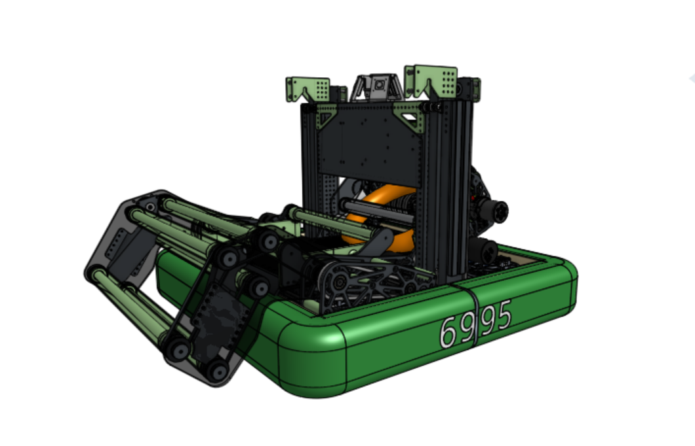


Princess Agnes

TABLE OF CONTENTS
Analysis
Crescendo 4
Priority List 5
Design
Drivebase 7
Intake 8
Midtake 9
Shooter 10
Climb 11
Programming
Autonomous 13
Tele-Op 14
Drivebase 14
Shooter 15
Midtake 15
Intake 16
Climb 16
Driver Control 17
AprilTags 18

ANALYSIS

Crescendo

Priority List

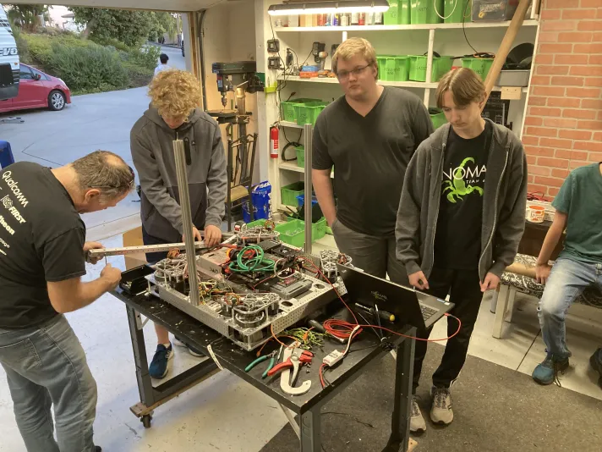

Crescendo - Strategy
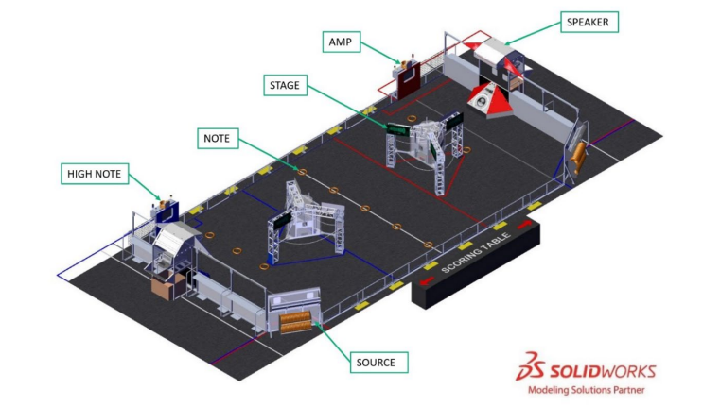
Crescendo challenges teams to build robots that can strategically collect and shoot notes into a speaker or amp. Two competing alliances are invited to score notes, amplify their speaker, harmonize onstage, and take the spotlight before time runs out. Alliances earn additional rewards for meeting specific scoring thresholds and for cooperating with their opponents.

Notes are laid out in the middle of the field before the game begins. Additional game pieces can be given to the robot by a human player using the source, located on the opposite corner of the field from each alliance's speaker.

Another way to gain points is by climbing the chain on the stage – a platform next to each alliance’s speaker, which moves under the robots as they mount. Alliances earn points by balancing on it with other robots and scoring in the trap.

Our team’s strategy involves using the speed and maneuverability of the swerve drive to easily position our robot both to score game pieces and climb the chain. For scoring notes, we have a shooter.

PRIORITY LIST - Goals & Design
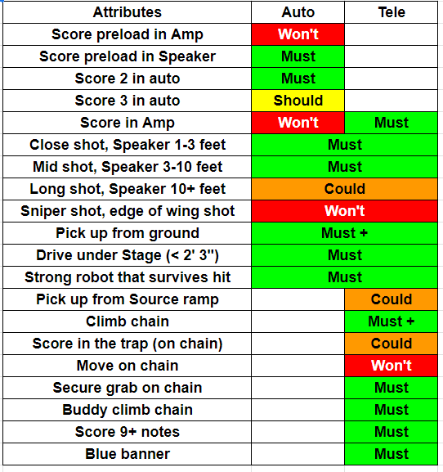

Drivebase
- Because we can only handle one game piece at a time, our robot needs to be small and maneuverable.
  - We accomplished this by building a small drivebase (25.5 x 25.5 inches), enabling our robot to be quick and compact.
  - We also designed our robot to use swerve drive, which allows us to dance around the defense and traffic in the center field.
- We anticipate field congestion will be a major problem this year, since robots have limited paths to use to cross the field. A small robot will allow us to squeeze through traffic jams and reduce congestion. Additionally, our short height enables us to drive under the stage and avoid congestion entirely.
  - Our robot is small and sturdy, with a low center of gravity and stable maneuvering. This allows us to score and cycle safely during the match.

Shooter:
- After a small amount of prototyping, we discovered that flywheels spanning the top of the note gave far better results than two on the edges. We also knew that our team needed to be able to shoot from multiple positions; this meant the shooter needed to be able to pivot.
Midtake:
- We needed to hold the game piece somewhere inside the robot after floor pickup. Designing this part last, we had a very small amount of room to make it fit. This was designed to hold the game piece comfortably inside the space we had remaining and be able to send it into the shooter quickly
Intake:
- We immediately chose an over-the-bumper intake and decided to focus only on picking up from the floor. The counter option to this, an under-the-bumper intake, was not considered due to our small drive base size. We also decided it was better for us to make the intake in a way that would pass off the note to a midtake to hold it. This means we could retract the intake to be safe and remove extra complexity.
Climb:
- We wanted two separate climb hooks attached to two individual elevators. This allows us to climb with another robot but keep our drive base flat and parallel to the ground.

Design

Drivebase

Shooter

Midtake

Intake

Climb

Drivebase
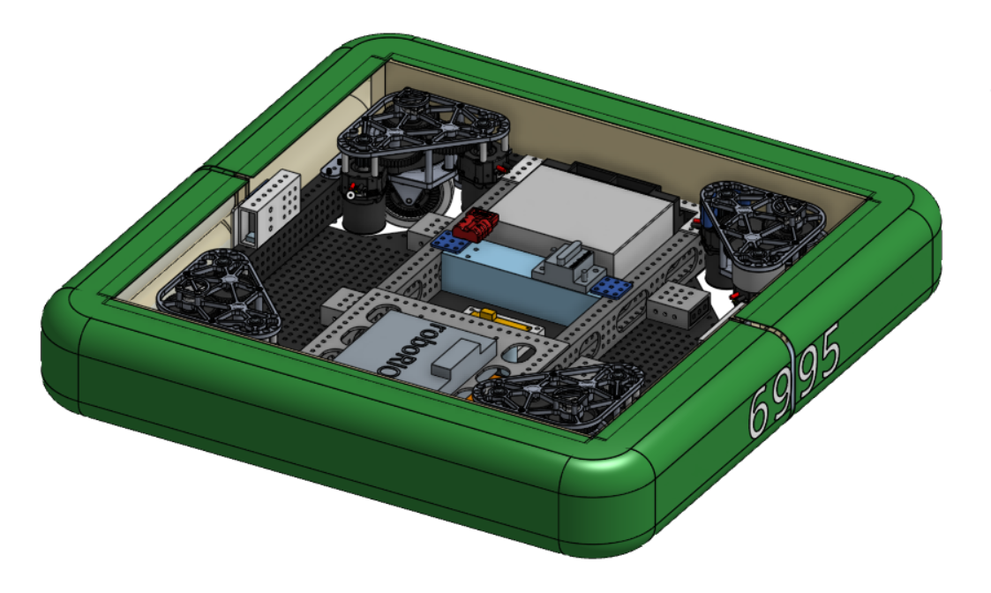

We decided to build a small 25.5” by 25.5” drivebase to reduce congestion in high traffic areas on the field. Our design is small and maneuverable, enabling us to quickly speed across the field. Additionally, our Swerve drive lets us dance around the defense and traffic in the center field. This gives our robot an advantage over other drive base systems, such as Tank Drive, Mecanum Drive, or H-drive, whose movement is significantly hampered by the small size of the community area.

Highlights
- Quad SDS swerve modules with 4” wheels
- 2 piece bumper
- L3 Gearboxes, which give us power up to 19 fps free speed

Shooter
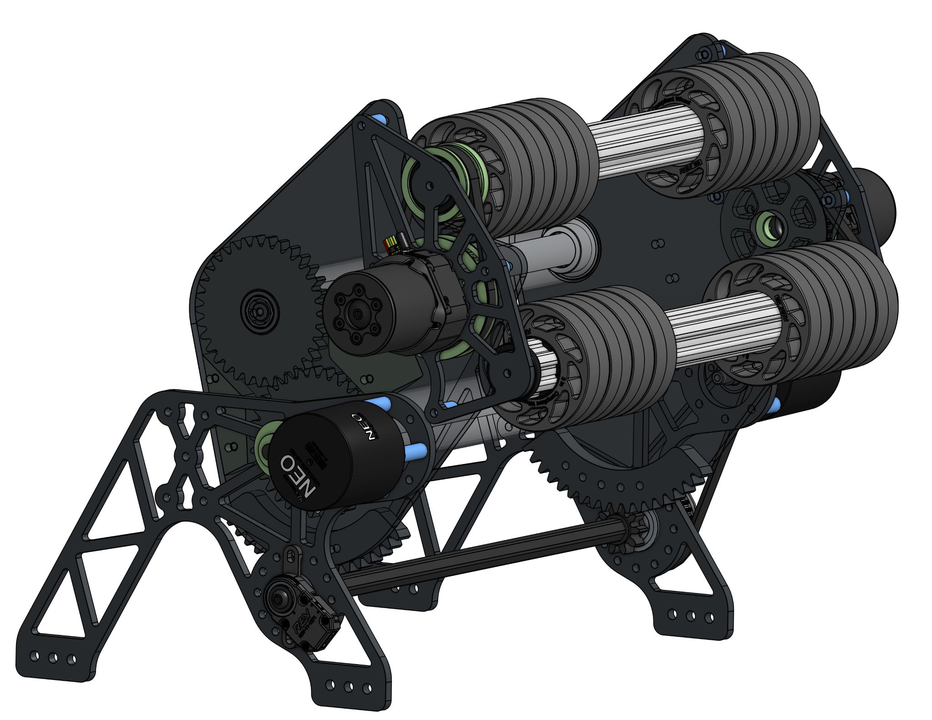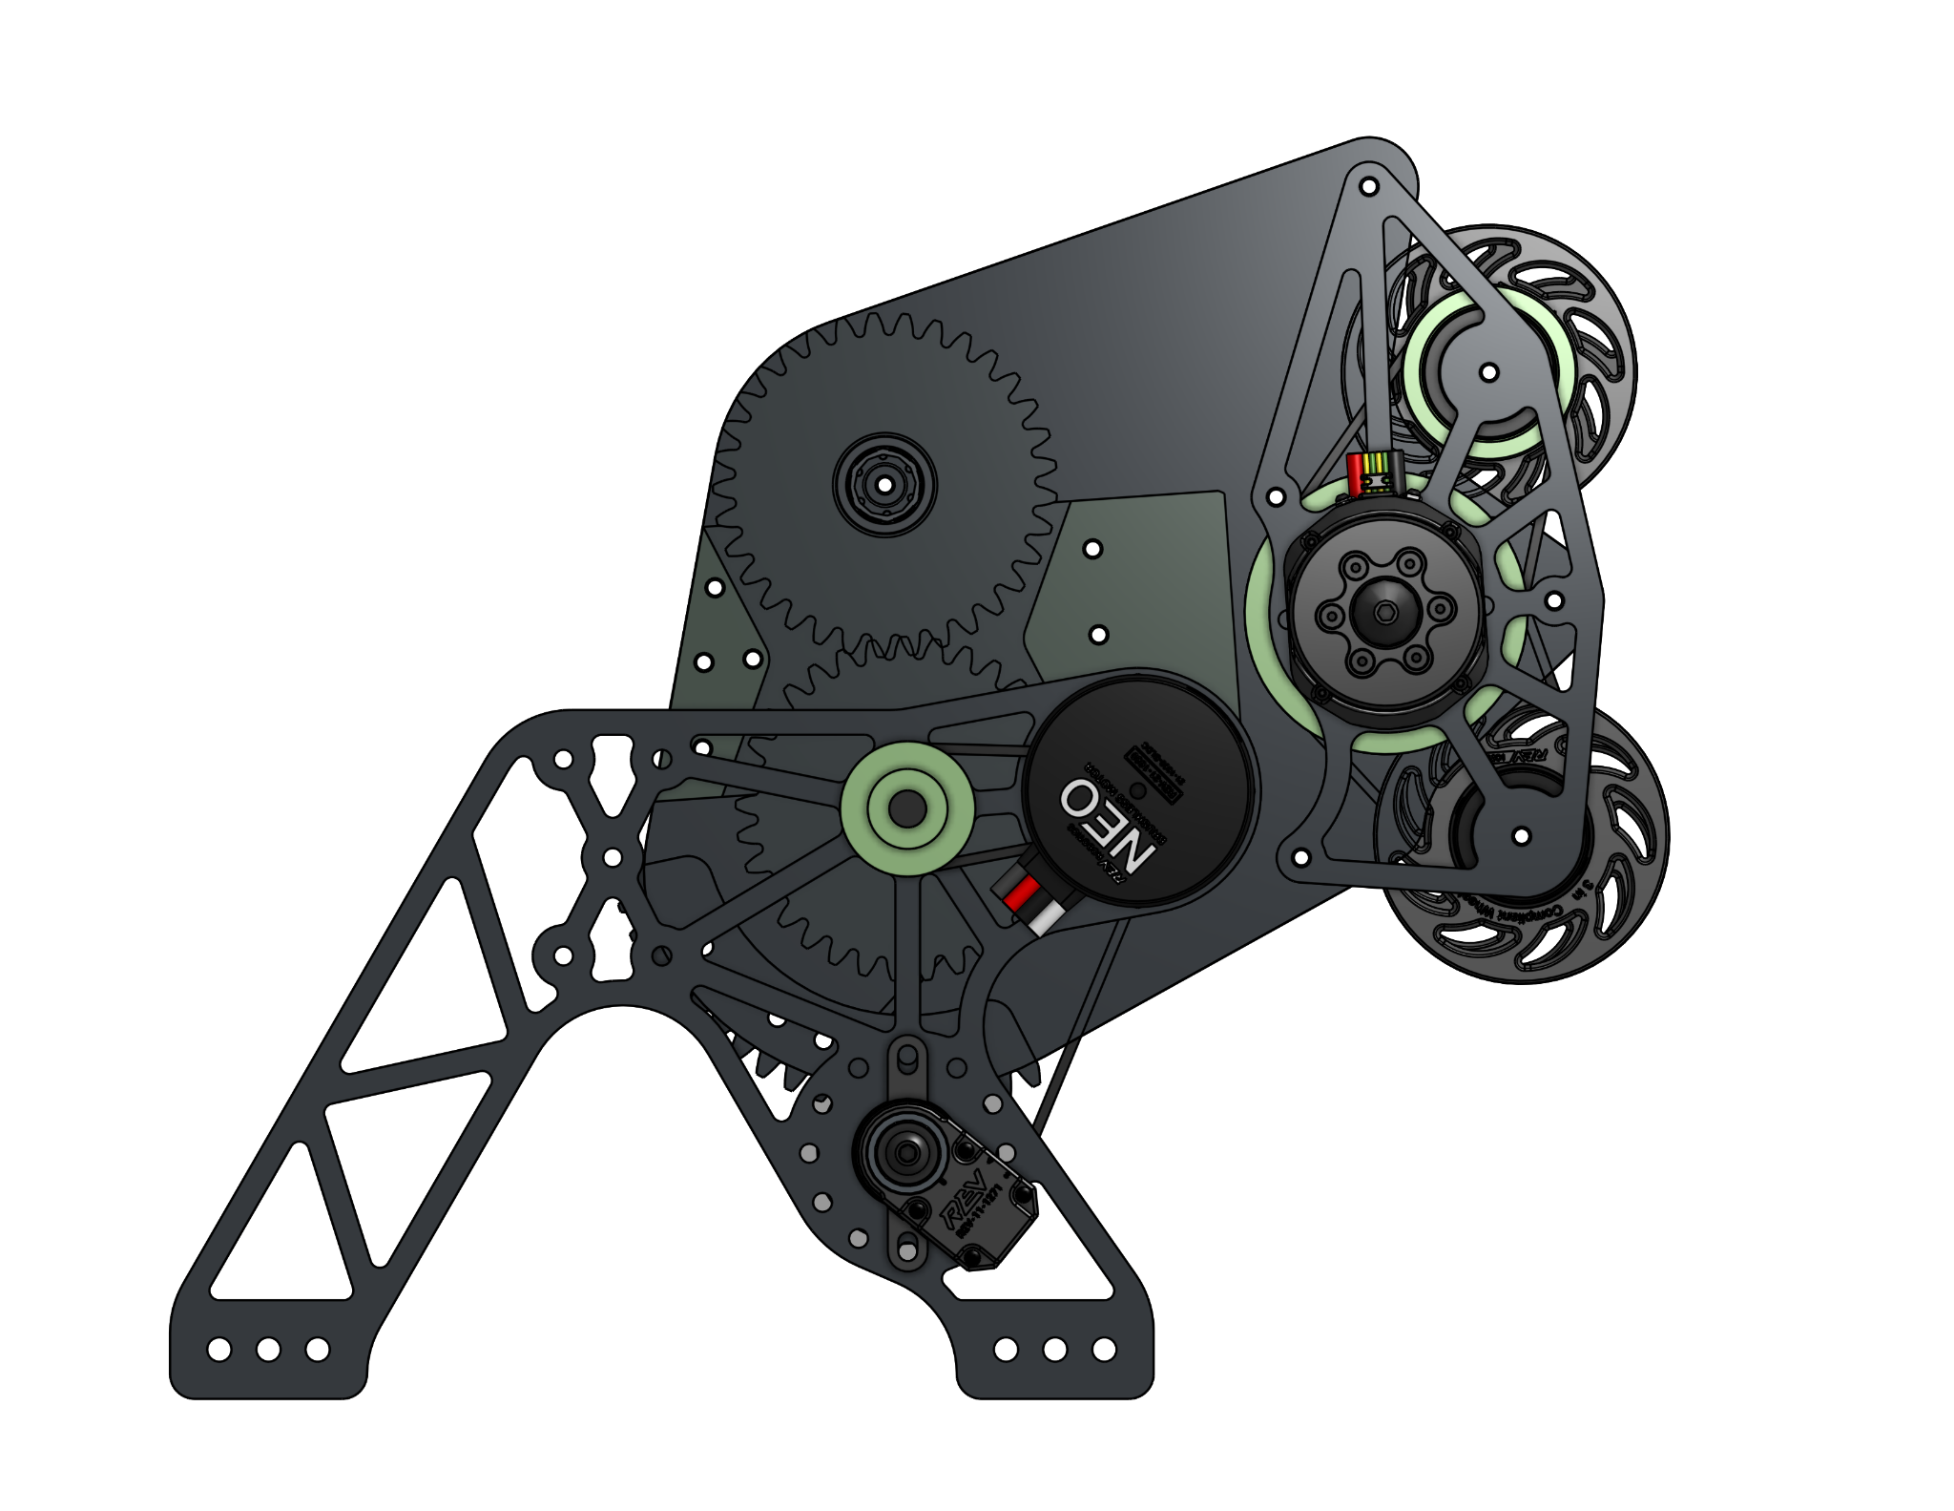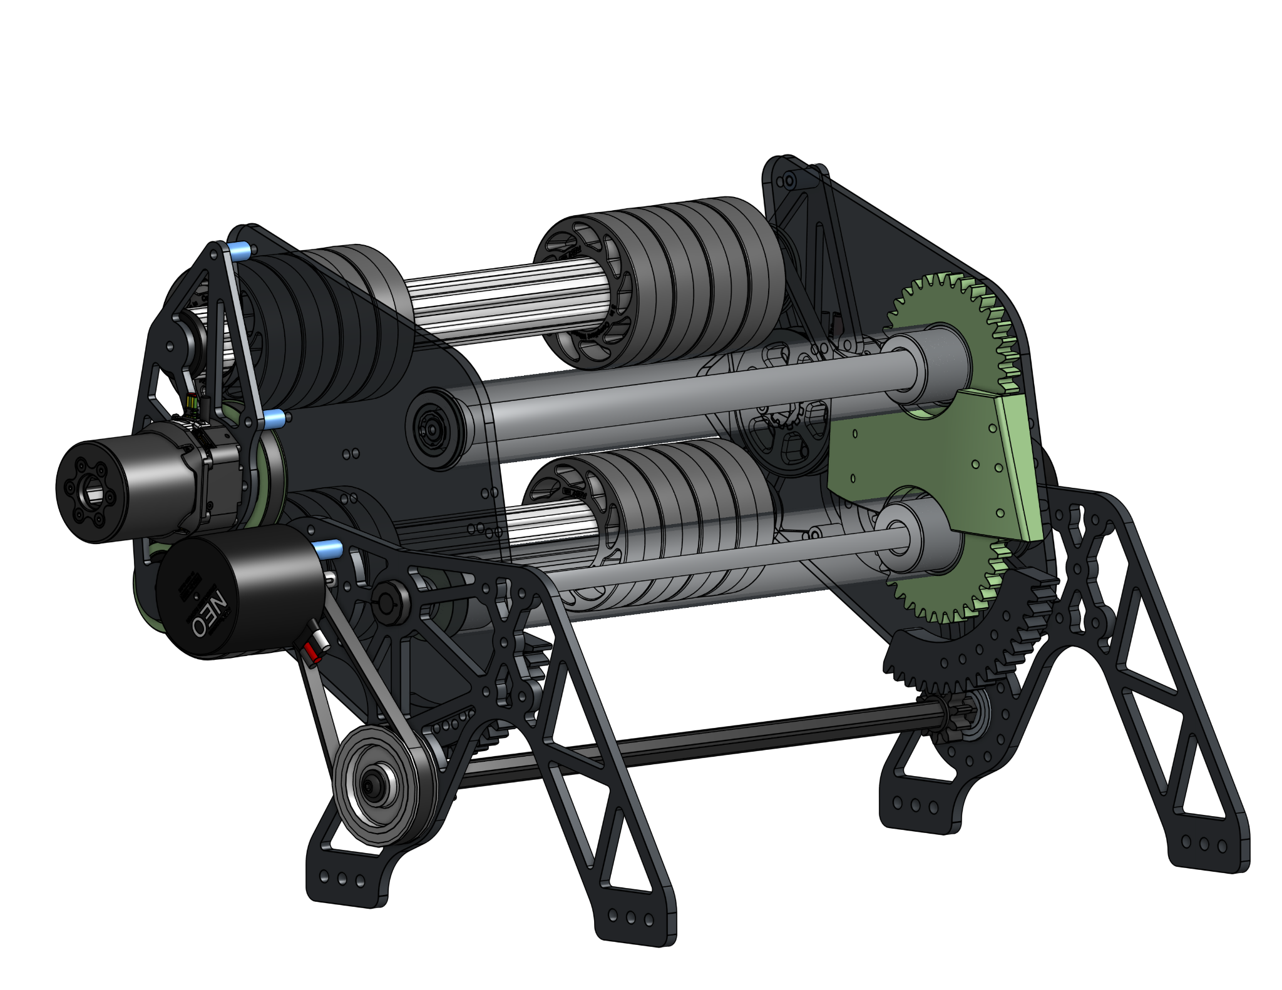

This year we decided to go with a shooter design using two horizontal sets of wheels. We used eight 3” 60 durometer wheels on each roller. Our original design used two bigger wheels, side to side, but we found that these shots were inconsistent, weak, and floppy. After taking inspiration from open build teams, we built a quick prototype and almost instantly managed 50 foot flat shots with our new wheel orientation. Our shooter side plates are made of 1⁄4'' polycarbonate. The plates used to mount the shooter are 6061 pocketed aluminum. The outside plates on the shooter are also 6061 pocketed aluminum.

One of the biggest challenges with designing the shooter this year was the packaging. With a small frame perimeter of 25.5” square, integrating the shooter with the climb and midtake, while keeping it inside the frame, called for multiple major design changes. Finally, after many CAD meetings and workshops, we found a design that works perfectly with the midtake, climb, and frame perimeter. After calculating the distances and angles from where we would be shooting from, we found that the required angles ranged from 15 ̊ to 60˚.

Highlights
- 2 Vortex motors powering shooter wheels
- 2 NEO motors for feeder rollers and pivot
- Rack-and-pinion style gearbox
- Approximately 6000 rpm on average

Midtake
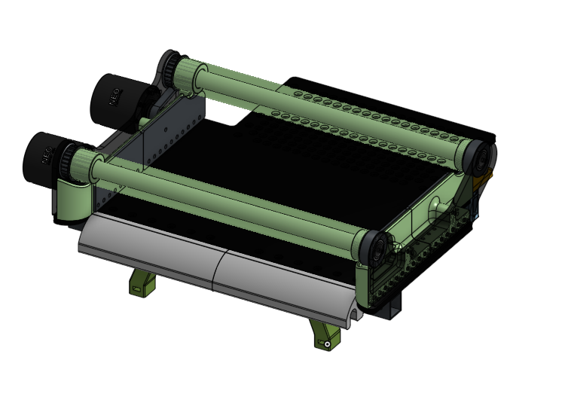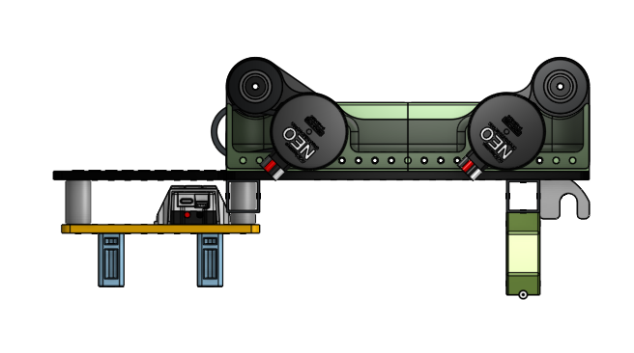

The midtake is where the note is stored between the intake and the shooter. After being loaded, the note has to stop within 0.02 seconds before being ripped out by the shooter at approximately 6000 rpm. To solve this, we separated the rollers mechanically and added a ratcheting function on the front roller leading into the shooter. Generally, these rollers work in tandem with one another. When the shooter pulls the note out from the midtake, the ratcheting roller is free to spin and release the note.

We had a very small amount of space left for the midtake after designing the rest of the robot. This challenge was made even more difficult because we did not want to compress the note when we sent it into the shooter. Overcoming this challenge required multiple, minor revisions to compensate for this issue. The midtake acts as a barrier between electronics and the game pieces, making sure that everything is tightly packaged and well protected.

Highlights
- 2 NEO motors driving the rollers separately
- TOF sensor under the front roller for game piece detection

Intake
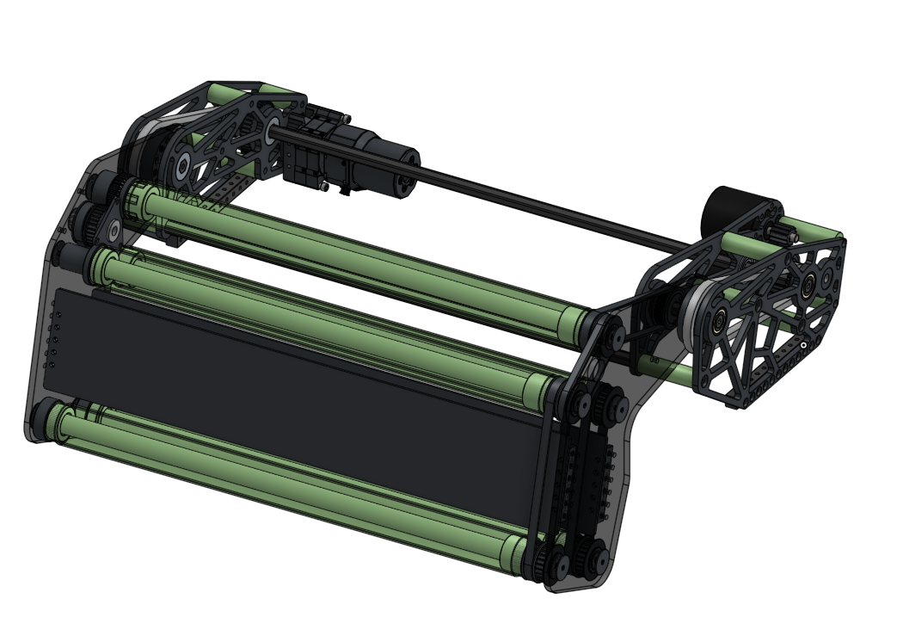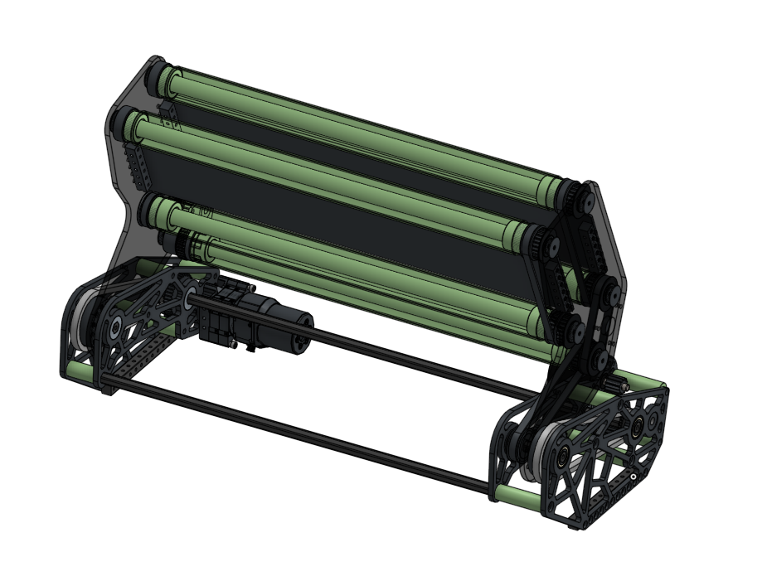

The purpose of the intake is to pick up game pieces from either the ground or the source. We prioritized ground pickup and designed an over the bumper design inspired by Ri3D teams and past robots.

This was one of the first things we designed, which gave us the most room to work on creating this system. The intake is stored vertically to maintain horizontal freedom of design for the midtake and shooter. Originally, the intake was designed with the intention of the side plates all being cut out of aluminum. However, after we built our first functional test out of polycarbonate, we decided to use polycarbonate for our final build to allow it to flex on impact. The intake spans the entire width of the robot, making it easy to pick up a game piece from anywhere in front of the robot.

We ran the pivot and rollers off the same hex shaft. Thus we had to separate the pivot point from the hex shaft but still allow it to use the same area. The added challenge was matching belt distances and chain distances for all of the different moving parts. All of this had to be kept small enough to stay within the bounds of the front third portion of the robot.

Highlights
- 1 Vortex motor for the pivot
- 1 NEO motor for the rollers
- Draws 10.5v power
- Polycarbonate rollers

Climb
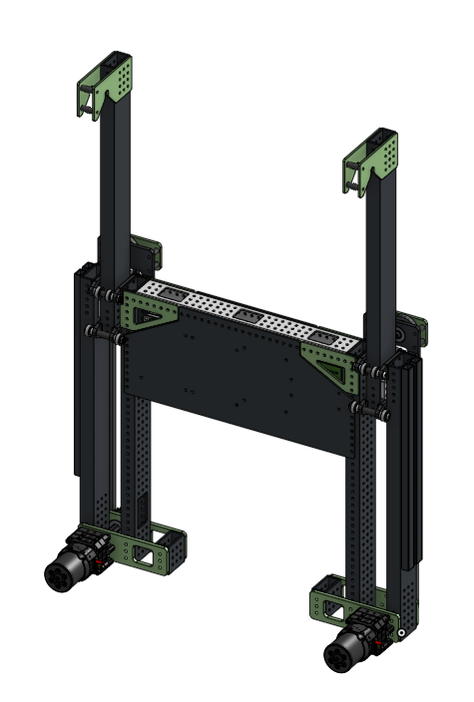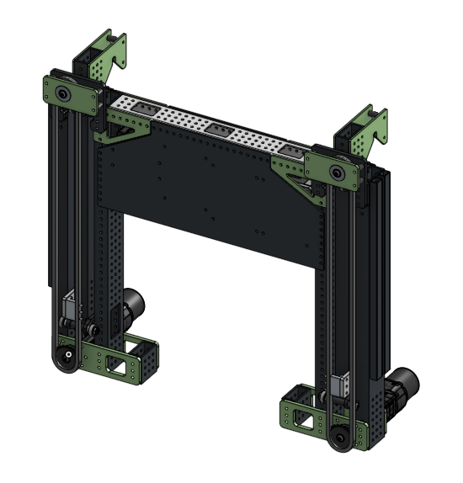

Our climb uses two telescoping arms driven separately by two Vortex motors. The center of gravity for the robot is low and in line with the climbers. Each arm on our robot can pull approximately 120+lbs individually! That means if one fails, the robot should still be mechanically able to climb.

The climb assembly is also the support for our camera mount and RSL. This position was chosen because it offers the highest vantage point on the robot, allowing the camera to easily spot all of the April tags.

The climb was the easiest subsystem to design because it was so much like previous designs we have used in the past. It also took up the smallest amount of space on the robot, making it easier to fit.

Highlights
- 2 NEO motors powering the arms
- Bolt in assembly for future iterations

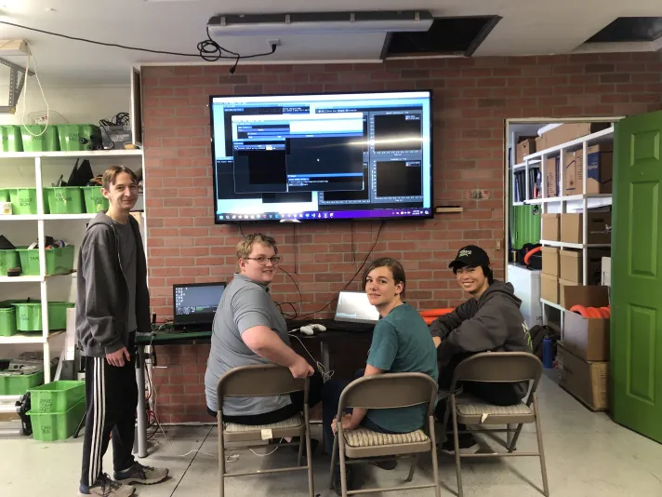
Programming

Autonomous

Tele-Op

Constraints

Driver Control

AUTONOMOUS

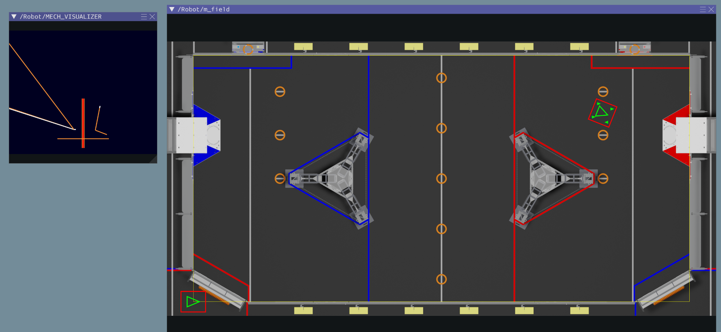
- We have multiple auto paths to maximize our alliance capability and accommodate our alliance partners.
- We prioritized quick autonomous paths to score more game pieces. Our auto runs will exclusively score speaker shots, instead of amp, since every autonomous speaker score is equivalent to a tele-op amplified score.
- We use the rotation sensors on the drive and steer motors, along with a gyroscope sensor, to determine how the robot has moved. This allows us to have a baseline pose estimation, which is then corrected with AprilTags.
- We rely on one camera to detect four of the sixteen AprilTags that will help our robot correct its position estimate and accurately aim at the goal. Previously, we used all of the available AprilTags at once. We changed from using sixteen to using four AprilTags because our cameras were giving us the wrong information and we found that we only needed the tags on the speaker.
- We use our position estimate to run several auto-aim routines to face targets such as the speaker, amp, and climb chains. These routines control the direction the robot faces, while giving the driver manual control of motion across the field.

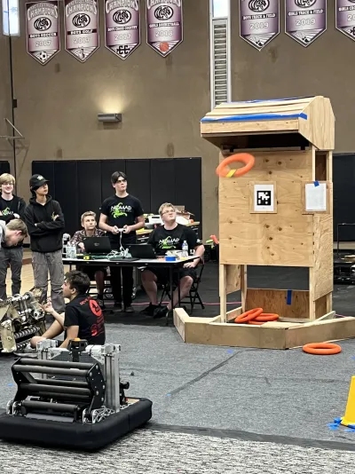
TELE-OP

Drivebase

- Our robot has four swerve modules: one on each corner of the drivebase. Each module is equipped with two motors. One motor spins the wheel for driving and the other turns it for steering. Unlike tank drive, which we used in the past, our drivebase can move in any direction at any angle, allowing for significant driver control and freedom.
- Except for during the autonomous period, we minimize the amount of automated driving available to the driver. Most of our driver automation simply rotates the drivetrain to face a particular direction, while leaving motion across the field to the driver. This makes issues with position estimation or selecting the wrong target position less dangerous.
- To optimize driver control, maintain workshop safety, and prevent damage to any hardware, our drivebase has limits on the velocity, acceleration, and angle of each swerve module. These limits are essential to maintaining our drivebase, but can be edited for the autonomous, teleoperated, and endgame periods. We use PID and feed forward constants to keep our robot running as smoothly as possible.
- Each swerve module uses an absolute encoder to measure the rotation of the wheel. These encoders allow us to compensate for the discrepancy between the alignment of each module, as well as determine the direction the robot is facing.
- Because we are able to easily calculate the speed and rotation of our drivebase, we can constantly update the robot’s position on the field. The robot knows where it is at all times and uses AprilTags around the field to correct any errors caused by skidding or defense. This allows us to accurately and automatically line up the robot to important areas on the field such as the stage, speaker, and amp.

Shooter

- The shooter has four motors. One motor controls the pivot angle, and two motors control the speeds of the top and bottom rollers. A fourth motor drives the feeder roller that pushes the note into the high-speed rollers. To protect the mechanisms, the pivot motor controller is limited to avoid driving into the hardstops on either end of its range.
- To determine the right pivot angle and speeds for a given distance to the speaker, we use interpolation maps. These interpolation maps define a relationship of distance to angle/speed using several data points and straight lines between them. With data points approximately every eighteen inches, we have a good approximation of the angle and speeds for each possible shooting distance.
- Each motor has a built-in rotation sensor, called an encoder. On the roller motors, these are used to determine the actual speed of the shooter wheels. Due to the limited resolution of the pivot motor’s encoder, we use a separate encoder to measure the angle of the shooter to better than 0.1 degrees.
- Our biggest challenge with the shooter was choosing shot speeds and angles that would be consistent for various levels of note wear.
- Because we don’t have wheels on the right side of the shooter, notes fly slightly right when we shoot them. To counteract this, we have the robot aim slightly left when we press align.

Midtake

- There are 2 NEOs that drive the rollers and a time of flight sensor, which tells us when we have a note in the midtake.
- When the time of flight sensor sees a note in the midtake, it slows the midtake rollers, as well as the intake rollers, until the note is no longer in view of the sensor. When that happens, the midtake rollers will stop.
- There were not many programming problems for the midtake. However, sometimes a note would get stuck in a position that would make it impossible for us to feed into our shooter. Because of this, we gave the operator two buttons to move the midtake rollers very slowly to get the note into a better position. A third button runs the intake and midtake in reverse when the note cannot be realigned.

Intake

- The intake uses one motor to pivot outside and inside the robot perimeter, and one motor to drive the five rollers. For the intake pivot, speed is the priority. Therefore the intake motor drives at a constant voltage towards the goal position. We use this information to calculate the fastest possible deploy and retract given the available voltage.
- During pre-match setup, the on-robot LEDs and dashboard indicators remind the driver to manually retract the intake fully and to press a button. This resets the position measurement of the intake. Without this, the robot cannot be sure where the intake is on startup.
- The biggest challenge to programming the intake was designing our intake-to-midtake transition sequence. The intake rollers needed to be fast enough to pick up the note while the drivebase was going full speed; but the midtake also needed to be able to receive a note coming in quickly. We now use the laser distance sensor in the midtake to slow both sets of rollers as the note enters the midtake.
- To detect a note in our midtake, we use a laser distance sensor which looks across the midtake under the front roller.

Climb
- There are 2 Vortex motors that control the arms of the climb separately.
- We use soft limits on arm extensions. If the arms were allowed to extend as far as possible, they would exceed the height limit. The soft limit tells the robot to not allow the arms to go past a certain point.
- The operator has the option to drive the arms together or separately. This way we can easily climb in the middle of the chain. If we want to simultaneously climb with another robot, we can raise the climber arms to different heights so they pull on the slanted chain at the same time.

Driver Control
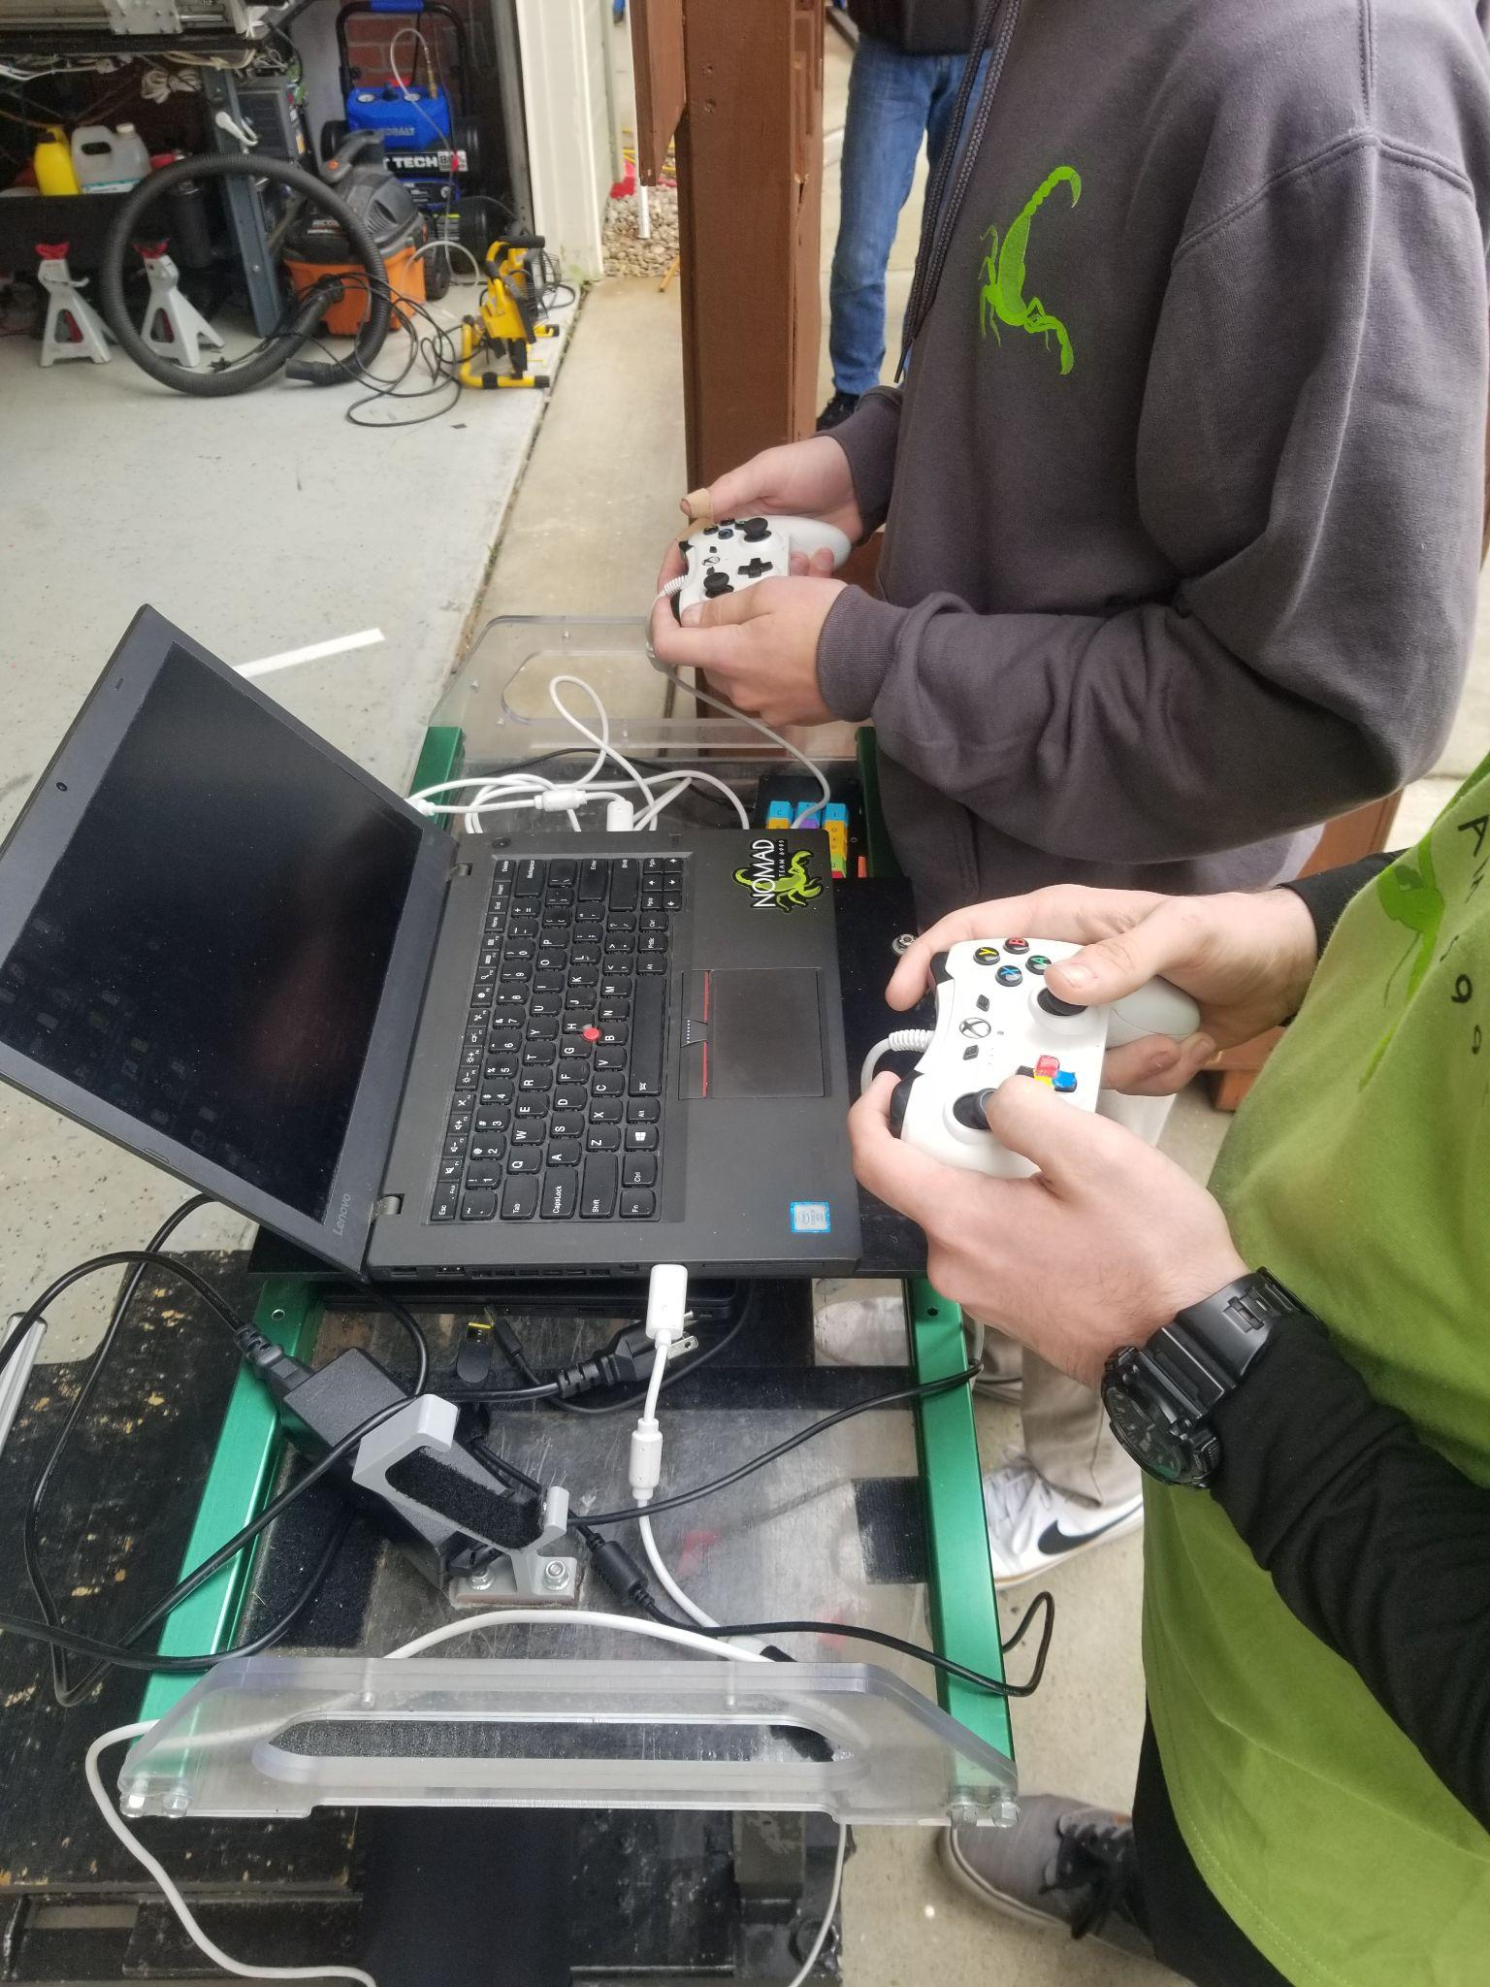
- Our driver and operator each use a standard Xbox controller.
- Driver responsibilities:
  - Controlling the swerve drivebase
  - Controlling the intake
  - Auto aligning to targets (speaker/amp/climb positions)
- Operator responsibilities:
  - Controlling shooter speed for speaker and amp
  - Controlling shooter pivot for amp
  - Feeding notes from midtake to shooter
  - Moving climber arms, together or separately
- The shooter pivot is always adjusting its angle to aim toward the speaker.
- We automatically align to the speaker and amp for scoring. We also strafe (move while facing the same way) facing the speaker and stage.
- We have taken into account the ergonomics of the driver controller to determine which buttons should be assigned to what. The right driver stick is used for rotating the robot. The buttons above should not interfere with that need, so they are assigned to other commands that rotate the robot. X, Y, and B rotate the drive base to align with different stage positions.
- We also use our climb auto-positioning in order to align to the source for note pickup.
- Our driver station has ten colored boxes along the top and side of the screen to tell the operator when certain robot functions are ready or in use. These feedback points include note detection inside the robot, angle and speed of the shooter, and whether the intake has been recalibrated before the match. When the boxes turn red or green, the operator uses that information to determine when to shoot or what to tell the driver during the match.
- The second camera is displayed on the driver station to help with intaking and detecting notes stuck in the intake.
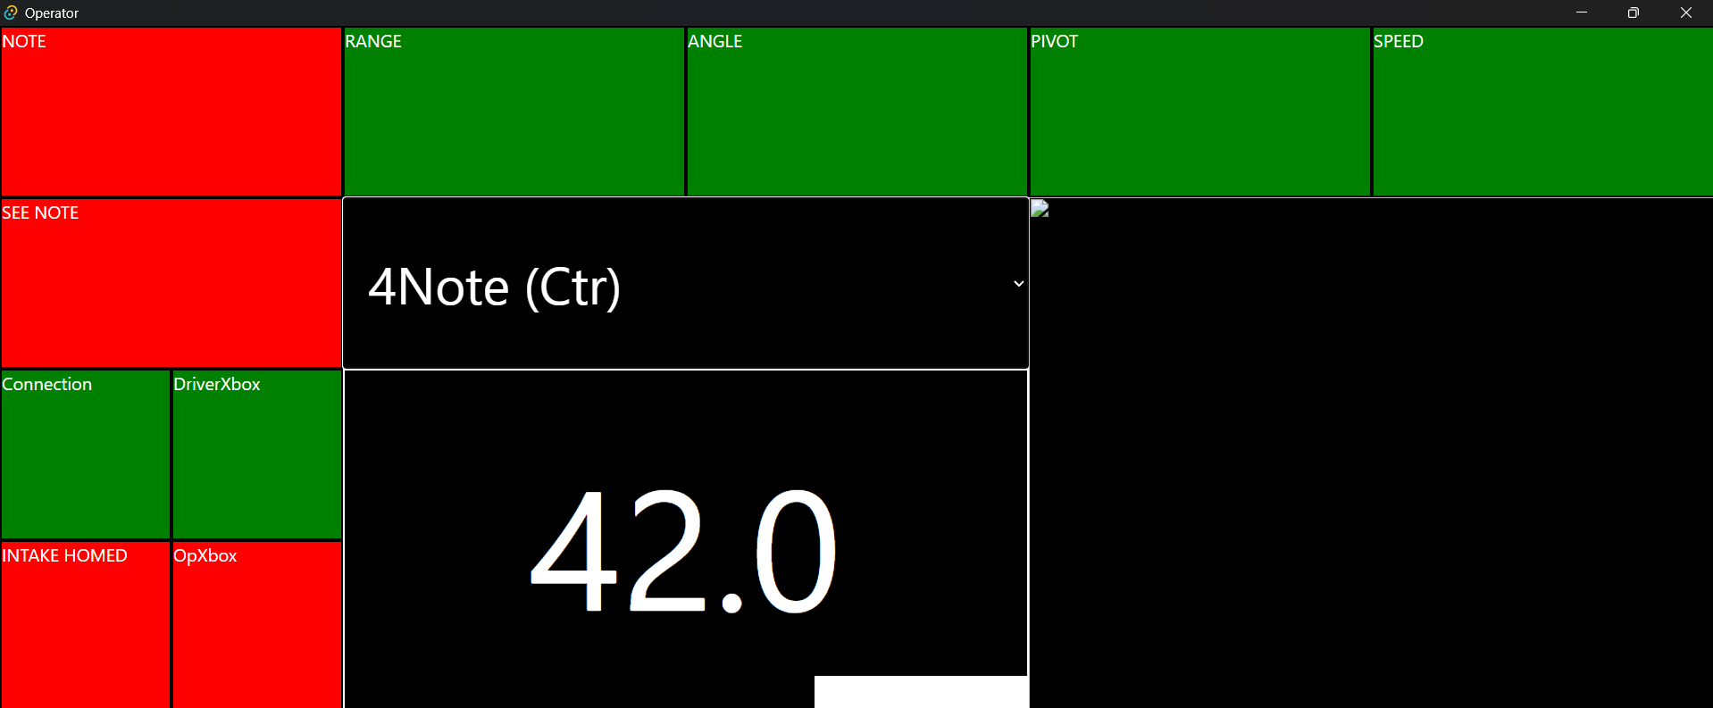

AprilTags
- AprilTags are like QR codes detected by the camera on our robot. The AprilTag visual fiducial system provides robots with a spatial reference to calculate its position in three-dimensional space.
- Our robot can detect the sixteen April tags placed throughout the field, but we only use the information from the four AprilTags on the speakers. Our drivebase knows its position at all times because of the odometry calculations, but our reference point can be erroneous because of skidding or defense. We use AprilTags to correct these errors and keep constant reference points.
- Our cameras analyze the images of the tags to determine the relative distance, yaw, pitch, and roll as compared with the robot. This gives our robot the information necessary to precisely measure its position on the field.
- We rely on our camera to detect the sixteen AprilTags that will help our robot correct its position estimate and accurately aim at the goal.

