6995 Team NOMAD

Outreach Binder


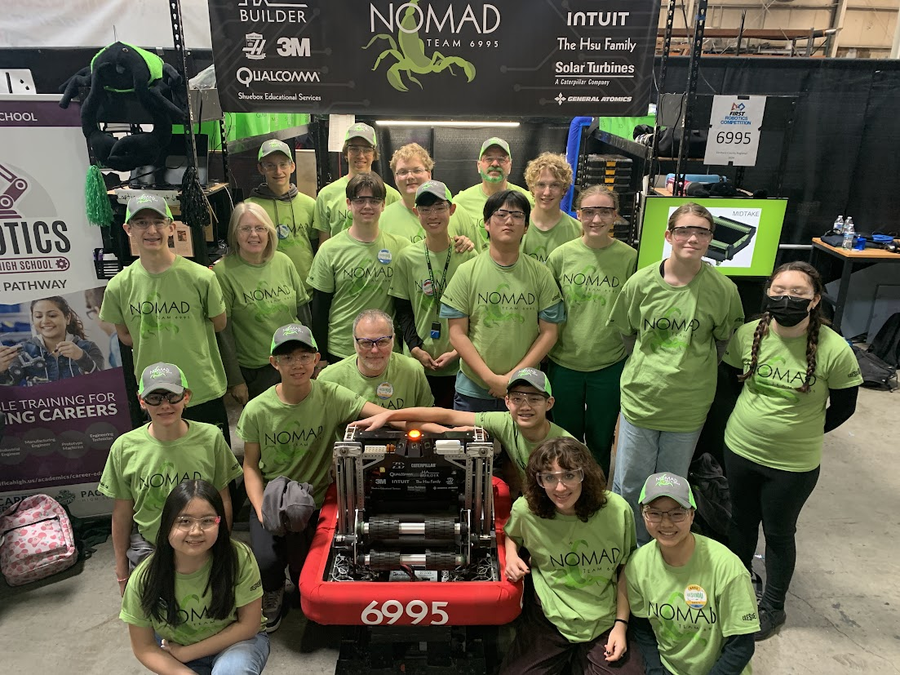

Mission Statement
NOMAD’s goal is to provide opportunities for all students to develop lifelong skills through hands-on STEM and business experiences in an exciting and fun environment. NOMAD endeavors to give students who would not normally have the opportunity to be part of a robotics team (such as homeschool or charter school students) the chance to be involved in the FIRST community. In all of our pursuits, NOMAD strives to build productive relationships, inspire the next generation, and leave a positive impact.

Outreach Philosophy
Through our seven years of existence, NOMAD’s outreach has developed into a particular style of initiative. We strive to bring the community together, whether that is the local FRC community or the broader community our students are a part of. Most of our outreach efforts depend on word-of-mouth advertising from our small number of students (under 22 each year), which causes distinct groups to overlap and find a common interest in robotics. Recently, outreach events such as Water Games (explained below) have brought the local FRC community together and helped students to develop cross-team friendships.

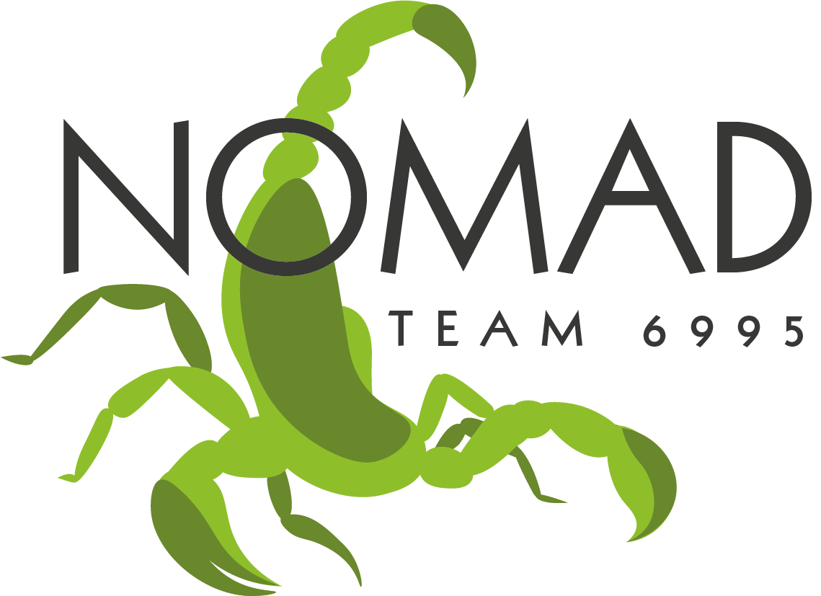
Outreach Over The Years
Past Outreach
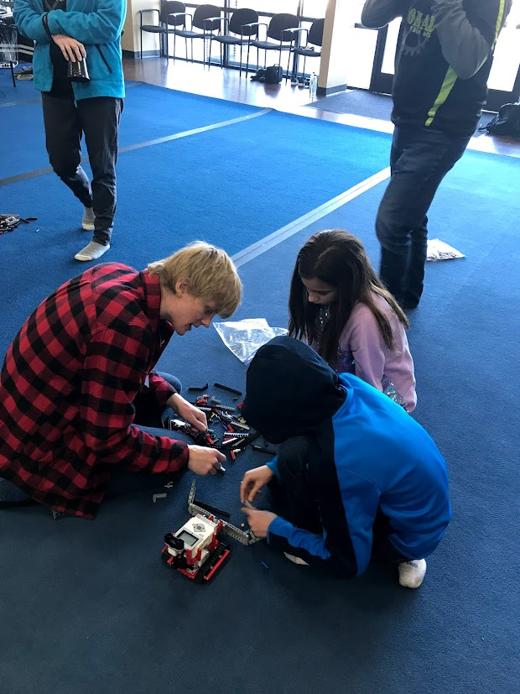
Robocamps
Our very first team outreach effort took place during the fall of 2018, before our first build season, with the creation of Robocamps – day camps for kids aged 8-14 to learn the basics of robotics using the LEGO EV3 kits. We operated several camps in 2018, impacting an estimated 30-40 kids.
Robot Demonstrations
One outreach type we have consistently done since our first year is robot demonstrations at our local community groups and events. Because our team members come from so many circles, we have plenty of opportunities to demonstrate our robot. Sometimes we bring the robot to an event, other times we invite groups from various places to an open house at our workshop. Robot demonstrations are the fastest and most exciting way to introduce the idea of FRC and FIRST Robotics in general to adults and students of all ages.
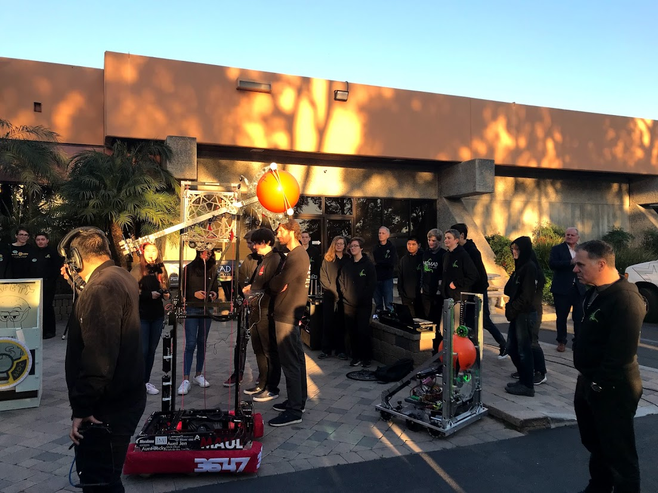
KUSI News Appearance
After winning the San Diego Regional in 2019, we were invited, along with our alliance partners, to appear on the local television station KUSI Morning News with our robot. Here, we explained our team story and robot design process live on air. This was our first of now three news appearances, the second and third of which occurred at the World Championships that year.
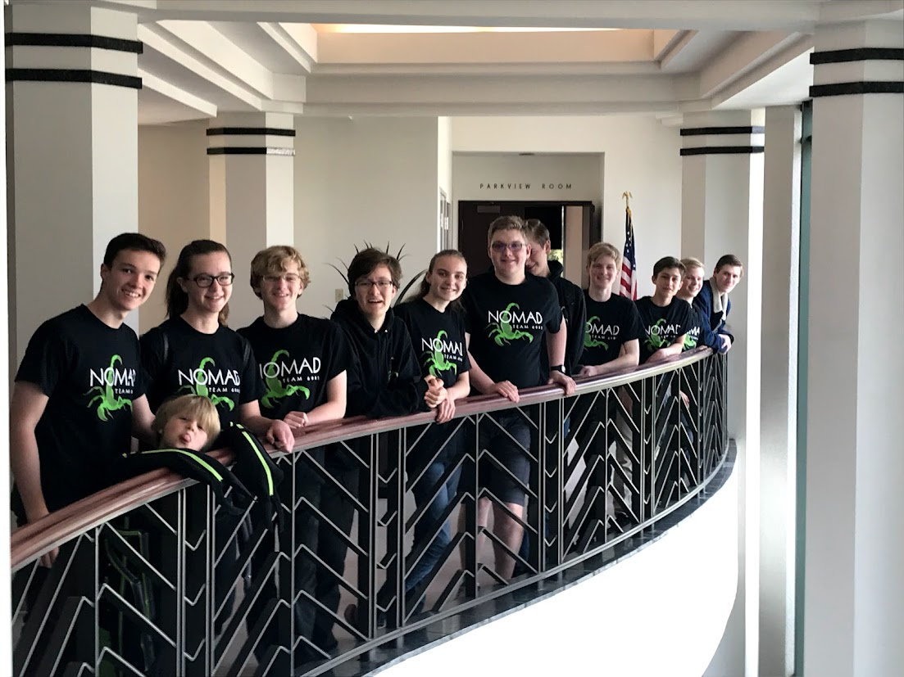
Meet the Mayor
In between our regional win and trip to the World Championships in 2019, we brought our team and mascot to meet the mayor of Escondido at the time, Paul McNamara. While there, we attended a City Hall meeting and presented our team to both the mayor and the city council. After we mentioned our Robocamp outreach, Mayor McNamara asked if we would be willing to make it part of their city summer camp program. We agreed, and added it to our summer plans.
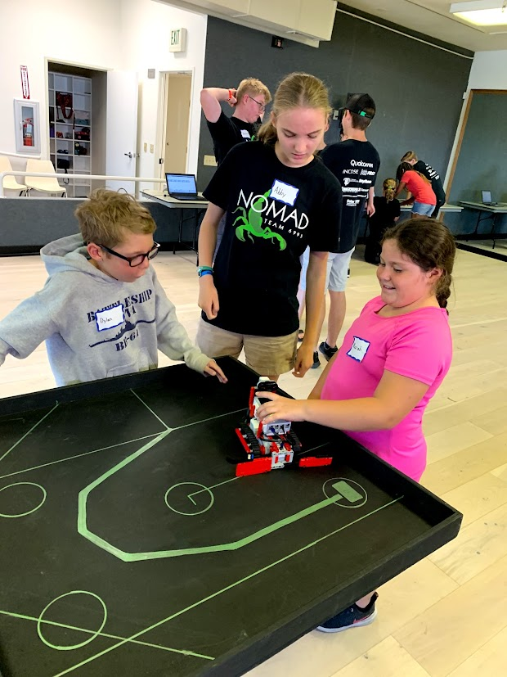
Robocamps
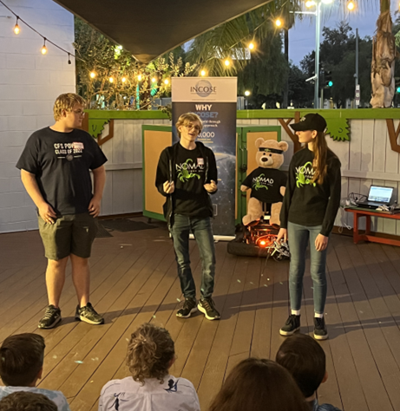
In the fall of 2019, we repeated our Robocamp outreach and fundraiser. This time, we hosted Robocamps in multiple locations, and impacted approximately 50 kids. Partnering with the city of Escondido, we were able to provide one set of Robocamps free of charge to their summer program for low-income kids. As this was hosted at the Escondido Library, our presence there also sparked a few conversations with library patrons about FIRST Robotics.
INCOSE STEM Night
One of our past sponsors, INCOSE, invites all of their grant recipients to a STEM demonstration event every year. We first attended this event in 2019, and later in 2022, where we were able to demonstrate a specific feature on our robot that we had focused on developing during the previous year – our vision systems. Through this event, we were able to form connections with professionals in systems engineering, as well as meet the other nonprofits INCOSE has sponsored.

2023-2024 Outreach
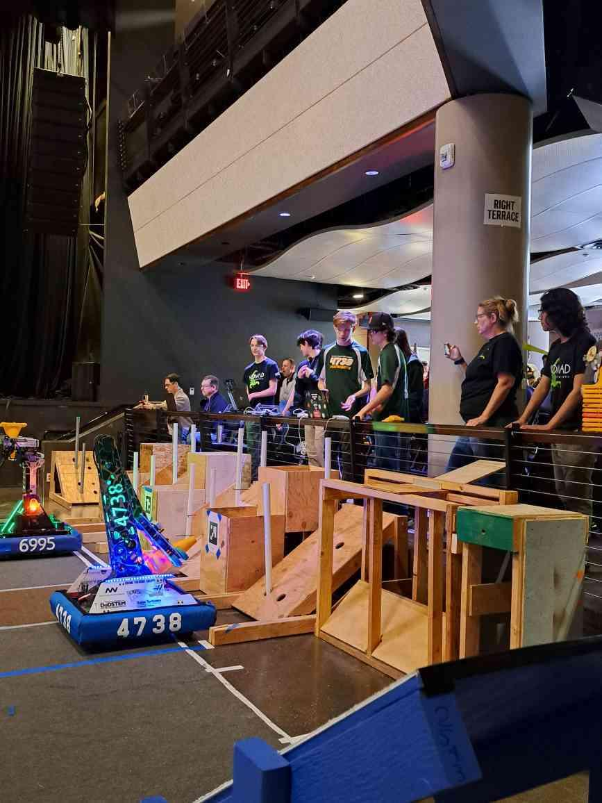
San Diego Fair
In June of 2023, we attended a scrimmage at the San Diego County Fair with other local teams. Using our 2023 robot, ARMANDA, we competed in matches and introduced fairgoers to the world of FIRST Robotics. Fifteen local teams attended the event, which was a highlight of the Fair.
Water Games
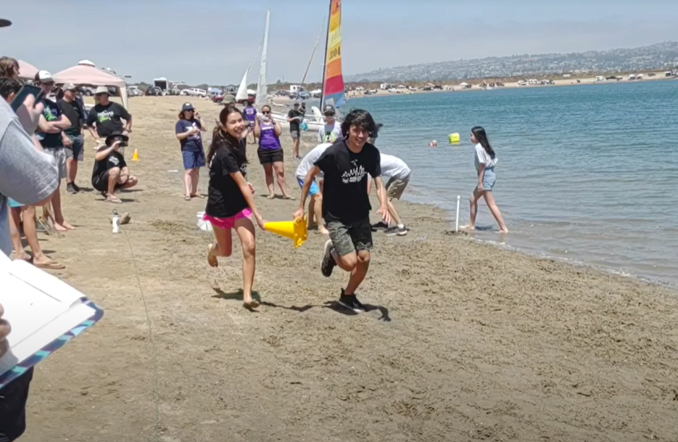
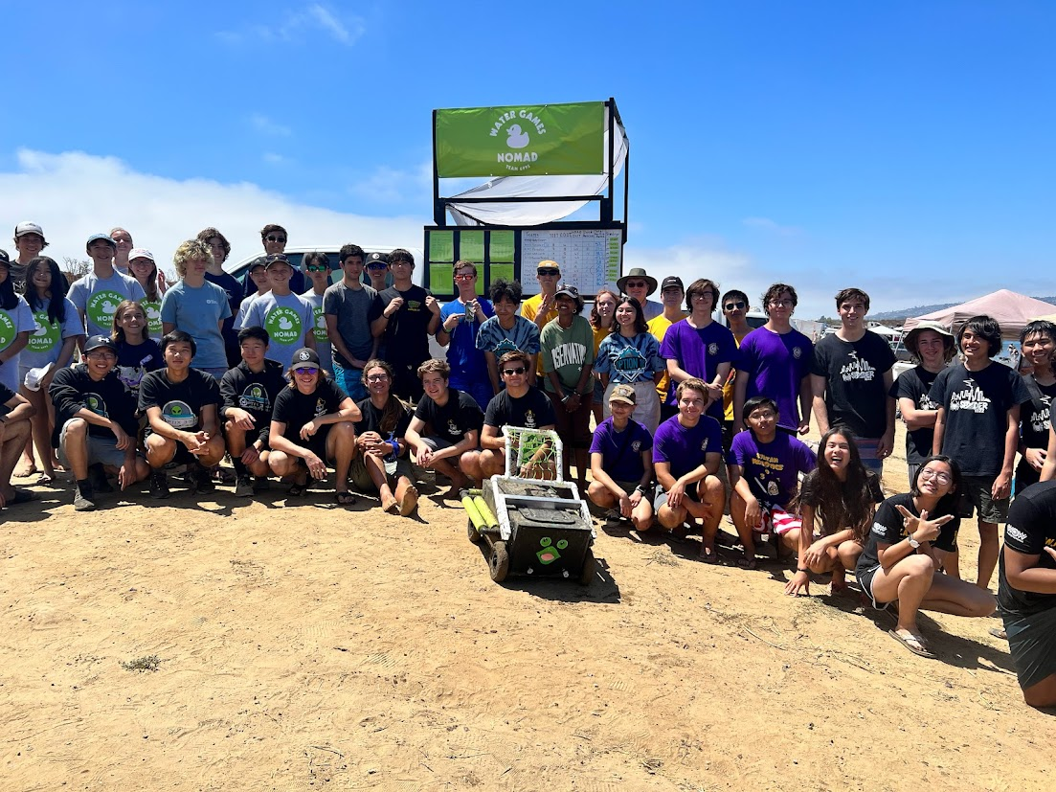
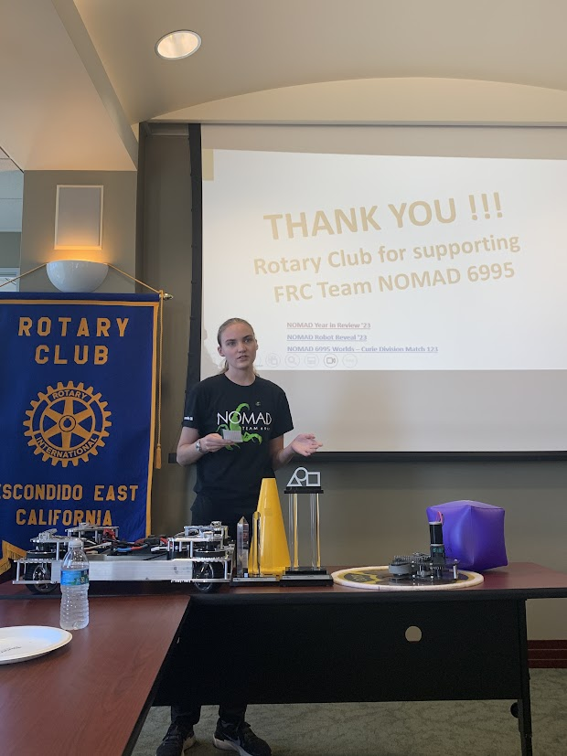
On August 5th, 2023, we hosted the First Annual NOMAD Water Games, a multi-team off-season competition where eleven teams from the San Diego area competed in beach games involving past FIRST game pieces. Games included Load Out--tossing various sized balls into tote boxes, Yeet--throwing pool noodles for distance, and Don’t Drip, Don’t Trip, which involved two people each holding the same 2023 cone with one hand and carrying water in it. The last game consisted of driving our amphibious robot, DUCK NORRIS, through an obstacle course over land and sea to rescue rubber ducks from a pond and release them into the ocean. Through this event, we expanded our outreach program and improved our relationships with other local teams. Two students joined NOMAD as a direct result of attending Water Games, and many other students shared that they became more committed to the team after attending the event.
Escondido Rotary Club
After earning a ticket to Worlds in 2023, we reached out to local organizations for sponsorship, including the Escondido Rotary Club. In September, they invited us to attend one of their meetings and present our team and robot. This became an invaluable opportunity to introduce our new business team members to representing the team. We showed videos from Worlds, robot parts, and game pieces, as well as our team structure and mission. After our presentation, we answered questions and learned about the Rotary Club’s mission.
INCOSE STEM Night
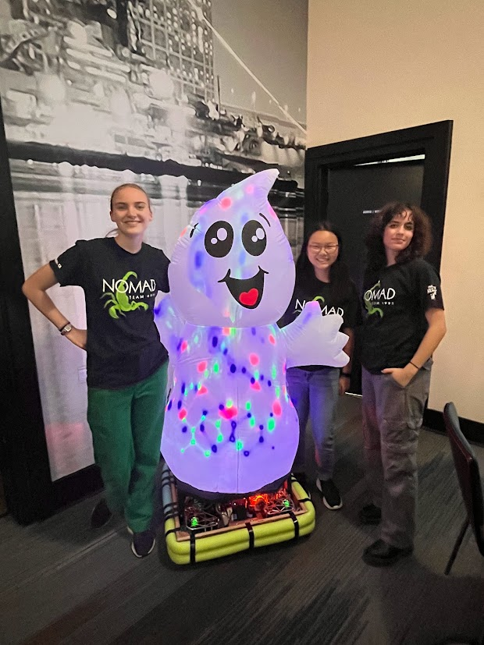
We were sponsored by INCOSE again in 2023 and were invited back to their STEM inspiration event. This time, it occurred during the Beach Blitz offseason competition, so we sent our business team and a few mentors with our new inverted swerve drive base to demonstrate swerve drive, which was our main development that year. We also planned on demonstrating AprilTag processing by having the robot follow an AprilTag around the room. As soon as we arrived, the robot broke, and our business students learned how to fix it with rudimentary tools while adjusting plans for our presentation on the fly. Through this experience, we connected with industry professionals who watched us work through the problem and were inspired by our resilience. We were then able to introduce the students and adults in attendance to FIRST Robotics and its mission of adaptability and problem solving.
Qualcomm Marketplace and Craft Fair
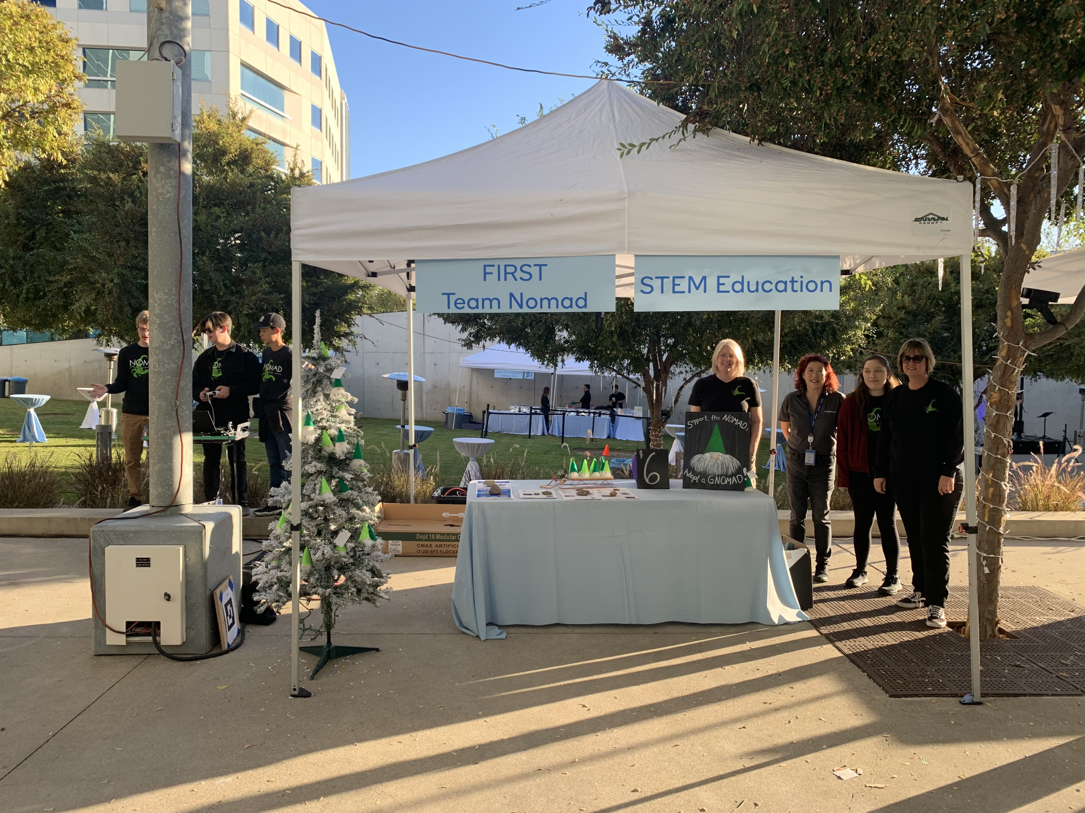
In December of 2023, we were invited by the Qualcomm Manager of Government Affairs for our area to attend the company’s Winter Marketplace. Here, companies and organizations connected to Qualcomm present their products to Qualcomm employees. Despite Qualcomm’s involvement with FIRST, many of the employees we talked to did not know much about the program. We introduced around 80 employees and visitors to FIRST Robotics, and caught the attention of dozens of kids with our robot demonstration.
SDR Field Trip
Currently, we are in the process of planning a STEM field trip for third through fifth grade students to visit the San Diego Regional. Students will be split into groups of ten and will be assigned an FRC Student Ambassador, either a member from our team or a volunteer from another team. Groups will then participate in three different activities: watching practice matches, exploring the pits with a scavenger hunt, and building paper airplanes to solve a problem. Since this is such a large project, we have been working closely with FIRST California to find which schools to invite and how to run the event most efficiently. This year, we will impact up to 200 students and their chaperones. Through this field trip, we hope to raise interest in FIRST and especially FLL among groups that do not already have an FLL team available.

Future Opportunities

FLL Info Night
Since the San Diego Regional field trip is aimed at FLL-aged kids, we plan to organize an FIRST LEGO League information event following the field trip. Here, parents and teachers will learn how to find a local FLL team or start their own at home or in the classroom.

K-2nd Grade Robotics Program
Recently, a local private K-2nd grade school reached out to us asking for advice on how to promote STEM and robotics education in their classrooms. After the competition season, we will likely work with them through demos, activities, and possibly events to create excitement for STEM and maybe an FLL team in the future. This may become a long-term partnership if the kids are engaged and a partnership seems feasible.

San Diego County Fair
The scrimmage at the 2023 Fair was received so well by Fair directors and attendees alike that it may be repeated next year. If so, this will have opened the door to more STEM-focused events for kids in partnership between the Fair and the San Diego FRC community.

Water Games
Hopefully, the summer of 2024 will feature the Second Annual NOMAD Water Games. After the success of the first event, we received a flood of positive feedback from other teams and mentors. One possible direction to take the event would be for teams to build their own amphibious robots to compete in a racing-style challenge.
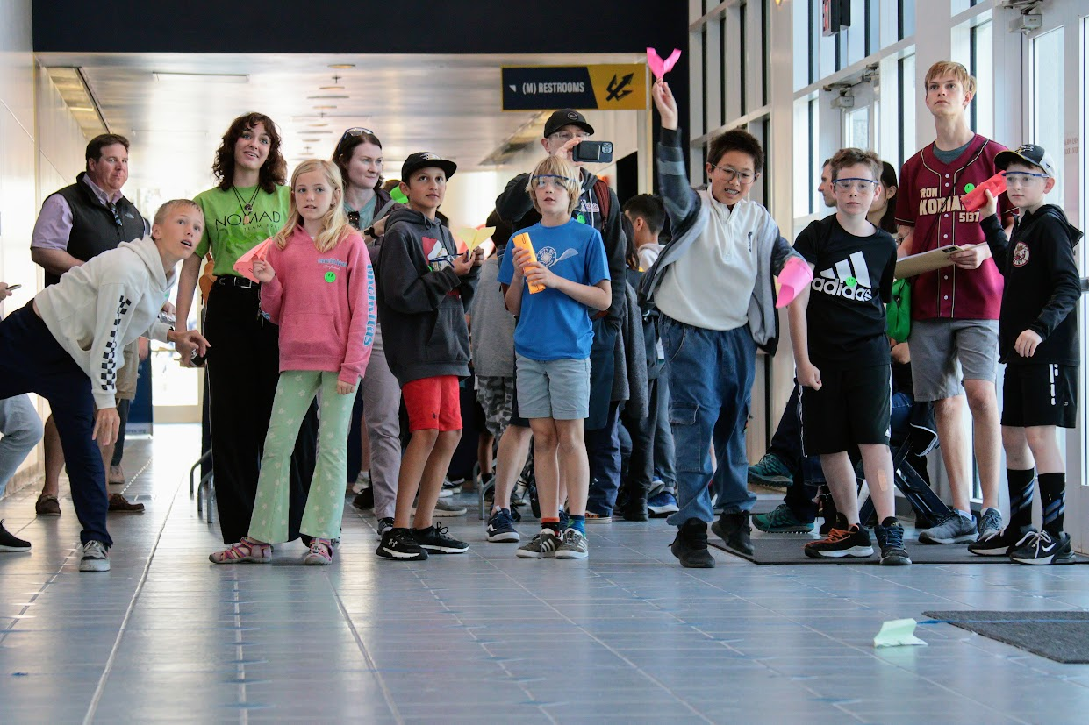
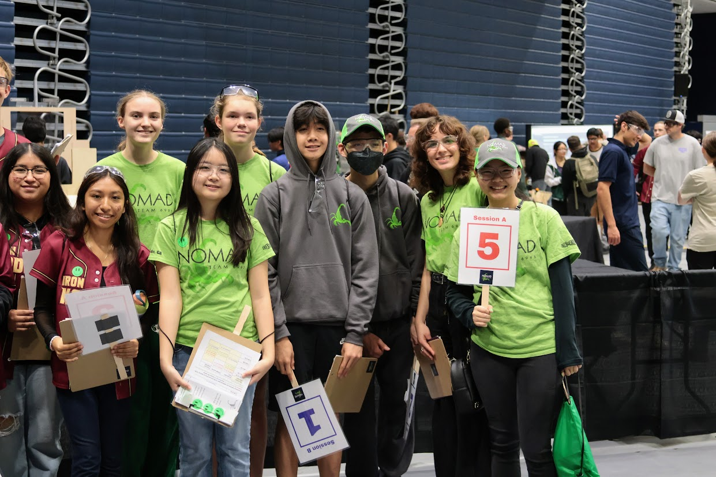
SDR Field Trip Pictures
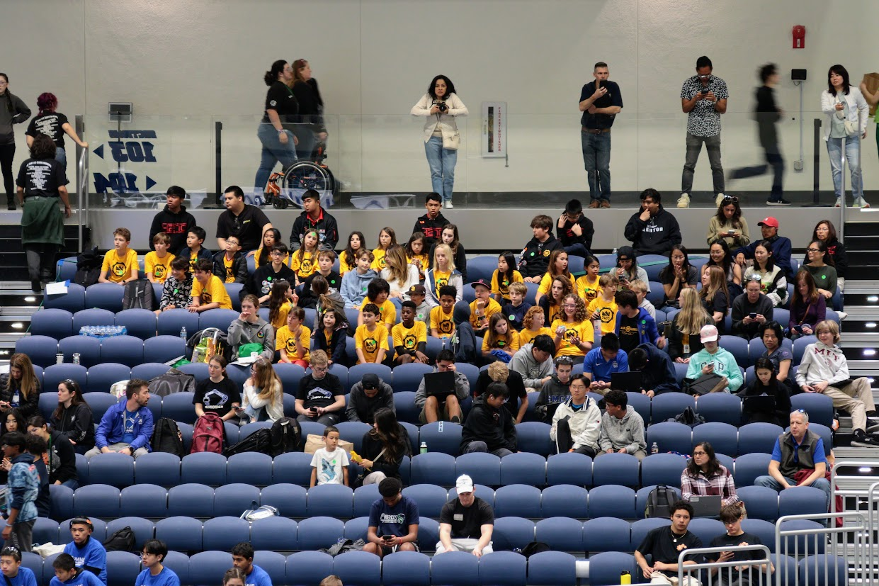
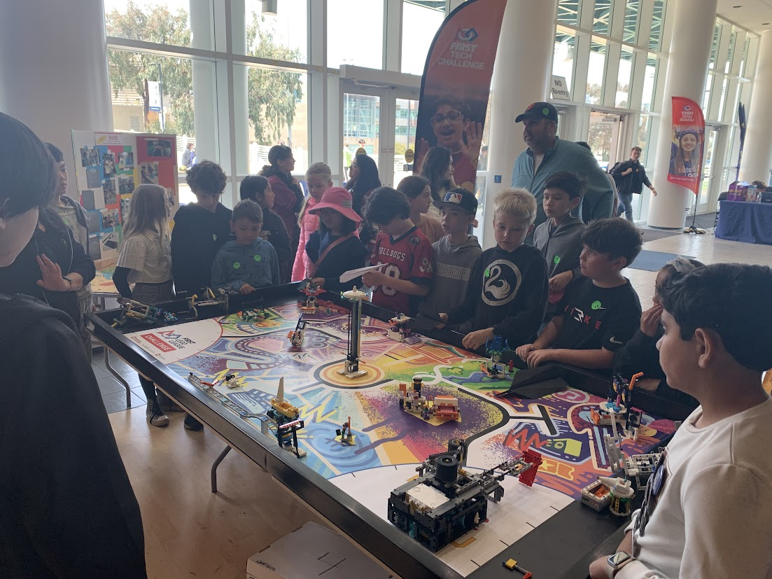
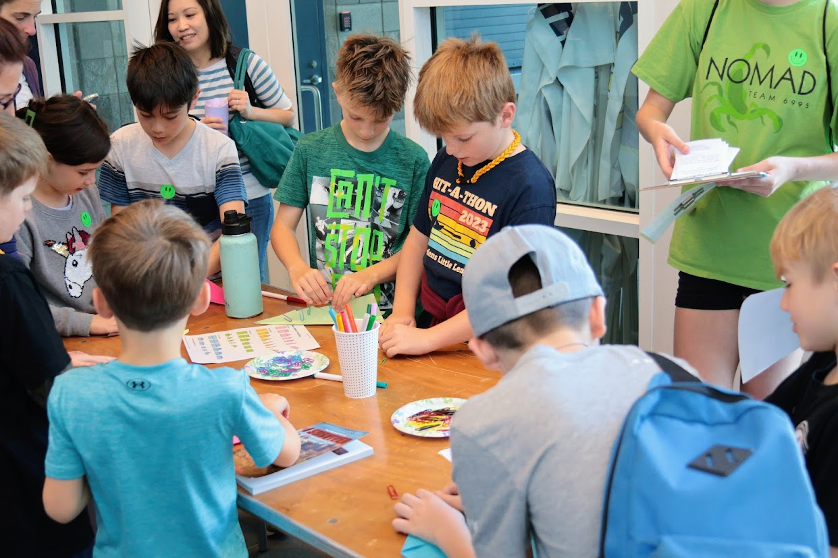
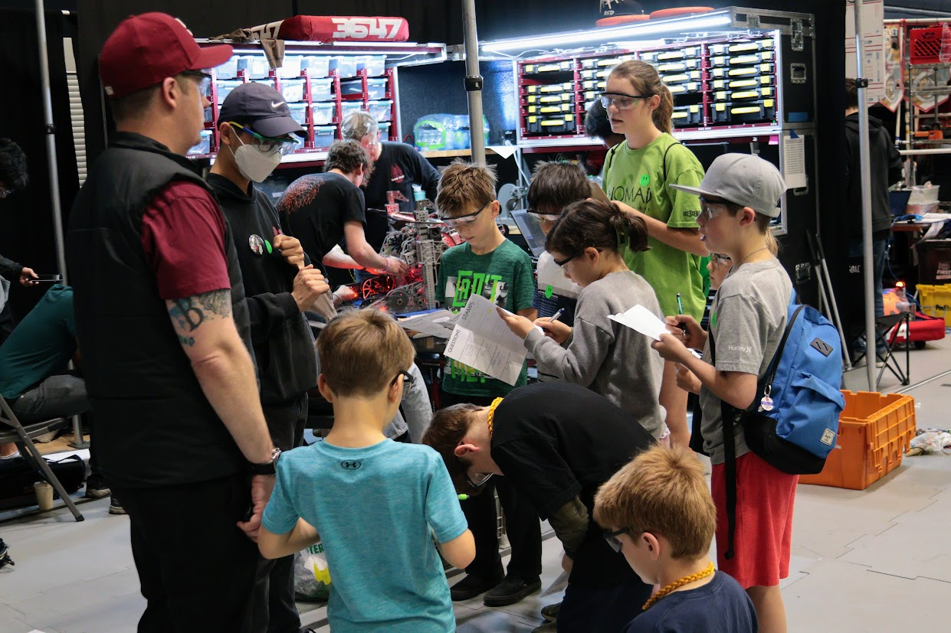
Our field trip impacted a total of 125 kids, plus over 25 chaperones and family members. Four schools were represented, as well as twelve individual families. Overall, the field trip was a success.

