6995 Team NOMAD

Technical Binder 2023

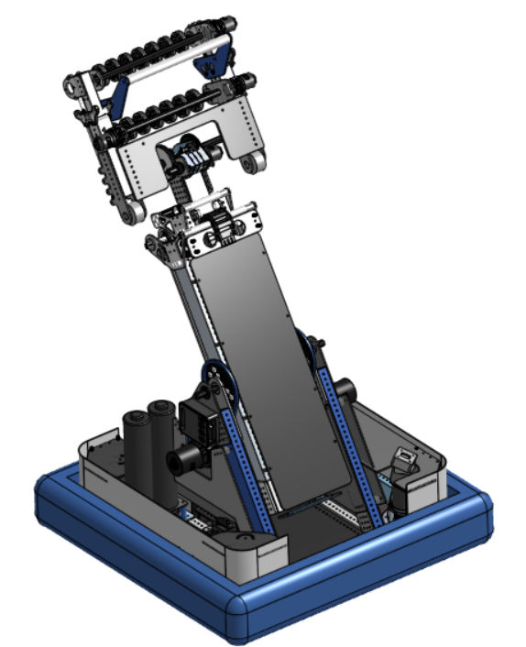


ARMANDA

TABLE OF CONTENTS
Analysis
Charged Up 4
Priority List 5
Design
Drivebase 7
Arm 8
Wrist 9
Hand 10
Programming
Autonomous 12
Tele-Op 13
ALCF 16
Driver Control 17
AprilTags 18

ANALYSIS

Charged Up

Priority List

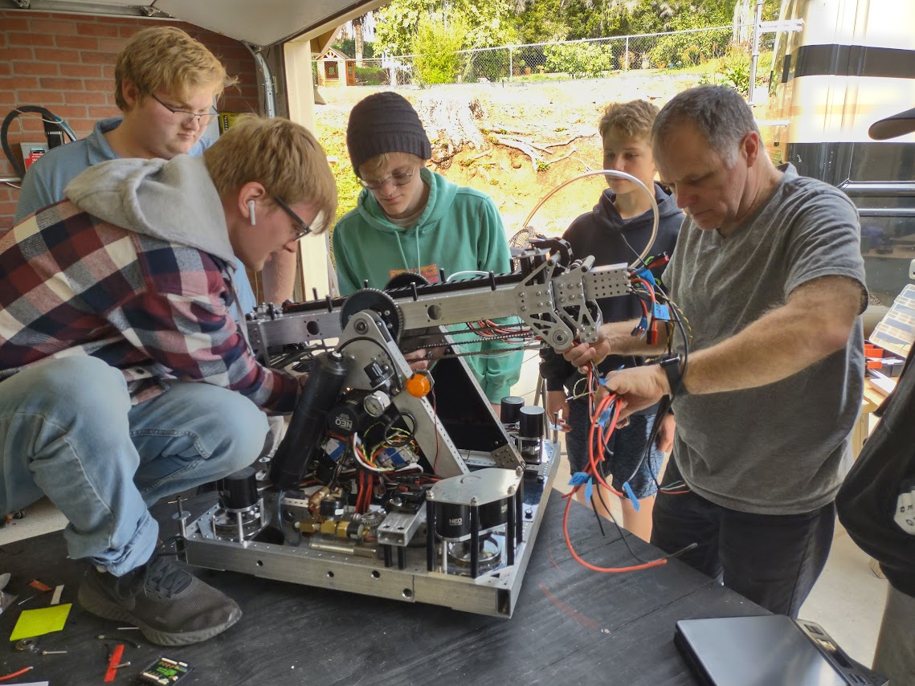

CHARGED UP - Strategy
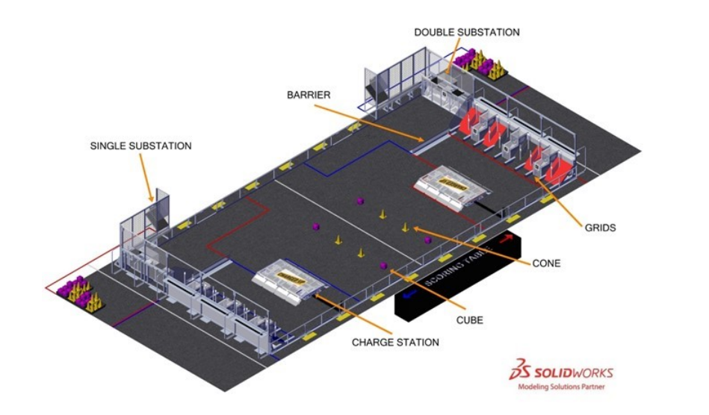
Charged Up challenges teams to build robots that can strategically collect and deposit cones and cubes onto nodes on a grid. There are twelve nodes for cones, six for cubes, and nine nodes which can take either. A link of three cones/cubes in a row equals a link, five of which equal a ranking point. Also, if both teams place three pieces in the middle section of the grid, they earn a “coopertition bonus”, lowering both teams’ link requirement to four.
Several cones and cubes are laid out in the middle of the field before the game begins. Additional game pieces can be given to the robot by a human player using substations, located on the opposite corner of the field from each alliance's grid.
Another way to gain points is by balancing the robot on the charge station– a platform next to each alliance’s grid which moves under the robots as they mount. Alliances earn points by balancing on it both in auto and during the endgame.
Our team’s strategy includes using the speed and maneuverability of the swerve drive to easily position our robot both to score game pieces and climb the charge station. For placing pieces, we have an arm capable of handling both cones and cubes.
The following section offers an in-depth prioritization of the game.
PRIORITY LIST - Goals & Design
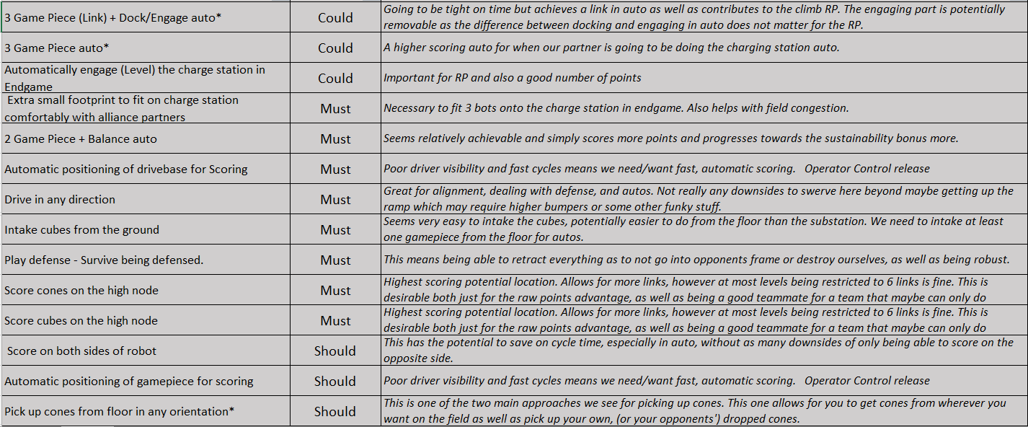
Drivebase
- Because we can only handle one game piece at a time, our robot needs to be fast and maneuverable.
  - We accomplished this by building a small drivebase (25 x 25 inches), enabling our robot to be quick and compact.
  - We also designed our robot to use swerve drive, which allows us to orient our scoring arm correctly from any angle of driving. This is essential during gameplay.
- We anticipate that field congestion will be a major problem this year, since the cycle path of each alliance crosses through the middle of the field. A small robot will allow us to squeeze through traffic jams and reduce congestion.
  - Our robot is small and sturdy, with a low center of gravity and stable maneuvering. This allows us to score and cycle safely during the match.

Arm
- We need to be able to score on both sides of the robot.
  - Because the scoring area is small and has limited access points, ease of scoring from any position is imperative. Our arm swings to either side of the robot and, with the swerve drivebase, can intake and score no matter how the robot is oriented originally.
- Our robot should be able to score both cones and cubes easily.
  - Because of the limited space available inside the frame perimeter, it wasn’t feasible to incorporate two different mechanisms for cones and cubes. Therefore, our hand design is able to hold either cones or cubes, depending on what is needed.
  - We are able to intake both upright and knocked over cones, as well as cubes, from the ground. This is important to improve cycle time, as we will not have to traverse the entire field to receive a game piece from the substation each cycle.
- We need to automatically position the robot and game piece to score.
  - This year’s field includes AprilTags on each Alliance Grid for robots to use in position calculations. We will use these markers to automatically line up our drivebase for the desired scoring location. This both reduces driver error in positioning and allows for a faster, more reliable cycle time.
  - Because there are so many scoring locations, targeting and scoring in the correct location every time is a challenge. Automatically positioning the game piece to score will solve this problem, leading to a faster cycle and overall higher score in the match.

Design

Drivebase

Arm

Wrist

Hand

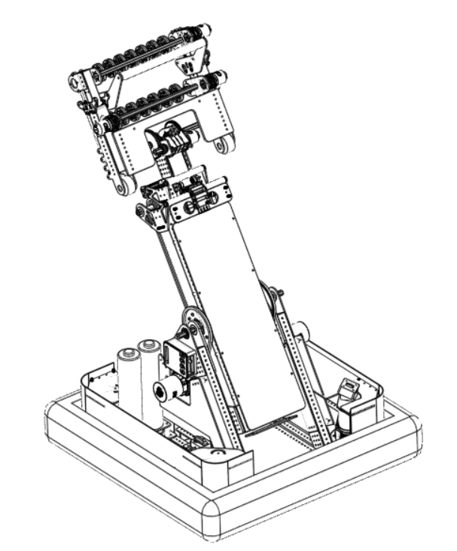

Drivebase
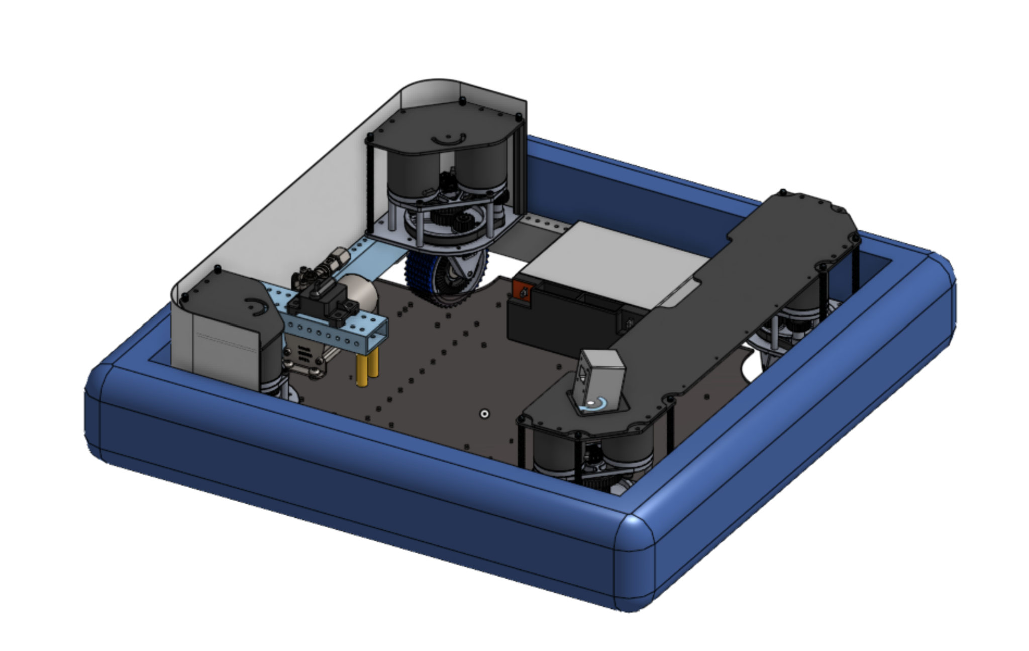

We decided to build a small 25” by 25” drivebase to reduce congestion in high traffic areas on the field. Our design is small and maneuverable, enabling us to quickly speed across the field from the community to the loading zone. Additionally, our Swerve drive lets us dance around the defense and traffic in the center field. This gives our robot an advantage over other drive base systems, such as Tank Drive, Mecanum Drive, or H-drive, whose movement is significantly hampered by the small size of the community area.

Highlights
- Quad SDS swerve modules with 4” wheels
- 1 piece bumper with clearance to traverse ramp

Arm

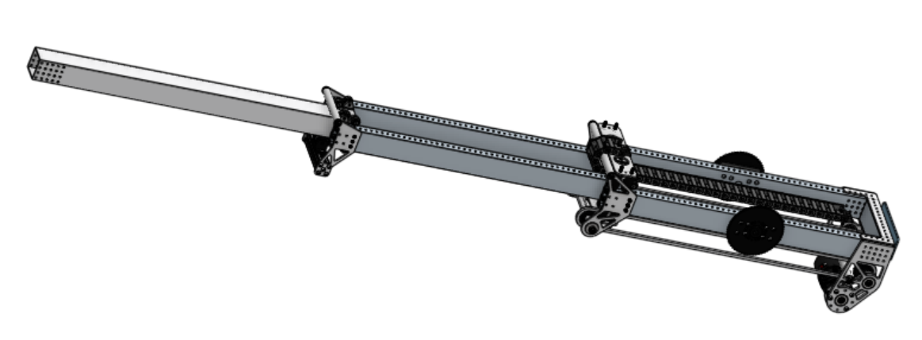

For this year’s CHARGED UP challenge our team decided to build a telescoping arm, which gives the reach and height needed for all levels of each grid. With 5 feet of extension total, the arm easily compacts to 30 inches which keeps it small and easy to maneuver. It also moves quickly and can cross over the top of the robot. This enables the robot to reliably score from either side.

Highlights
- Stable three-stage arm design
- Full range of motion to all scoring locations
- Compact 30” starting position

Wrist
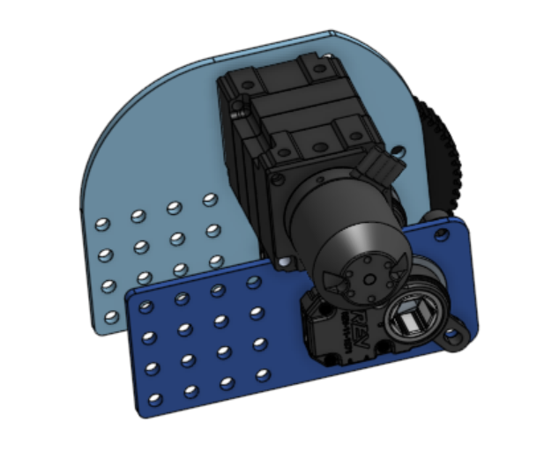

Our bendable wrist allows the robot to precisely maneuver and score game pieces. It provides the torque required to lift the hand and any game piece it may be moving. A REV through bore encoder, located in the internal joint, is used to obtain angle calculations for wrist positions. This allows us to lift the hand and game pieces to locations that are required for scoring and intaking game pieces.

Highlights
- 1 NEO 550 with 300:1 gear reduction
- 180° rotation
- Position control independent from arm position

Hand
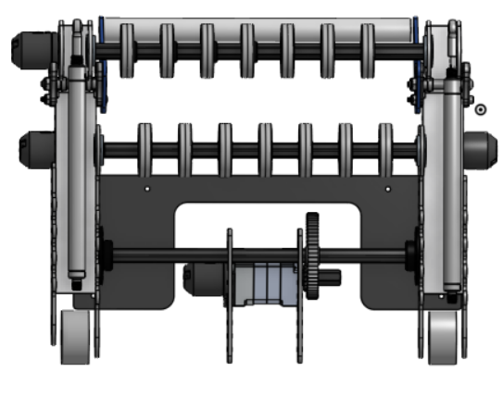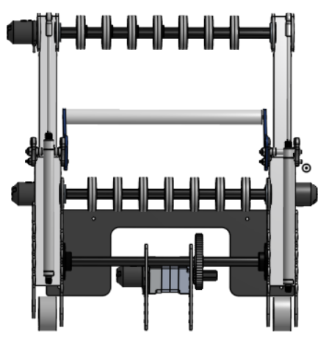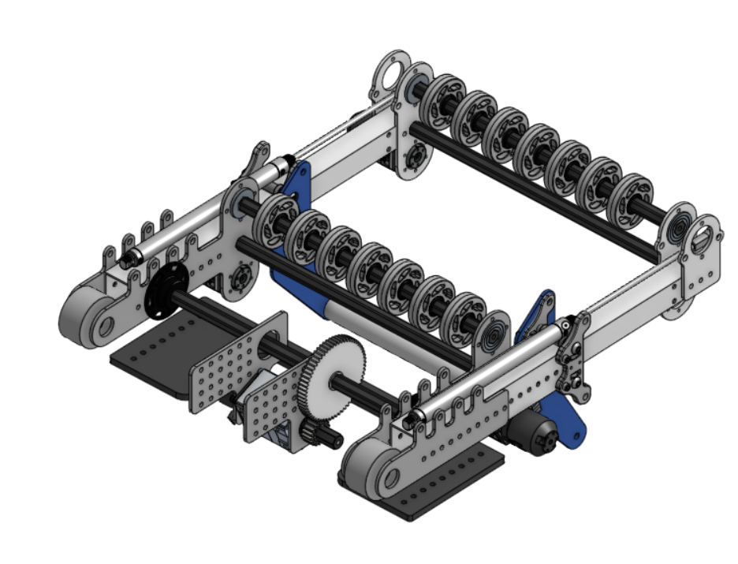
Top View - retracted Top View - extended

Our hand needs to be able to collect both cones and cubes, and ensure a consistent cone position for automated scoring. We designed the hand to retract and extend using pneumatic cylinders, to accommodate both game pieces. Once positioned correctly, the rollers easily intake the game piece, which is then held in with a bar inside the hand. When combined with the arm and wrist, our hand can retrieve game pieces from almost all locations and positions. As the hand is the only way to interact within this game, we took great care to make it as robust as possible, mechanically and electrically. All of the plates are made with ⅛" aluminum and thick walled box tubes. Strategically placed rollers allow us to pass very low to the ground without fear of scraping it.

Highlights
- 5" extension, 10" width pneumatic cylinders
- 14x 2" compliant wheels
- 2x Neo 550 Motors
- 5:1 gear ratio
- 2200 roller rpm
Programming
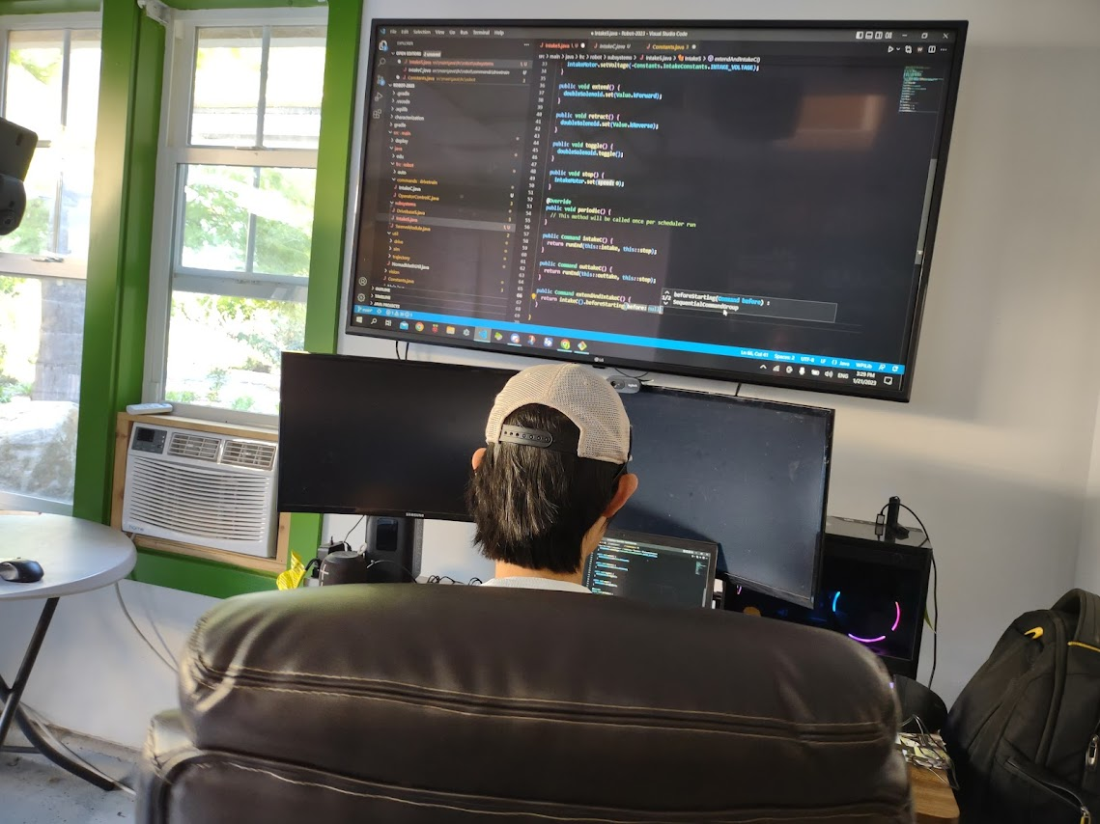

Autonomous

Tele-Op

Constraints

Driver Control

AUTONOMOUS

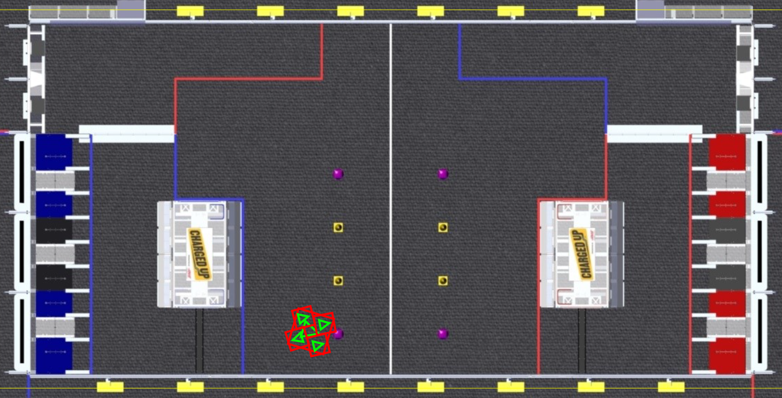
- We have multiple auto paths to maximize our alliance capability and accommodate our alliance partners. Several paths allow us to score various game pieces and either engage the charge station or allow our alliance partner to do so.
- All of our autonomous paths are planned to score high game pieces to begin high-scoring links and start the match with as many points as possible.
- We rely on our two cameras to detect the eight AprilTags that help our robot adjust its path and accurately align to scoring nodes.
- We designed our swerve base to move quickly to specified positions. This way, we do not rely on unreliable timed commands. Our arm uses similar position-based commands, allowing us to score repeatedly without risk of miscalculation.
- What changed: Since Ventura Regional, we have added multiple new autonomous paths. Also, our robot can use two methods for balancing on the charge station during the autonomous period. At Ventura Regional, we used our NavX to determine our angle on the charge station and balance during autonomous. As of recently, we can also use our odometry, aided by AprilTags, to align positionally onto the charge station.

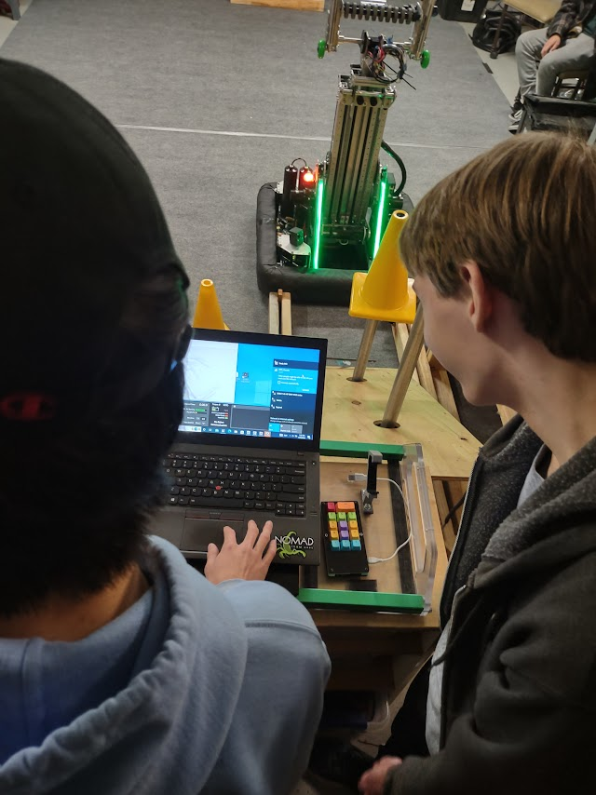
TELE-OP

Drivebase

- Our robot has four swerve modules: one on each corner of the drivebase. Each module is equipped with two motors. One motor spins the wheel for driving and the other turns it for steering. Unlike tank drive, which we used in the past, our drivebase can move in any direction at any angle, allowing for significant driver control and freedom.
- To optimize driver control, maintain workshop safety, and prevent damage to any hardware, our drivebase has limits on the velocity, acceleration, and angle of each swerve module. These limits are essential to maintaining our drivebase, but can be edited for the autonomous, teleoperated, and endgame periods. We use PID and feed forward constants to keep our robot running as smoothly as possible.
- Each swerve module uses an absolute encoder to measure the rotation of the wheel. These encoders allow us to compensate for the discrepancy between the alignment of each module as well as determine the direction the robot is facing.
- Because we are able to easily calculate the speed and rotation of our drivebase, we can constantly update the robot’s position on the field. The robot knows where it is at all times and uses AprilTags around the field to correct any errors caused by skidding or defense. This allows us to accurately and automatically line up the robot to important areas on the field such as the scoring grids and substations.
- What Changed: Since Ventura Regional, we have eliminated our reliance on the relative encoders built into the steering motors. We also recharacterized our drivebase to more accurately support our fully built robot. These improvements have massively improved our driving accuracy, control, and speed.

Arm
- Our arm is the main subsystem of our robot. Our design and strategy is built around a well-functioning, well-designed, robust arm.
- Our robot arm is controlled by defining specific positions for each task. This gives us significant freedom to automate important movements while retaining driver control. While driving, the arm is held in a “stowed” position that optimizes our center of gravity, maintains safe extension, and stays close to other key positions.
- We have a limit switch on the lower end of the arm that communicates whether the arm is fully retracted or not. This gives us a base-line homing position to help the robot accurately calculate the length of the arm.
- We use a through-bore encoder on the pivot joint to find the exact rotation of the arm assembly.
- Calculating the rotation and extension of the arm is important for determining the required limits for the wrist rotation and hand extension. It gives us parameters to keep the hand in a specific position relative to the field and maintain legal extension. These functions are the foundation of our scoring capability.
- Our arm uses PID to operate quickly and smoothly. It also gives our robot the ability to repeatedly determine the desired voltage for a desired position without relying on timed commands.
- What changed: Since Ventura Regional, we have optimized our extension and pivot acceleration. We spent hours analyzing data to figure out the best acceleration and velocity for the arm as well as testing and tuning our code. These changes allow us to maximize our autonomous routines and teleoperated scoring.

Wrist

- Our robot’s wrist works with the arm to position the hand correctly. Its job is to keep the hand in the correct orientation.

- The wrist has built-in soft limits that give it limited rotation and speed.

- We use a through-bore encoder on the wrist joint to measure the precise angle of the wrist relative to the arm.

- One challenge we faced was simply determining the exact desired positions for each task. We had to take into account efficiency, consistency, and exposure of important hardware (such as our through-bore encoder). Working through each position gave us a well-tuned wrist..

Hand

- Our hand uses two NEO 550s to drive the intake rollers on our hands and two pneumatic cylinders to extend or retract. These positions are determined by whether we need to intake a cone or cube.

- The hand has limited speed for the rollers based on which game piece we intake. These speeds are tuned to pick up game pieces quickly without the danger of knocking them away or pushing cubes hard against the backstop.

- We use a beam-break sensor that returns whether we have a game piece. When a game piece breaks the path of the beam, our arm and hand automatically retract to the “stowed” position. Similarly, when the beam break detects that we have successfully outtaked and scored, our arm retracts automatically.

- Our operator keypad tells the robot to assume important positions for intaking, scoring, and driving. The specific position of the hand is determined relative to the arm. The hand is controlled entirely automatically.

Arm Length Constraint Function (ALCF)

- When planning points of interest on the field (such as scoring nodes, the double substation, and center game pieces), we determine the necessary positions of the arm and hand assemblies for each location. We map out these positions using a “two degree of freedom” system.
- Using parameters for legal extension and safe limits, we constructed a two-dimensional graph to determine significant coordinates for arm extension and rotation. The x axis of the graph defines the rotation of the pivot joint and the y axis defines the extension of the arm.
- This system is important to plan automated movement for the robot arm as well as keep the arm translating as efficiently as possible.
- Within the constraints of the system, we can set commands for the arm to move from one position to another based on planned coordinates. These coordinates are defined in our code and bound to the operator keypad buttons.
- By using a class to determine the optimal path from one point on the graph to another, we can tell our arm to move rapidly and efficiently within legal space.

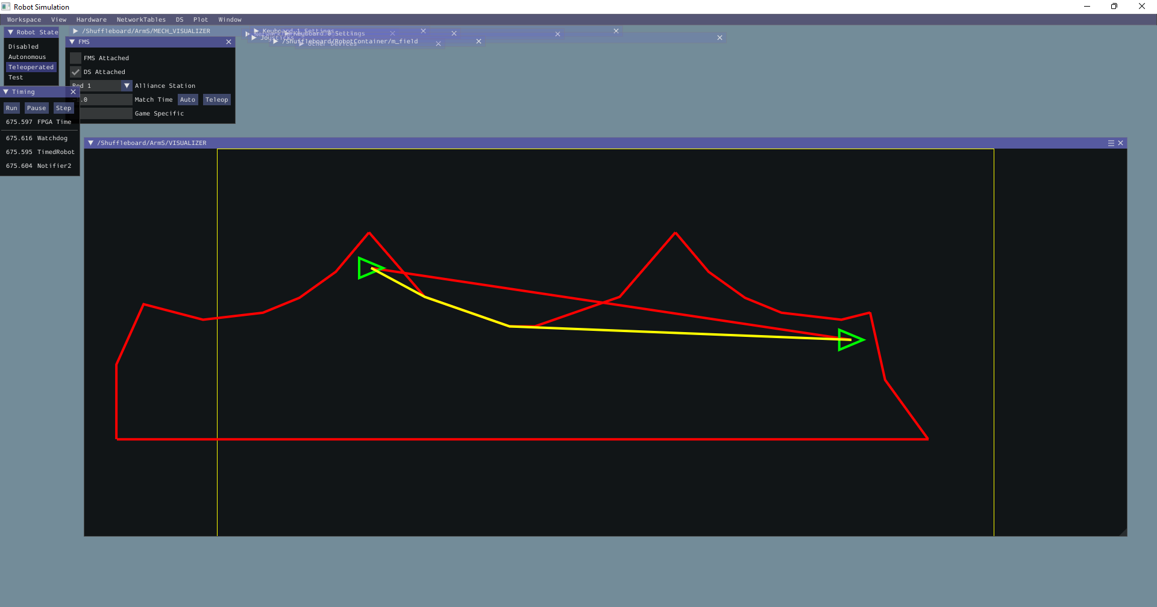
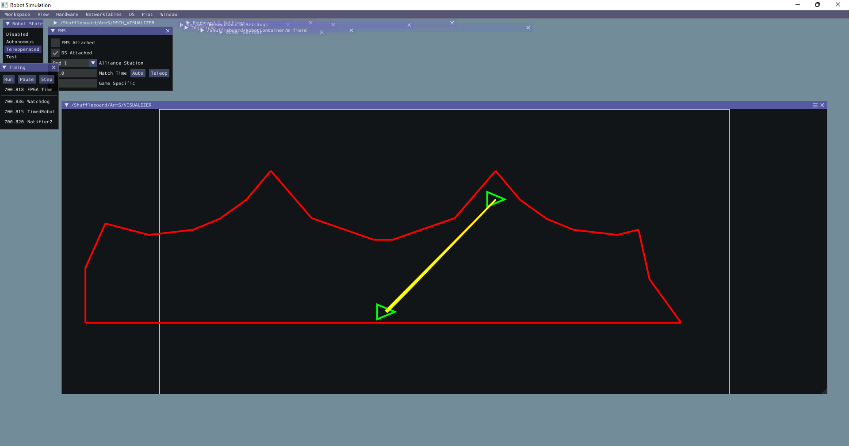

Driver Control
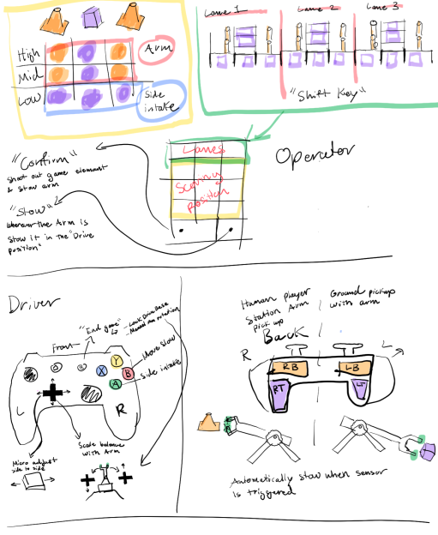
- Our driver and operator use a standard Xbox controller and a 14-key number pad.
- Our driver controls the drivebase manually, triggers the arm intake sequence for intake from the ground and the human player, puts the arm in the “stowed position,” outtakes game pieces when scoring, and controls the endgame period. Our operator controls the automated scoring sequence, determines the “cube or cone mode” for intaking and scoring, and can manually intake loose game pieces.
- Our robot’s position is determined by the “cube or cone mode.” Each position (e.g. ground intake, double substation, etc.) takes into account whether the drive team wants to score a cube or cone. The positions are modified accordingly, but still bound to a single button. This prevents an unnecessary number of buttons and provides intuitive controls.
- We decided to use a keypad for the operator because it is easy to use and fits well with the Charged Up game. It is small, cheap, customizable, and “mind-blowingly, eye-poppingly, nose-fizzingly clicky”.
- The first row of keys represents the three scoring grids in the alliance community. These three keys are used as modifier keys. The next three rows represent the low, mid, and high rows of scoring nodes in each of the grids. By holding down one of the grid keys and pressing one of the node keys, the operator selects the exact scoring position for the robot. This combination controls the drivebase and arm assembly automatically.
- Our driver station includes displays for both the driver and operator. These displays include camera visuals, limit feedback, a graphic of the operator’s selected position, and several other displays to help with driver control.

AprilTags
- AprilTags are like QR codes that can be detected by the cameras on our robot. The AprilTag visual fiducial system is meant to provide robots with a spatial reference to calculate its position in three-dimensional space.
- There are eight tags placed around the field where our robot can detect them. Our drivebase knows where it is at all times because of the odometry calculations, but our reference point can be erroneous because of skidding or defense. We use AprilTags to correct these errors and keep constant reference points.
- Our cameras analyze the images of the tags to determine the relative distance, yaw, pitch, and roll as compared with the robot. This gives our robot the information necessary to precisely measure its position on the field.

