6995 Team NOMAD

Technical Binder 2022

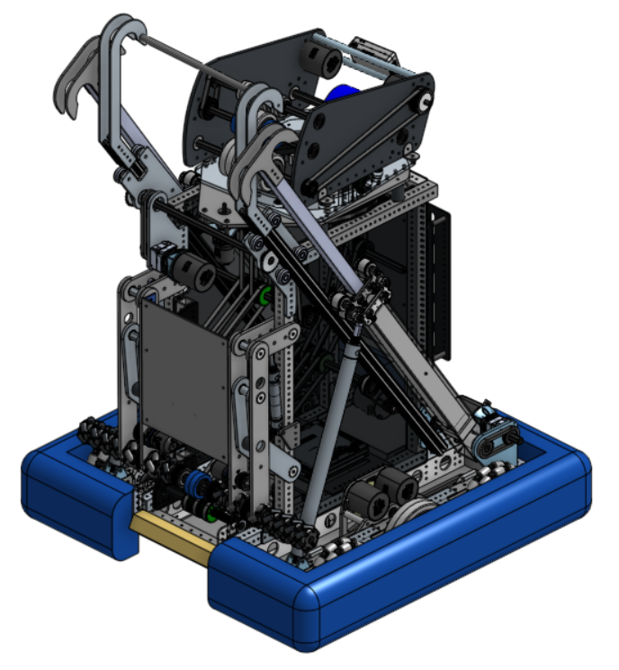


CLAWDIA

TABLE OF CONTENTS
Analysis
Rapid React 4
Priority List 5
Design
Drivebase 7
Intake 8
Midtake 9
Shooter 10
Turret 11
Climb 12
Programming
Autonomous 14
Tele-Op 15
Aimbot 16

Analysis

Rapid React

Priority List

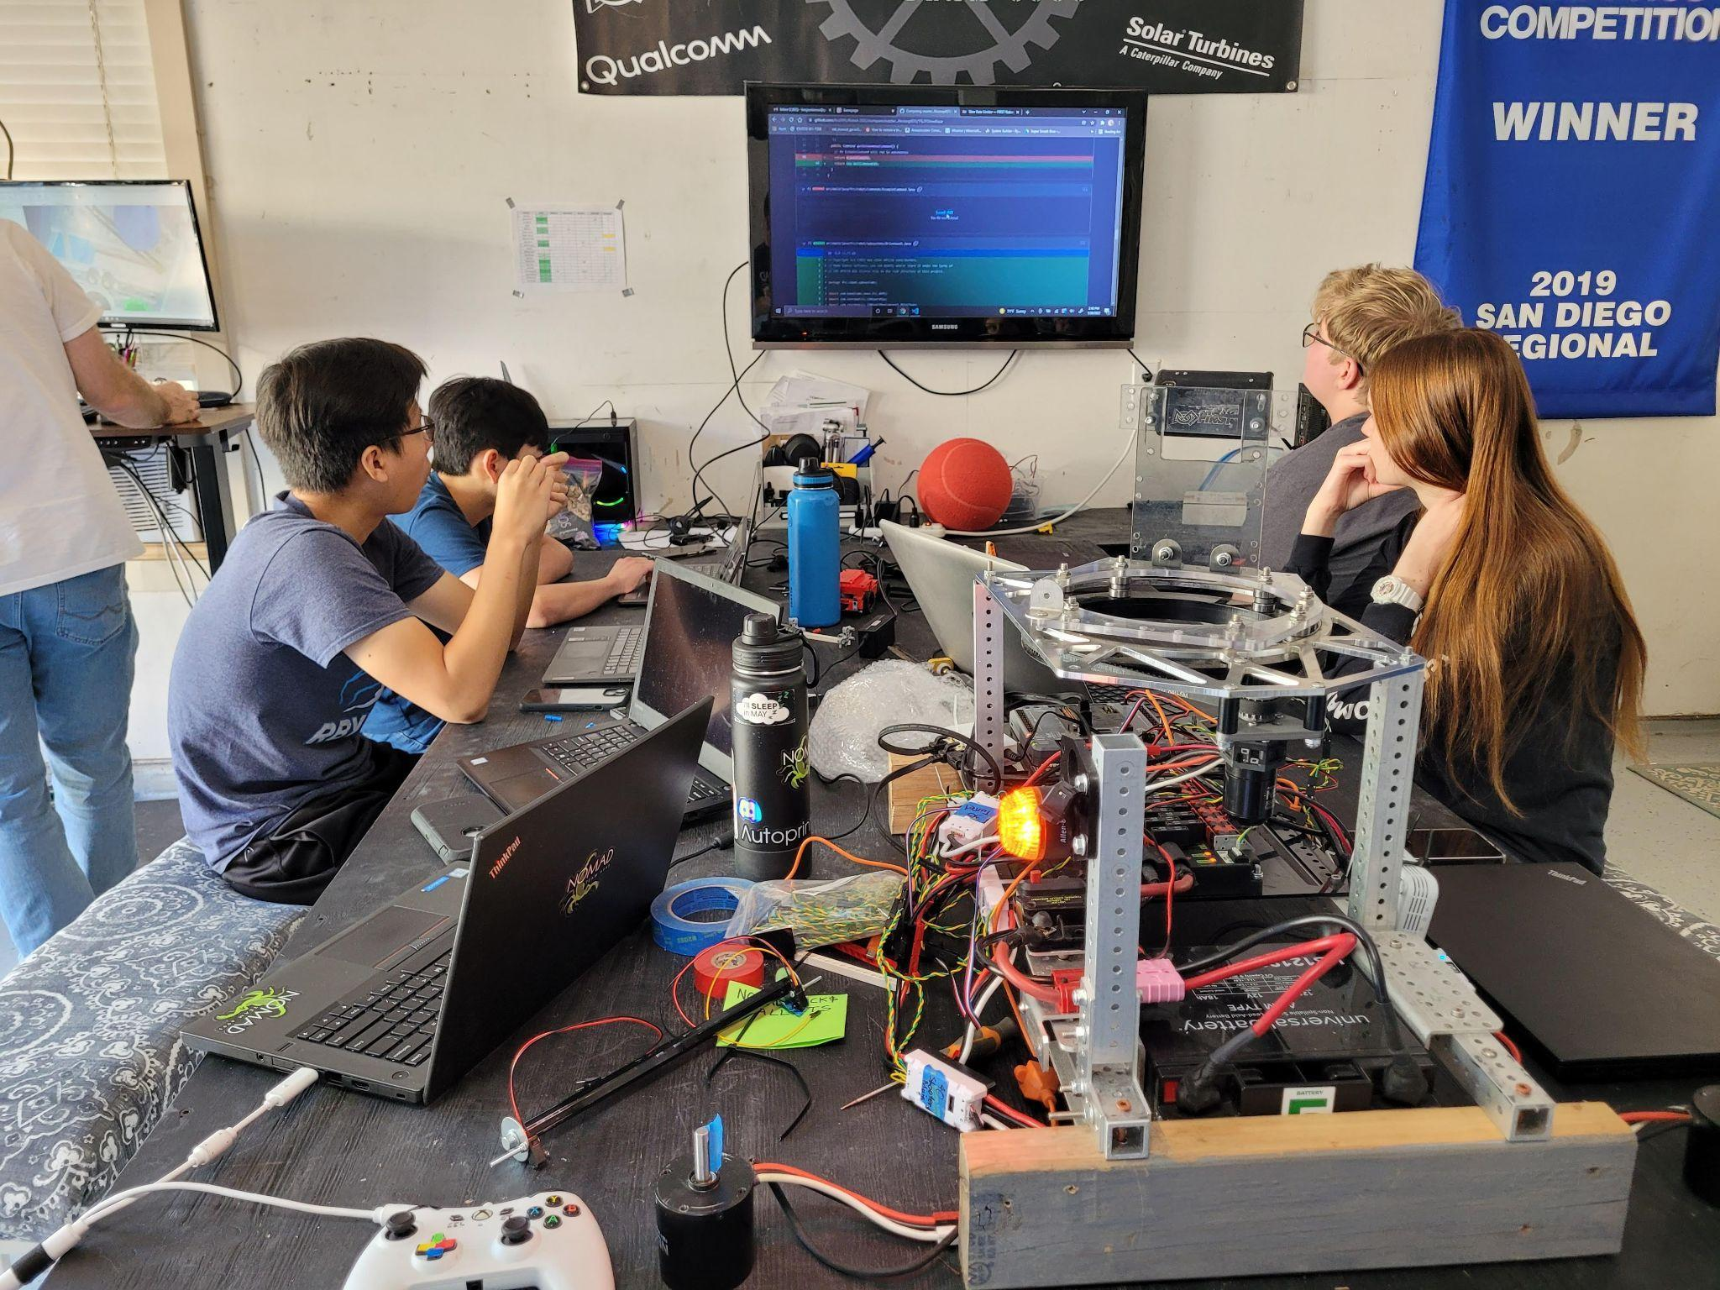

RAPID REACT - Strategy
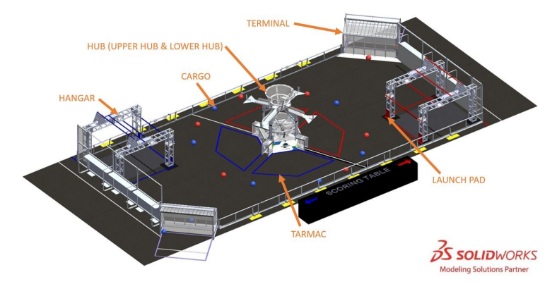
Rapid React challenges teams to build robots that can strategically collect and deposit colored cargo balls into the Hub located at the center of the field. Cargo scored in the Upper Hub are worth twice as many points as those scored in the Lower Hub. During Endgame, robots move to the Hangar where they are challenged to traverse up increasingly higher bars. Both the Hub and Hangar provide an opportunity for the alliances to score ranking points.

Team NOMAD’s strategy for Rapid React focuses on scoring cargo into the Upper Hub. In addition, NOMAD plans to have a consistent climb solution and movement through the Mid and High Bars as we progress through the season. NOMAD chose to focus on scoring in the Upper Hub rather than the Lower so that our robot has the opportunity to quickly intake and score from anywhere on the field. This will reduce traffic congestion with other robots, as we anticipate that many robots will be on and near the Tarmac during Tele-Op. During Endgame, NOMAD plans to bypass the Low Bar and start the climb at the Mid Bar, giving us more time to reach the Traverse Bar. According to this strategy, NOMAD prioritized having a fast, reliable intake and shooter as well as a consistent climb system. The following section offers an in-depth prioritization of the game.

PRIORITY LIST - Goals & Design
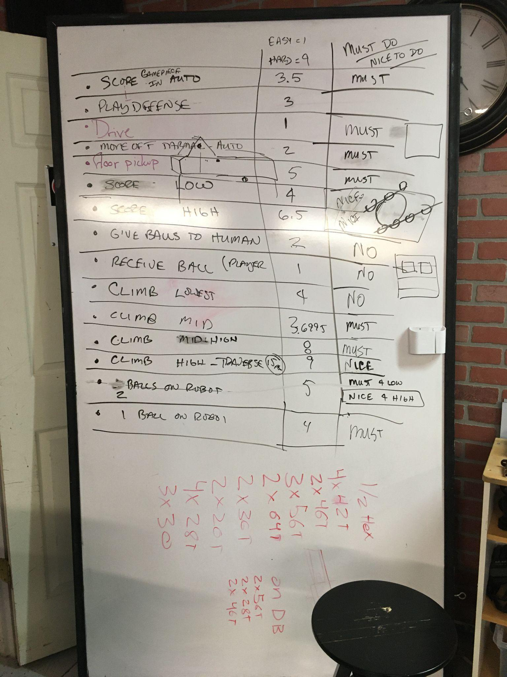
Drivebase
- Due to the limited amount of Cargo on the field, our robot needs to be fast.
  - We accomplished this by building a small drivebase (25 x 25 inches), enabling our robot to be quick and compact.
- We anticipate that defense will play a crucial role in Rapid React gameplay, because the majority of Tele-Op consists of picking up and scoring Cargo. A quick robot will enable us to avoid defense robots as much as possible.
  - Our robot is compact, with a 15 ft/sec gear ratio, which gives us the ability to move quickly around the field.

Intake
- Our intake needs to be fast and reliable.
  - We have mecanum wheels that spin at 4,200 rpm, allowing the intake to consistently line up and intake balls.
- There is limited cargo on the field during a match (11 cargo balls per alliance). If one ball gets away, we will lose valuable time by having to find new cargo.

Shooter
- Once 20 cargo balls are scored, the alliance earns a Ranking Point; NOMAD chose to prioritize scoring every ball in order to accomplish this task. In addition, we incorporated vision sensing of the Upper Hub’s reflective tape to calculate an ideal trajectory.
  - The turret limelight helps the robot aim at the Hub and shoot cargo with a reliable orientation.
  - Our code has enabled velocity interpolation for the shooter; depending on how far the robot is from the Hub, the velocity at which the Shooter launches Cargo is adjusted accordingly.
- With only 11 cargo balls for each alliance, every shot is valuable. Therefore, having an accurate shooter and turret are a top priority.

Climb
- We want our robot climb to be reliable.This will enable us to quickly organize Endgame strategies with our alliance partners prior to a match and work around unplanned difficulties while in the Hangar.
  - Our climb design is simple and compact, which allows multiple robots to climb on a single Hangar bar at once.
- Many points are available during Endgame; the higher we climb, the greater our alliance’s chance of gaining a Ranking Point (16 Hangar points equates to 1 ranking point.

Design

Drivebase

Intake

Midtake

Turret

Shooter

Climb

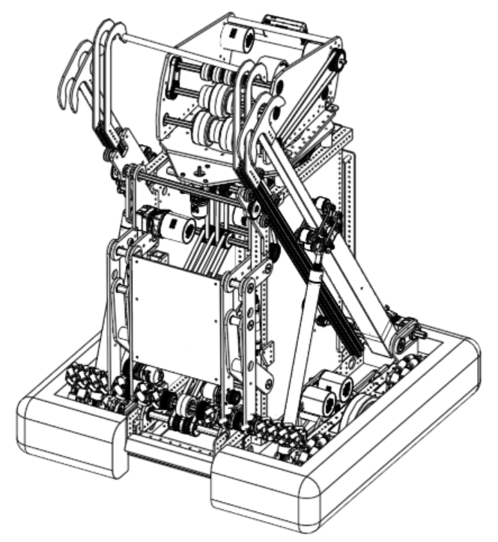

DRIVEBASE
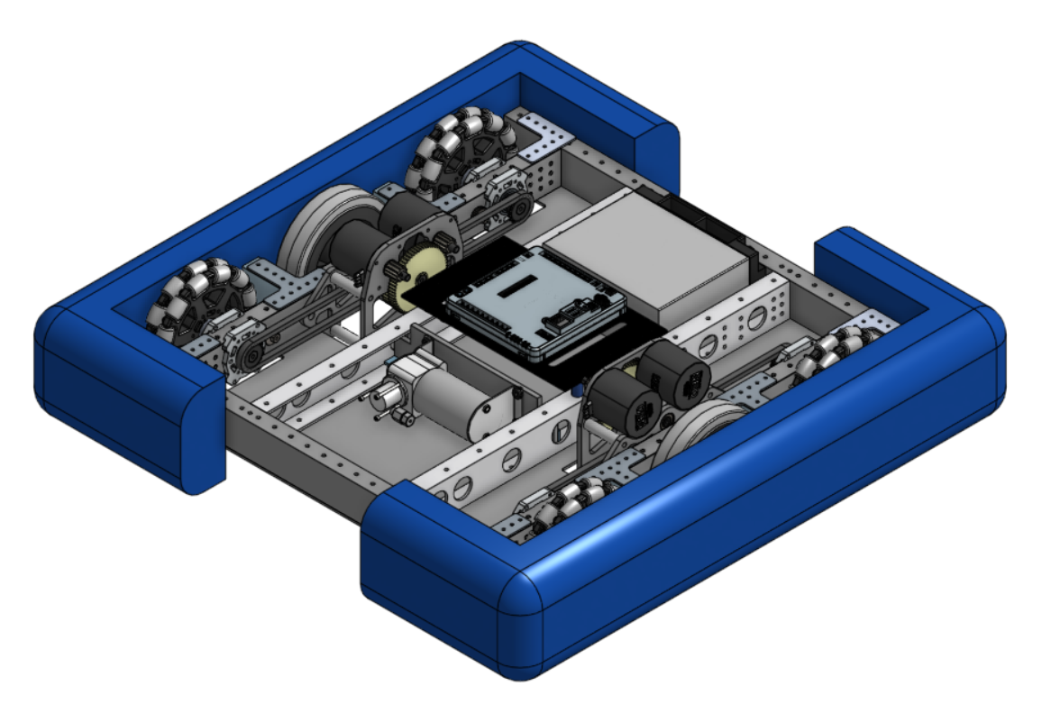
We decided to build a small 25” by 25” drivebase to reduce congestion in high traffic areas on the field. Our design is small and maneuverable which supplements a comparably fast and stable intake system. Additionally, our West-Coast style design provides protection against possible collisions on the field as it is resistant to defense bots. This gives our robot an advantage over other drive base systems, such as swerve, Kiwi, or H-drive, whose movement is significantly hampered by collisions.

Highlights
- Quad 6” omni and double high-grip “tank” style wheel design
- 2 piece bumper with 10” gap in front for intake
- 2 Twin Double NEO Gearboxes supplying 15fps of speed
- Lightweight Versa Tube construction
INTAKE

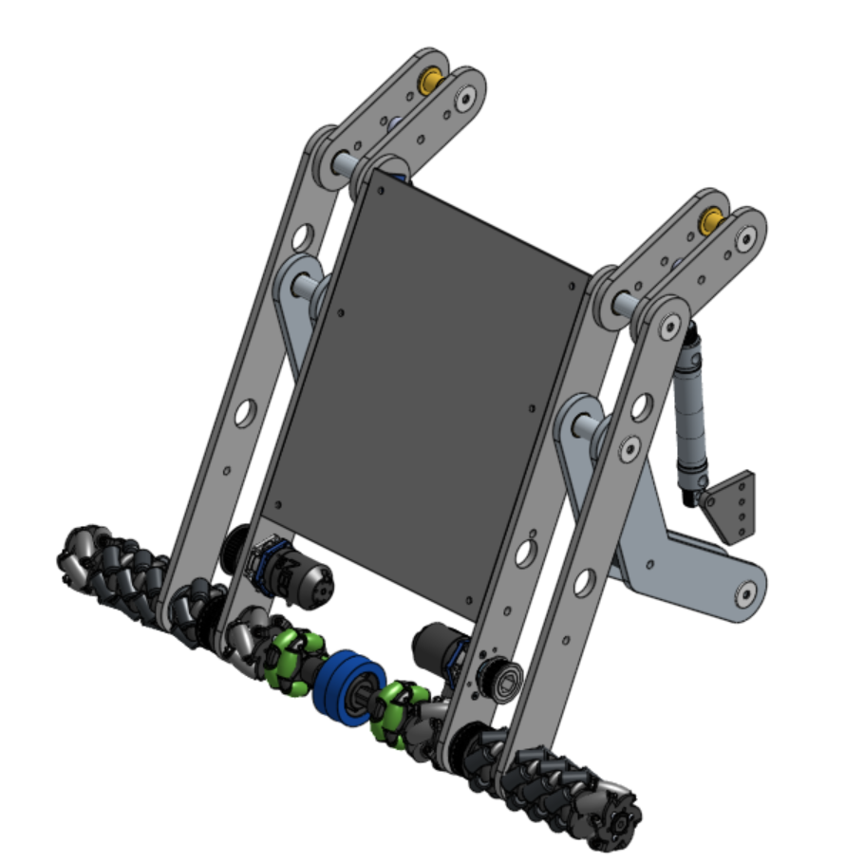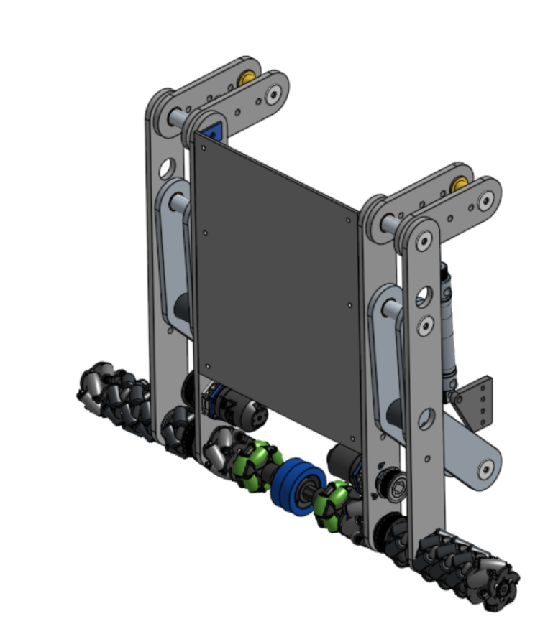

Dual Motors
Pneumatic Actuation
23.5” Bar Design

Our intake is designed to limit and avoid possible damages on the field.The intake's short quad-arm assembly improves this year’s design from the fragility of our past robots. In addition, the intake utilizes a simple roller system, resulting in a quick and efficient collection of cargo. By having the surface speed of the wheels higher than the speed of the drive base, any cargo we come across on the field will be quickly controlled and collected by the robot.

Highlights
- Stable quad-arm design
- 4200 rpm roller speed
- Compact and effective 23.5” roller bar
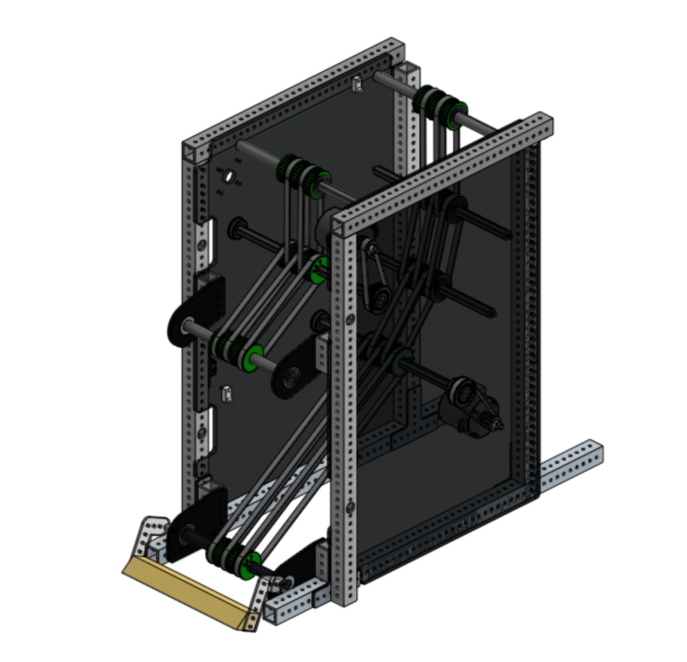
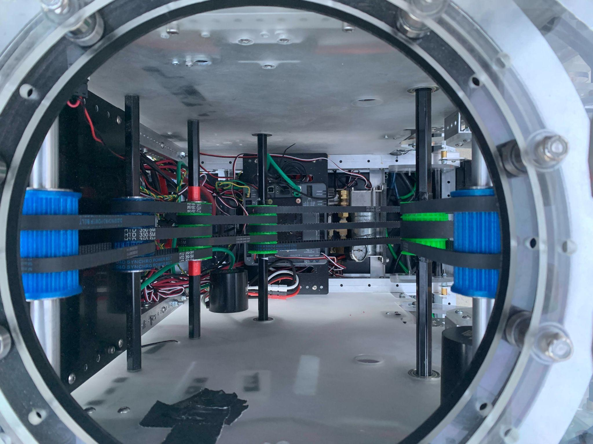
MIDTAKE

Top view, looking down

The midtake conveyor system provides the backbone of our robot both structurally and mechanically. It provides the framework and mounting points for our intake, shooter, and turret subsystems, while functioning as a medium by which cargo is transferred from the intake to the shooter. Our 12 belt pulley system uses feedback from beam-break sensors to automatically store and sequence cargo balls.

Highlights
- Primary Mounting Structure
- Simple, Custom Pulley Design
- Shafts spinning at approx 2000 rpm
- Sensor-based automated cargo handling.
SHOOTER
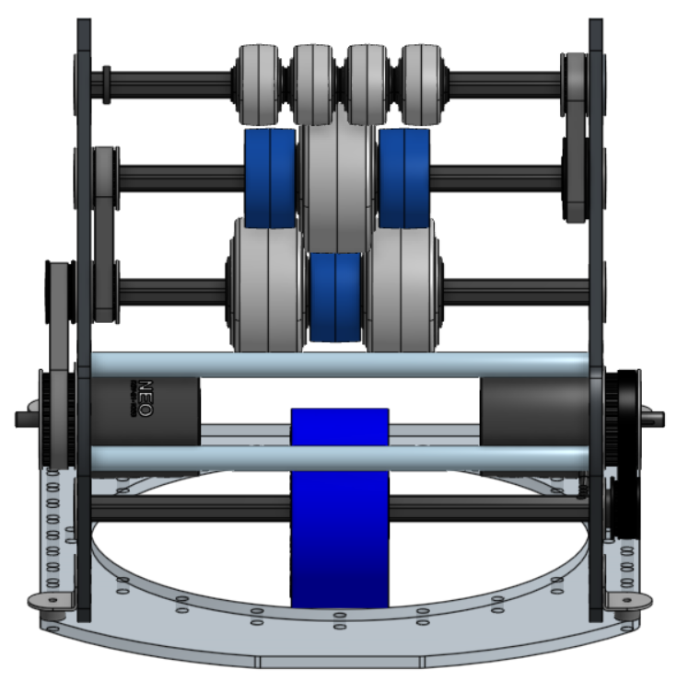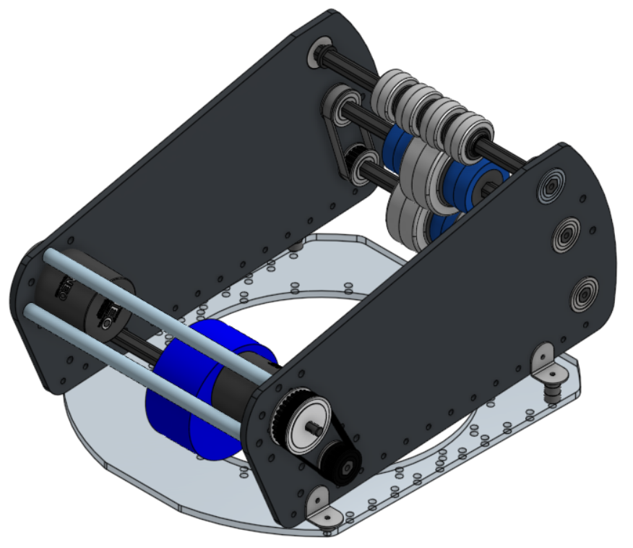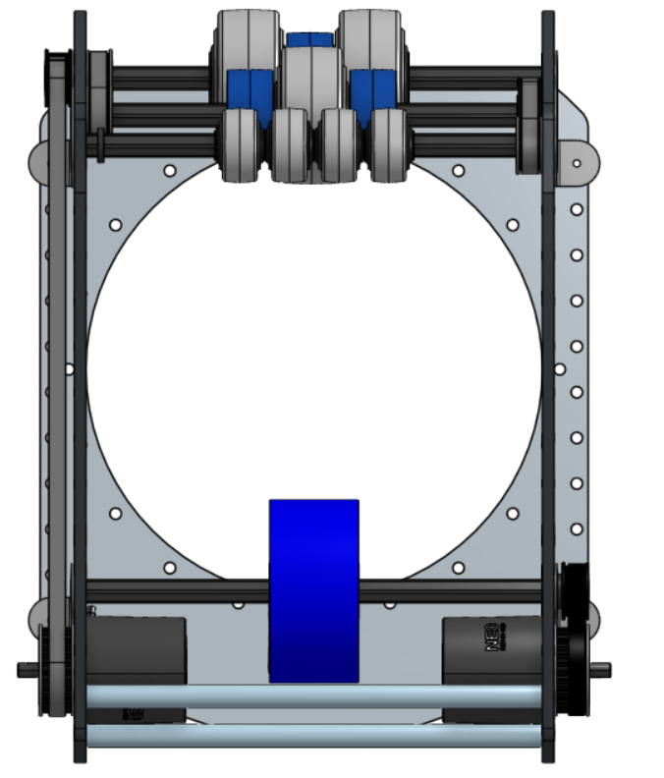
Front View Top View

Our shooter system integrates previous design experience while meeting the challenges of this season’s game pieces and a different shot trajectory. While this year's shooter functions very similarly to our design from last season, it has been finely tuned to provide the perfect amount of cargo ball compression to give each shot the ideal arc. Two sets of controllable wheels gives us the ability to change our shot angle and shoot from a wide range of distances.

Highlights
- 2000rpm Approximate Wheel Speed
- 8th Shooter Iteration
- 11 Wheel Grip System

TURRET
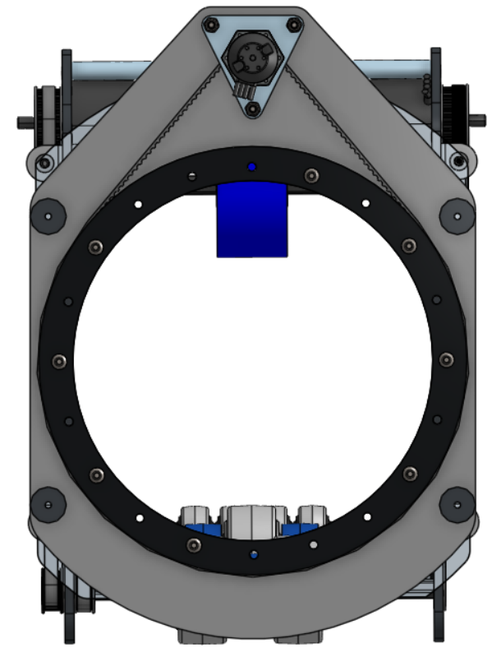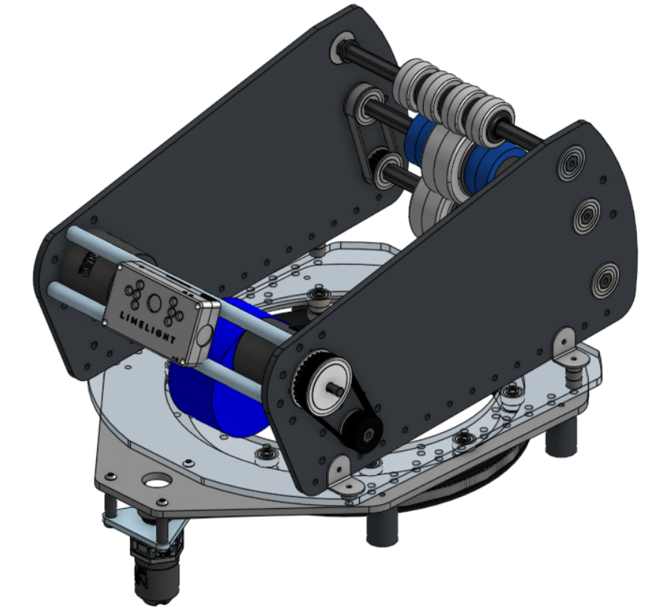

Our turret is mounted on the shooter subsystem and showcases our emphasis on driver usability. Building off of designs from previous seasons, the enlarged shooter system gives the user 220° aiming range. This allows the robot to easily track the target even while being heavily defended against. In addition, our robot has a built in encoder zero position which is used to ensure the turret is not obstructing the path of the climber during Endgame.

Highlights
- 188T Driving Belt
- 220º Range of Motion
- Built in Zero Position and Encoder Updates
CLIMB
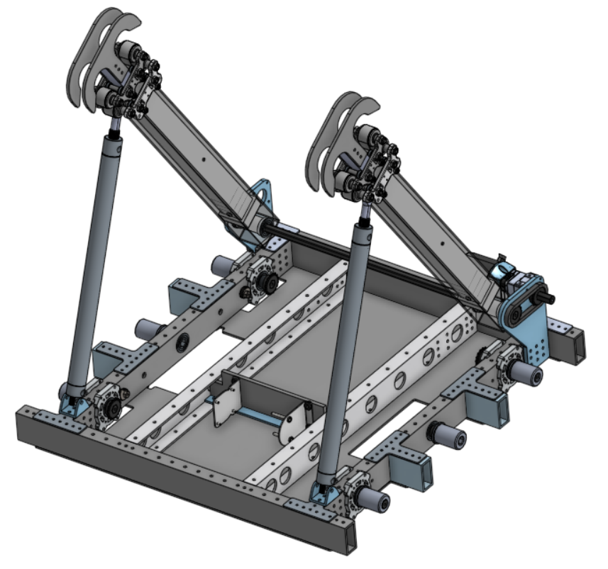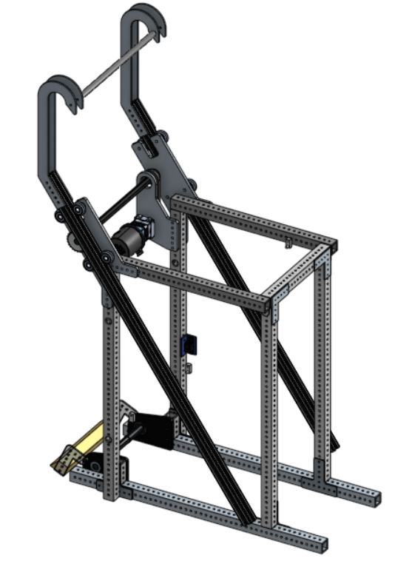
Back of Robot Front of Robot
To tackle this season’s unique climb challenge, we decided to have a two-stage climb on the back of our robot that can tilt in either direction to allow us to climb on the Mid Bar. A custom climb consisting of two arms was designed for the front of the robot to complete transition to the different bars. The robot latches to the Mid Bar, uses the back double hooks to reach the High Bar, and secures the climb with the single hooks. This sequence is repeated to reach the Traverse Bar.

Highlights
- 63” rear climber extension
- 49” front climber extension
- 50⁰ rear climber rotation
Programming
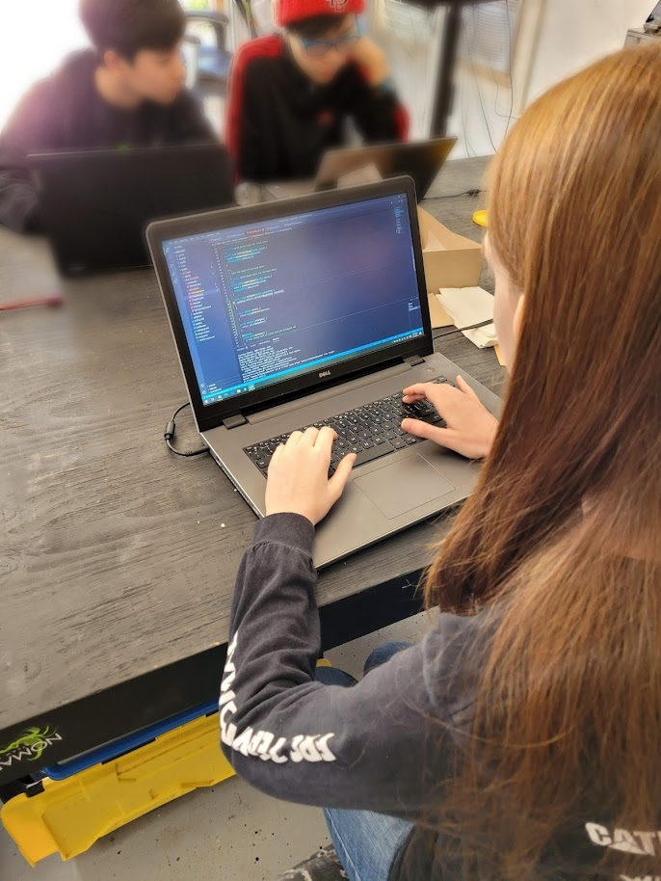

Autonomous

Tele-Op

Aimbot

AUTONOMOUS

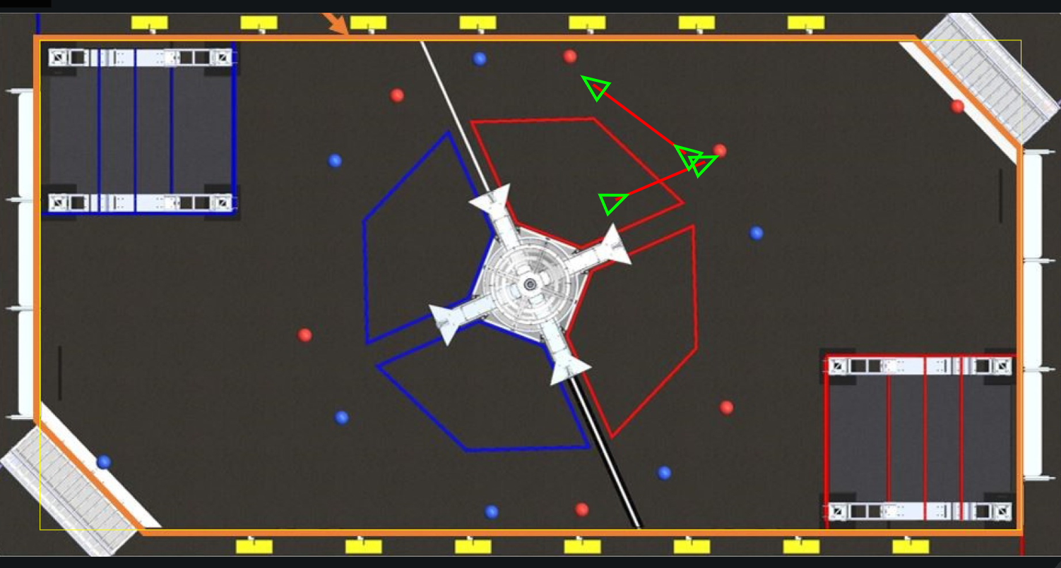

- The robot has the ability to score two balls from three different starting positions or a four ball auto run to help unlock the ranking point bonus.
- We designed our autonomous runs to be flexible and resilient to changes by using the drivebase neo encoders and the navx to accurately follow paths, as well as using our midtake sensors to detect when we pick up the ball we are driving towards.
- Our robot follows complex paths by sending a desired wheel speed to each side of the drivebase every code loop. Once the speeds are calculated for each time interval and the acceleration and velocity of the path are achievable by the robot, it is very consistent and repeatable. This enabled our four ball autonomous.
- NOMAD has also prepared simple autonomous code that we can distribute to other teams to make sure that our alliance always functions at top scoring capability.

TELE-OP

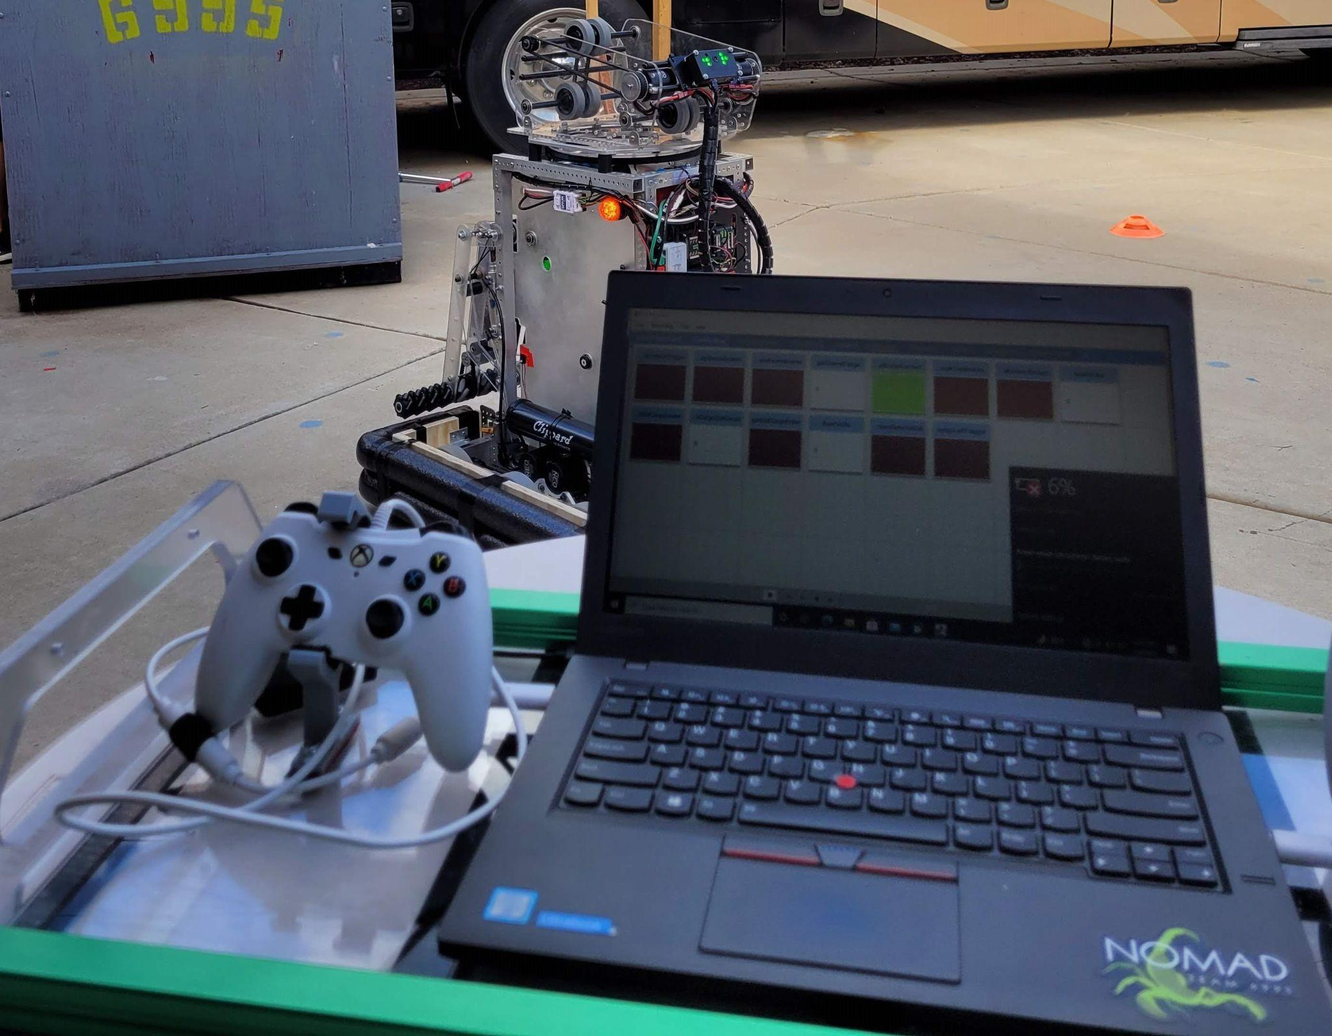

Drivebase
  - The drivebase code is designed to make our robot drive like a car, using arcing turns while moving forward or backward. Additionally, the robot will spin in place for quick turns.
  - In previous years we have had problems with our robots tipping over. To avoid this issue, this year’s software limits the acceleration of the drivebase so that it will not tip regardless of controller input.
- Cargo Handling
  - Our robot uses two sets of beam break sensors: one next to the intake and one on top of the midtake. This allows our robot to properly sequence cargo entering the robot. The sensor at the intake allows us to collect and organize up to two balls.
  - The beam break beneath the shooter enables the robot to shoot one ball at a time. This allows drivers to wait for the shooter to be ready between shots, making each shot more accurate.
- Shooting
  - The robot uses vision to track the target to know where and how fast to shoot. When the driver is ready to shoot the midtake will feed a cargo ball to the shooter, and prepare the next ball for feeding once the shooter recovers if there is another ball in sequence.

AIMBOT
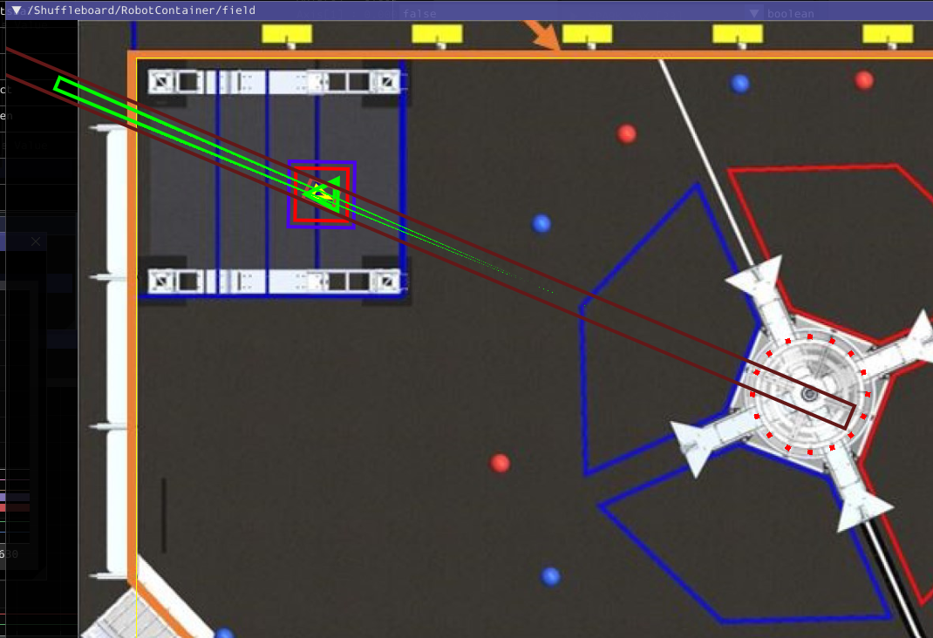
- When the robot sees a vision tape on the Upper Hub, it will automatically aim the turret towards it and adjust the speed of the shooter based on the distance from the target.
- Because of lighting conditions at some of our events, we decided to create an algorithm that would use the drivebase encoders to update the estimated location of the target as seen from the robot.
  - This system provides a continuously updating angle for the turret as well as a continuously updating distance for the shooter.
  - These outputs are updated even when the vision camera cannot see the target, but if the camera has a stable reading of the target, the vision output can be used to correct any error buildup in the aimbot.

