FIRST®️ Robotics Competition
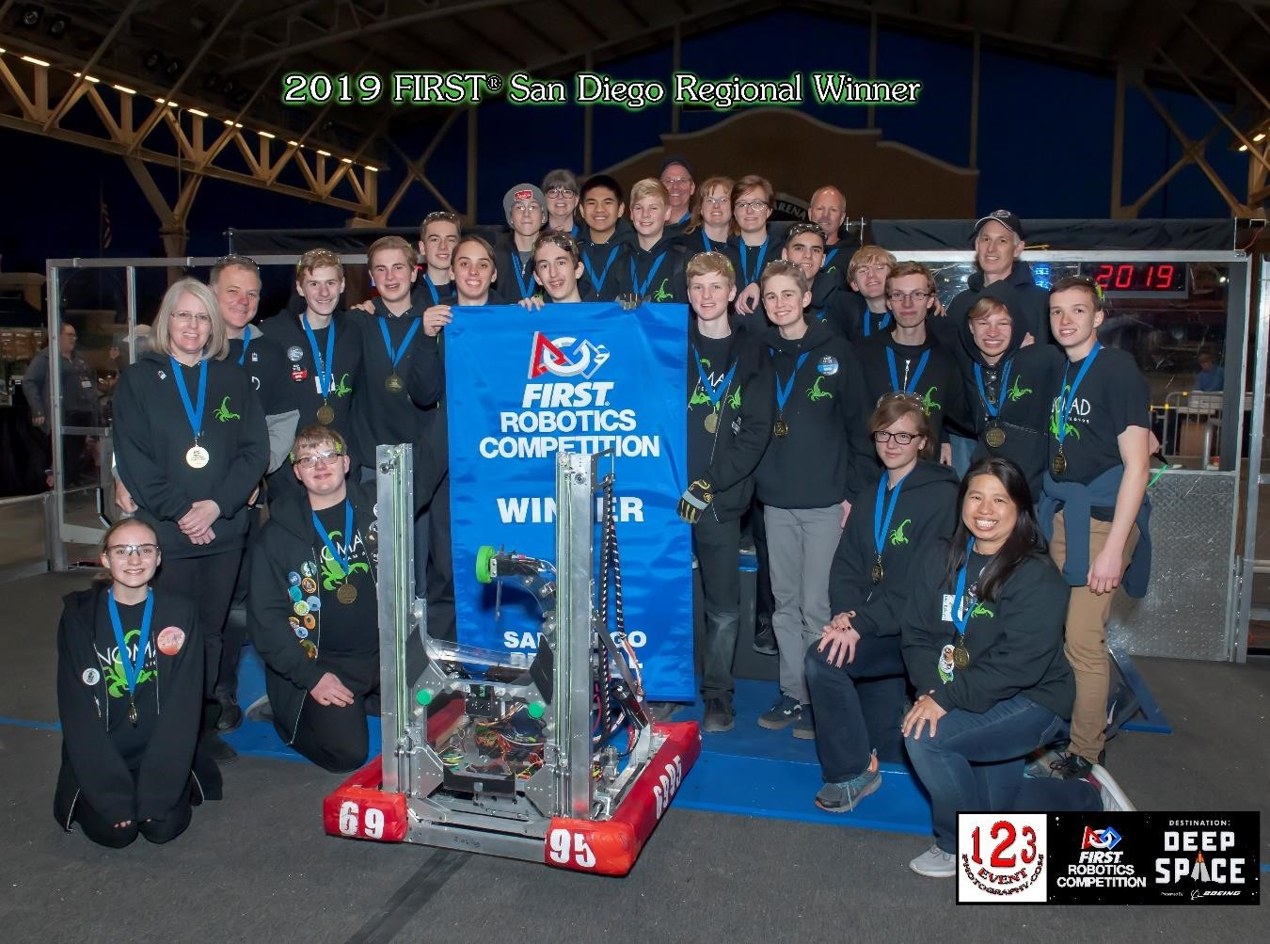
Community Team

Business Plan

www.frc6995nomad.com

1.0 Executive Summary

1.1 Mission Statement

Here at NOMAD, our goal is to provide an opportunity for all high school students, regardless of schooling choice, to develop lifelong skills through real-world, hands-on experiences in an exciting and fun environment. Through participating in FIRST® Robotics Competition, students have the opportunity to develop skills in creativity, problem solving, critical thinking, leadership, communication, collaboration, and adaptability. We strive to build productive relationships, inspire the next generation, and make a positive impact in all of our pursuits.

1.2 Team Summary

Established in September of 2017, FRC Team 6995 NOMAD provides high school students in the San Diego County an environment to develop skills that will enable them to succeed in their future careers and ambitions through participation in the FIRST®️ Robotics Competition. During competition season, students have six weeks to design, build, and program a life-size robot to accomplish specific non-combative tasks. Competition is designed in such a way as to require students to work in cooperation with other competitor teams. Outside of competition season, students have the opportunity to train incoming students, refine their own skills, raise funds for the team, build a team brand, and engage the youth in the community in STEM activities. NOMAD is the only community based FRC team in San Diego with its workshop located in Escondido.

1.3 Team Facts

Nickname | NOMAD
Team Number | 6995
Location | 2061 Lemon Avenue  Escondido CA 92029
Members | 21 High School Students
Head Coach | Kevin Brady, Mechanical Engineer
Team Budget | If attending one regional: $  If attending two regionals: $
Sponsors | FIRST, Solar Turbines, SamePage,
Awards | 2018 Rookie Highest Seed – San Diego Regional  2019 FIRST Regional Winner – San Diego Regional
Team’s Social Media | www.frc6995nomad.com  https://www.facebook.com/FRC6995NOMAD/  https://www.instagram.com/frc6995nomad/  frc6995nomad@gmail.com

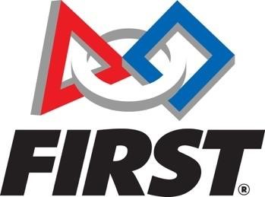

1.4 About FIRST®️

“FIRST®️ was founded by Dean Kamen in 1989 to inspire young people to explore science and technology and to show how one can impact their community using technology. FIRST®️ uses innovative programs and competitions to drive students towards STEM (Science, technology, engineering, and mathematics) and to help form a community.” – from the FIRST®️ website

FIRST core values include:
- Gracious Professionalism – “Fierce competition and mutual gain are not separate notions. Gracious professionals learn and compete like crazy, but treat one another with respect and kindness in the process.”
- Coopertition® - “Displaying unqualified kindness and respect in the face of fierce competition. Teams can and should help and cooperate with each other even as they compete. Coopertition means competing always, but assisting and enabling others when you can.”

1.5 Summary of Team Growth
As a rookie team in 2018 with very little FRC experience, we focused our energies on building the best robot we could. Due to the generosity of FIRST, Qualcomm, and our mentor’s employers, we were able to complete our rookie year within our budget of $7,000. We found our local FRC teams to be a valuable asset in both resources and experience. Although a small team, we learned to work well as a team, to persevere through missed deadlines and failures, and to celebrate the small and big successes. We learned many valuable lessons including the importance of completing the design process by the end of week two, allowing the software team more time to work with the drivebase, programming and testing autonomous early on, and making time for the drive team to practice with the robot. Although we did not accomplish all that we had set out to do with our robot in 2018, we were very proud of the work that we accomplished and excited about doing things better in 2019.

Now at the end of build season in 2019 we are very proud of the advances our team has made. We have grown tremendously and have 21 students on the team. Our team is divided into five sub-teams, Business, Computer Aided Design, Mechanical, Drive and Software. Each sub-team works together to ensure success for NOMAD. We have been successful in many of our goals, including allowing the software team more time with the drivebase and allowing more time for the drive team to practice with the robot. We also achieved the goal of having a student designed and built CNC machine to manufacture parts for our robot.

In addition to these goals we have also worked to make a difference in our community by the creation of RoboCamps for kids ages 8-14. These camps raise necessary funds for our team, but just as importantly we are fostering a love of STEM in future FRC students, and as a direct result of the camps hope to help launch three new FIRST LEGO league teams this coming year.

2.0 Team Overview

2.1 Team History

Our team leader, Kevin Brady, and his family lived in Australia for a time where they were involved in the formation of the FRC team 5584, ICRobotics. When they returned to the States, they wanted to continue participating in FIRST® Robotics Competition, but they were not eligible to join any of the existing teams in San Diego County. In September of 2017, FRC Team 6995 NOMAD was established so that all students in the San Diego county would have an opportunity to participate in FRC. We are the only San Diego team that is not affiliated with a school or organization. Our workshop is located in Escondido in our team leader’s garage.

In our rookie year, with the support of local FRC teams and our sponsors, NOMAD competed at the 2018 FRC San Diego regional and was excited to win the Highest Rookie Seed Award. Our sponsors included FIRST, Qualcomm, Solar Turbines, General Atomics, Symitar, and Samepage.

This year we competed in the 2019 FRC San Diego regional. Despite the illness of one of our drive team members, we ranked 18 out of 47 teams, and we were elated when we were picked to participate in the quarterfinals with the number 1 ranked team of the competition. It was a fierce competition through quarterfinals, then semifinals, and finally making it to finals. As a second-year team, we are still overwhelmed by the fact that we were part of the winning alliance. We couldn’t have done it without the support of sponsors: FIRST, Qualcomm, Solar Turbines, Mezier Enterprises, General Atomics, Samepage, and Shuebox Educational Services.

2.2 Student Team Members

Since team NOMAD is not affiliated with a particular school, our students represent various public, private, and charter schools. In our first year of FRC, our team consisted of seven male students, but as we prepare for the 2019 season, we have tripled in size and gained four female students.

2.3 Team Mentors

We currently have ten mentors. five of the ten mentors are Science, Technology, Engineering, and Mathematics (STEM) professionals. Three mentors constitute the team’s advisory board, which is responsible for overseeing the overall team organization and for creating and enforcing program rules and team policies.

2.4 What Makes Us Unique?

NOMAD is a community-based team in the FIRST®️ Robotics Competition. We are the only San Diego team that is not affiliated with a school or organization and have tripled in size since our rookie year, gaining both boys and girls from five different cities. Diversity is welcomed.

3.0 Team Management

3.1 Team Membership
NOMAD membership is a year-long commitment starting in May. Each team member must agree to follow the standards set forth in the NOMAD Student Handbook as well as register with FIRST and pay a $50 NOMAD registration fee. New team members may join May through October each year.

3.2 Team Structure

NOMAD is divided into five student teams supported by our mentors and sponsors. Many students contribute to more than one team.

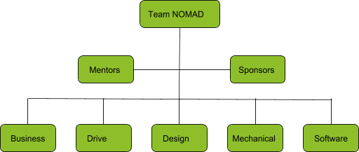

3.4 Team Descriptions
Business Team: The Business Team is responsible for raising funds, promoting the team to our community, and maintaining needed documentation. It is also responsible for designing and creating all the artistic items that the team will need and for the creation and implementation of RoboCamps.

Drive Team: The Drive Team is selected via tryouts and is responsible for driving the robot at all competition and demonstration events. Within the Drive Team there are main and backup drivers, operators, coaches, technicians, and human players

Design Team: The Design Team works in parallel with the Mechanical team to make a working representation of the robot sub-assemblies in CAD (Computer Aided Design) and is also responsible for design documentation necessary for robot construction.

Mechanics Team: The Mechanical Team is responsible for building the robot according to the specifications provided by the Design Team.

Software Team: The Software Team is responsible for developing and deploying Java code that operates the robot. They are also responsible for researching, choosing, and programming all robot sensors.

4.0 Future Team Plans

4.1 Long-term Goals
- Win a Regional competition *
- Participate in the Championship competition *
- Compete in two Regionals by 2020
- Obtain funding ($3,000) to build a second robot for community demonstrations and training
- Participate in community service projects
- Develop an advanced and junior version of our successful introductory RoboCamp
- Develop a 5-year plan for the team
- Seek out additional mentors with FIRST experience
- Submit Chairman’s Award
* Goals reached in 2019 season

4.2 Short-term Goals

- Finish under budget
- Develop training materials/workshops for new students
- Develop a schedule for build season as well as off-season activities
- Mentor younger STEM students
- Schedule visits to local community groups and schools to inspire younger students in STEM.

4.3 VERY Short-term Goals
- Raise $8,000 to participate in the World Championships!

5.0 Team Budget

Our initial budget for our 2019 Season is as follows:

2019 Anticipated Income | $11,500
2019 Anticipated Expenses | ($10,535)
Net Income (Loss) | $965

5.1 Income
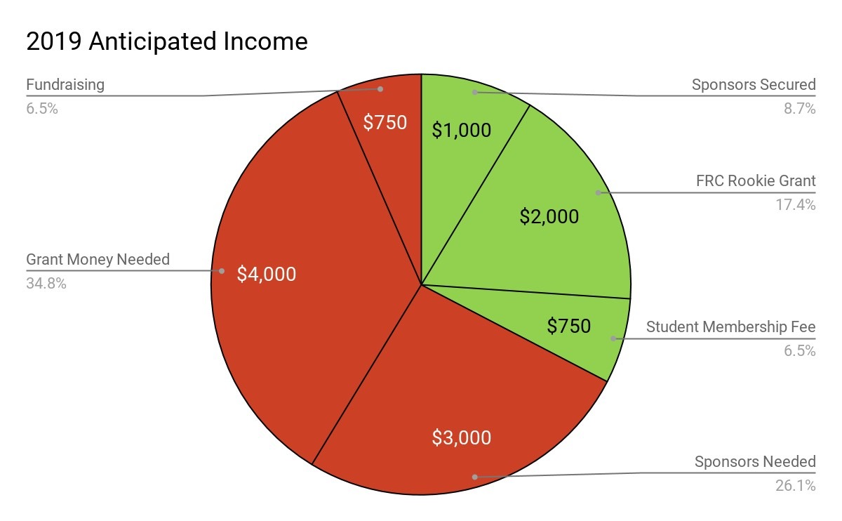

5.2 Expenses

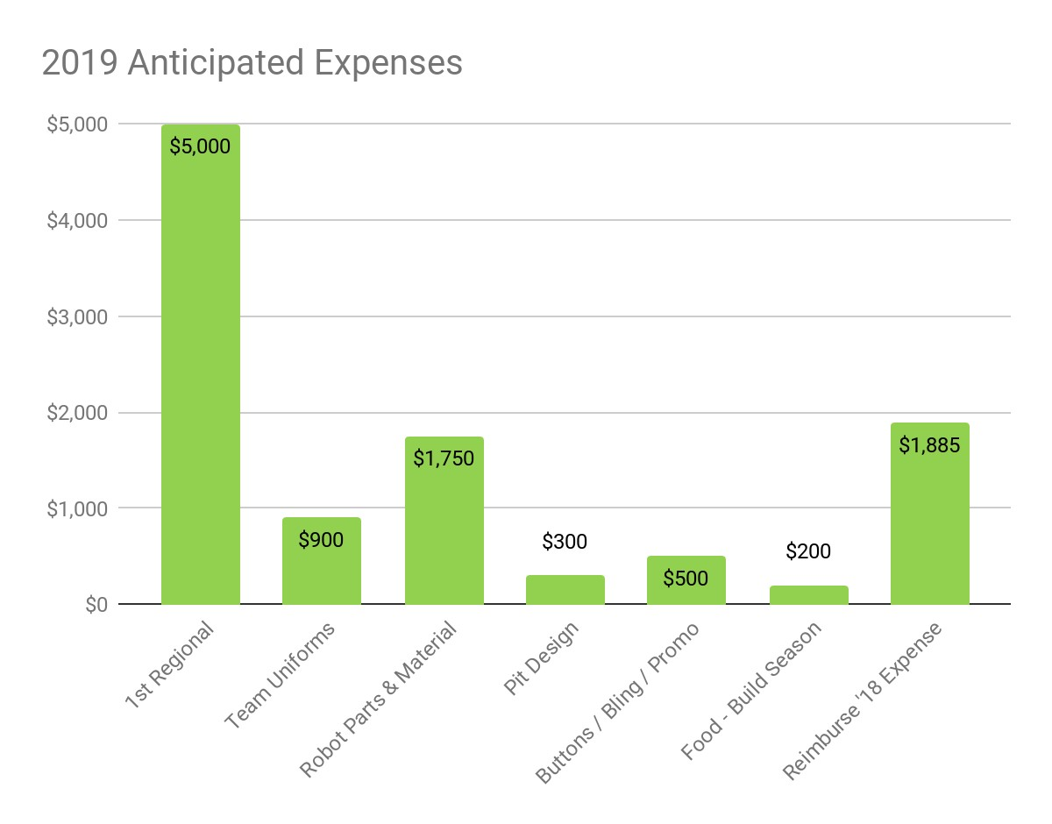

5.3 Fundraising Opportunities

- Iceplex fundraiser
- Sell Krispy Kreme donuts
- Chipotle, Panda Express, and Pieology Fundraisers
- Recycling Fundraiser
- Host RoboCamps

5.4 World Championship Budget
In 2019, we won the San Diego Regional. Our budget for going to the World Championships in Houston in April 2019 was the following. All students paid their own travel expenses, and the diagram below serves as a guide for future years’ championship budgets.

6.0 Sponsor Information
6.1 Sponsorship Levels
Platinum Level ($5,000 and up):
- Social media shout out once a month
- Team Shirt: Large logo of business
- Robot: Large logo of business on robot
- Banner: Large logo of business on banner (displayed at events & tournaments)
- Website: Large logo with link to sponsor’s website on sponsorship page
- Name in team slideshow at all competition events

Gold Level ($2,000-$4,999):
- Social media shout out every other month
- Team Shirt: Medium logo of business
- Robot: Medium logo of business on robot
- Banner: Medium logo of business on banner (displayed at events & tournaments)
- Website: Medium logo with link to sponsor’s website on sponsorship page • Name in team slideshow at all competition events

Silver Level ($500 - $1,999):
- Three social media shout outs a year
- Team Shirt: Small logo of business
- Robot: Small logo of business on robot
- Banner: Small logo of business on banner (displayed at events & tournaments)
- Website: Small logo with link to sponsor’s website on sponsorship page
- Name in team slideshow at all competition events

Bronze Level (Under $500):
- Two social media shout outs a year
- Website: Name of business/individual on sponsorship page
- Name in team slideshow at all competition events
6.2 Current Team Sponsors

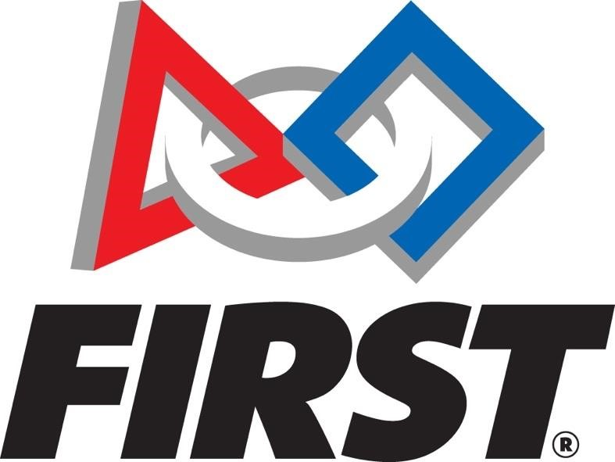 | The mission of FIRST® is to inspire young people to be science and technology leaders and innovators, by engaging them in exciting mentor-based programs that build science, engineering, and technology skills, that inspire innovation, and that foster well-rounded life capabilities including self-confidence, communication, and leadership.
 | Qualcomm focuses on a single goal— invent mobile technology breakthroughs.
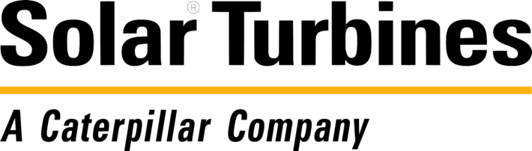 | Solar Turbines is a leading provider of industrial gas turbine engines, compressors and mechanical drive packages.
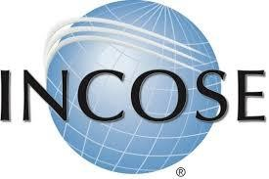 | The San Diego Chapter of INCOSE organizes educational and networking events for its members to develop, nurture, and enhance multi-disciplinary system development under the title of Systems Engineering.

Samepage is a collaboration software that helps teams manage projects online in
real-time with simultaneous editing, version control, task management, group video calling, file sharing and more.
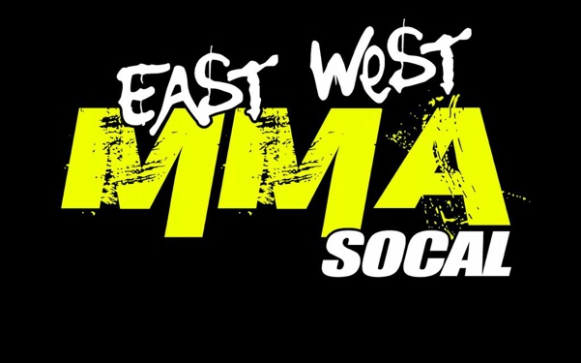 | East West MMA offers a variety of martial arts experiences, ranging from children's martial arts training and combat fitness to get you into shape all the way to MMA and Brazilian Jiu Jitsu.
Grandpa Lincoln | Grandpa Lincoln is the grandfather of one of our business team members, and is one of our most generous and warm-hearted supporters!
Symitar
CNC Parts
Smart and Final Charitable Foundation

7.0 Team Contact Information

General Contact

frc6995nomad@gmail.com

Business Team Contact

frc6995nomad.business@gmail.com

Kevin Brady, Lead Coach/Mentor 1

kevinbrady777@gmail.com
Cell: (760) 566-8252

Cynthia Brady, Lead Coach/Mentor 2

cyn.brady1@gmail.com
Cell: (760) 566-8251

Sheree Baluyot, Business Team Mentor

sbaluyot@gmail.com
Cell: (619) 920-5245

Mailing Address

FRC Team 6995 NOMAD
Att: Kevin Brady
2061 Lemon Ave.
Escondido, CA 92029

Website: frc6995nomad.com

Facebook: https://www.facebook.com/FRC6995NOMAD/

Instagram: https://www.instagram.com/frc6995nomad

FRC TEAM NOMAD INC is a 501c3 nonprofit organization
Federal Tax ID# 82-3354186

